Bountiful Heights Stake

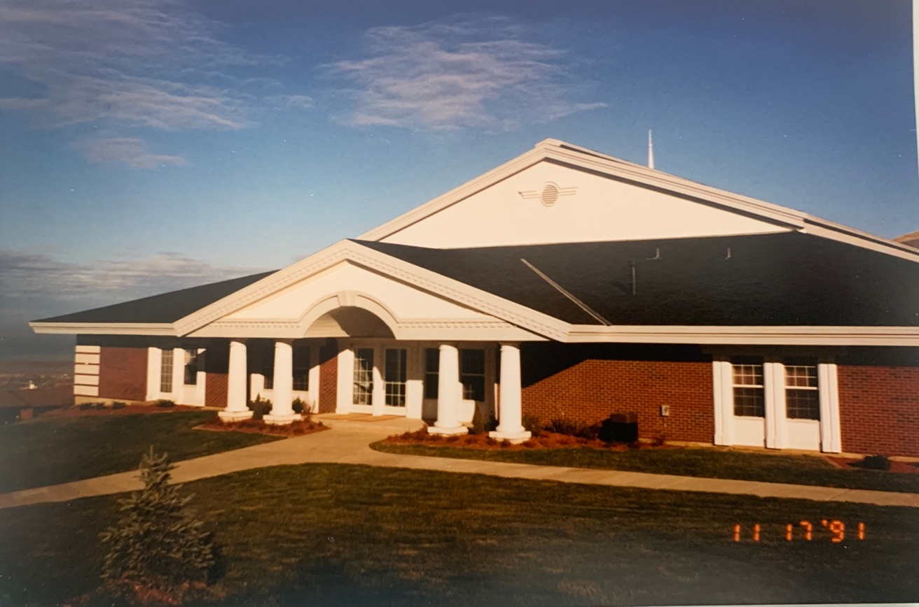

50 Year History
1971 - 2021

Contents
Stake Presidency Message 5
Highlights 7
State of the Stake 7
Honor Roll of 50-year Stake Members 7
Our Stake Presidencies 9
Our Stake Patriarchs 11
Patriarch Cutler’s Thoughts 12
Mission Presidents from the Stake 12
Stake Young Women’s Presidency 15
First Baptism - 15
1971 Organization 16
1971 Historical Report 16
2021 Organization 27
Stake Officers 27
Bishops 28
2020 Message from President Dan Lake: 28
2020 Message from President Barry Gibbons 29
2020 Easter Message from Bountiful Heights Stake Presidency 30
Stake Wards and Buildings Error! Bookmark not defined.
Timeline of Wards and Buildings 32
Bountiful 33rd Ward 33
Bountiful 34th Ward 33
The “Old Stake Center” 35
34th Ward Split to Form the 54th Ward 35
The Stake Center Construction 35
“Scout Building” or Family History Center 36
400 North 400 East Building 37
Alfalfa Field 38
Bountiful Temple 40
South Davis Branch 43
Building Construction 43
The Bountiful 50th Ward 44
Bountiful 50th Ward Bishoprics 46
Heights 1st Ward Creation Letter - First Presidency 50
Heights 2nd Ward – History 52
The Floods of 1983 62
The Floods of 1983 62
Stone Creek Mud Slide 63
Battle of Bountiful: Utah’s worst flood? - 66
Deseret News – Bountiful Flood 68
Flood – Davis Clipper Photo 69
The Fires of 2019 70
The Gun Range Fire – Asay Family 70
Angelic Help – Steve Gulbrandsen 71
Gun Range Fire – June Gulbrandsen 71
Gun Range Fire – George Family 74
Gun Range Fire – Bowen Family 76
The Youth 79
Sons of Helaman - 2000 Stripling Warrior Parade 79
Sons of Helaman March - Meridian Magazine 79
“Redeem the Cousins” Heights Ward Young Women Project – 2015 82
Middle Teton Climb Tradition 83
1981 Trek Flyer 85
Trek – 1989 Bruce Dibb 87
The Miracles of Trek - Pepper Murray 87
Lessons I learned from Trek 2002 - Pepper Murray 91
Stake Pioneer Trek - 93
Stake Pioneer Trek 2018 93
Pioneer Trek 2002 93
Service 96
2021 Service Project - Pierce Property 96
2021 Service Project - Hardman Property 100
2021 Service Project - Scott Property 103
2021 Service - Hernandez Property 106
2021 Service Project - Radmall Property 108
Personal Stories 109
Mary Alice Galt, Dry Creek Ward 109
Barbara Webb, Dry Creek Ward 109
Anonymous 110
Greg and Stephanie Jones, Dry Creek Ward 110
Valentine’s Dance – Dave and Jennifer Haygood 111
2018 Valentines Dinner Dance 112
2020 Valentine’s Dance 112
Robert and Marsha Bradbury, Dry Creek Ward 114
Ralph and Brigitte Wilcox, Dry Creek Ward 116
Jed and Patsy Spencer, Dry Creek Ward 117
Burnham Family - Crystal Burnham, 16th Ward 120
Dwight Galloway Assigned to the SA Ward 120
Curt Wilbur - Assigned to Bountiful 18th Ward 121
Evan Thomas - Assigned to Bountiful 24th Ward 122
Clint Beisinger - Assigned to 34th Ward 123
Erick Anderson - Assigned to the Bountiful 41st Ward 123
Jim Bergstedt - Assigned to the 50th Ward 124
Jonathan Rupp - Assigned to Dry Creek Ward 126
Roy Woodbury - Assigned to the 54th Ward 127
Carson Gautavai - Assigned to Heights Ward 127
Scott Kimber - Assigned to Ward Canyon Ward 128
Steven Moffit - Assigned to Bountiful 16th Ward 129
Heights Stake Auxiliaries Stake Primary President - Rochelle Gautavai 129
Stake Young Women’s 2020 130
Stake Relief Society - Monday, Apr 13, 2020 Service Opportunity 131
Face Mask Pattern 132
Facemask Memorandum - April 15, 2020 132
Facemask Thank Letter April 18, 2020 133
Stake Young Men’s 2020 134
Stake Sunday School 2020 134
Bountiful Heights Family History Center 2020 134
Bountiful Utah Heights Stake Additional Histories 136
40th Year Anniversary May 2011* 136
The Vineyard Neighborhood: A Brief History By Ralph Mabey 140

Stake Presidency Message

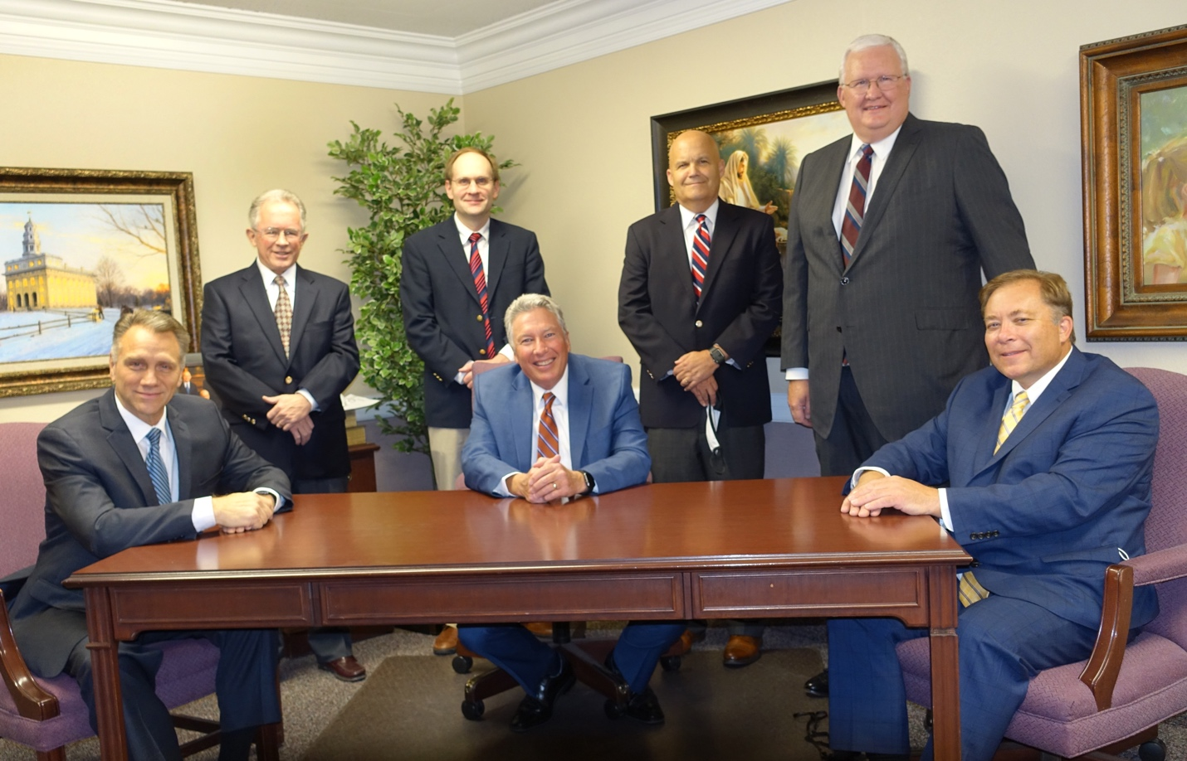

Dear members of the Bountiful Utah Heights Stake
Almost twenty years ago, during the summer of 2002, members of the Bountiful Heights Stake gathered together with President Randy Browning to end a special fast. The stake pioneer trek was to begin in just a few days, and stake members had been fasting and praying that the youth of the stake would have a successful experience. Of special concern was the forecasted weather. Temperatures in Salt Lake City were predicted to be well over a 100 degrees Fahrenheit, and concern for the safety of the youth was rising. Pioneer trek was to be an opportunity for the youth to unite together in remembering and experiencing just a few of the trials that strengthened generations of Church members, but to do so safely.
The gathering was a final check-in with the Mas and Pas of the coming trek — those that would be leading the “families” of youth through the next few days. A few testimonies were born, and then President Browning ended the special fast with a prayer. He and the other stake participants all knelt together. The Spirit was already strong, even before President Browning began to pray. The participants would not soon forget that prayer. Instead of praying that the conditions might improve, President Browning was inspired to ask for a different miracle. “We ask not that the elements be tempered, but that we may be strengthened to meet the challenges ahead.”
That prayer, spoken on behalf of so many leaders, parents, and youth, exemplifies the Bountiful Heights Stake. The Stake was established on May 16, 1971. Fifty years later, the Stake has been home to thousands of individuals who have been strengthened to meet the challenges of our times. The foundation of faith that sustained the pioneers as they crossed Wyoming lives on in the members of the Bountiful Heights Stake. Challenges have certainly arisen within the past fifty years, and many more trials are yet to come. But the members of this Stake have proven time and time again the sustaining power of faith. And while the faith of the pioneers inspired and continues to inspire members of the Stake, future generations will look to the past fifty years and call themselves blessed for the legacy of faith established by the Bountiful Heights Stake.
This history records a few of the many experiences and details that have made the Bountiful Heights Stake what it is today. Some of the experiences are entertaining. Some are faith promoting. Some of the experiences may even be considered as simple and ordinary — the experiences of everyday people having everyday lives. But in this, we are also reminded that “there are no ordinary people.” With these words, author C.S. Lewis famously concluded that we “live in a society of possible gods and goddesses.” The members of the Bountiful Heights Stake have demonstrated this truth over the past fifty years, and continue to live extraordinary lives.
And so this history is intended to be a reminder of the past, an inspiration today, and a hint of the future. It is a reflection of Zion — of individuals working together to be a God-like people. It is a representation of the salt of the earth and of the cities set as beacons on a hill, of the meek, of the loving, and of the faithful. It is a snapshot of the friends and family that make up the Bountiful Heights Stake.
Sincerely,
Bountiful Utah Heights Stake Presidency

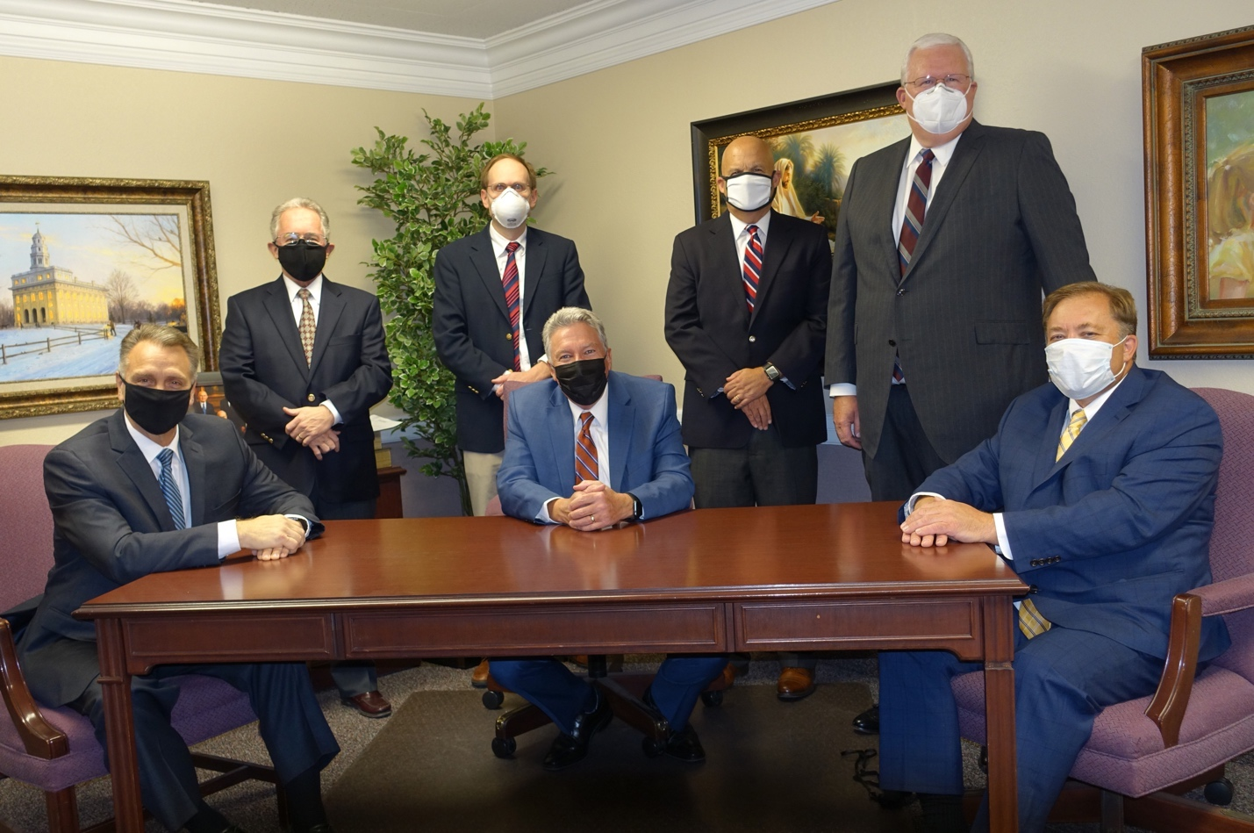

Highlights

State of the Stake
The Bountiful Heights Stake was formed on May 16, 1971, under the direction of Mark E. Peterson, of the Quorum of the Twelve Apostles, when the Bountiful Stake was divided.
On January 1, 1974, the official name of the Stake was changed to the Bountiful Utah Heights Stake (herein, the “Stake”). The Stake is currently a part of the Utah Area and is assigned to the Bountiful Utah Temple and to the Utah Layton Mission.
As of July 4, 2021, the Stake had 3,783 members, which are comprised of the following:
- Adult Men 1,347
- Adult Women 1,379
- Married Adults 1,772
- Single Adults 645
- Young Single Adults 334
- Total Households 1,592
- Young Men 244
- Young Women 196
- Children (3-11) 486
- Infants (0-2) 131

Honor Roll of 50-year Stake Members
The Stake’s history consists of more than just buildings, wards, and dates. Our history also consists of the stories the individual Stake members. The strength and faith of our Stake is not found in its organizations or buildings; it is found in the faith of its members. The collective faith of our membership has been especially enhanced by those who have remained in the Stake throughout its 50-year history. The following members have contributed faithfully to the Stake since its inception:
Stake Member Ward
- Barbara Jeppsen 16
- Bob and Barbara Armstrong 16
- Bryon and MarJean Stubbs 16
- Dean and Elaine Holbrook 16
- Dick and Kathy Chidester 16
- Elaine Steele 16
- Jan Asper 16
- Janet Brown 16
- Janet Gold 16
- Larry and Karen Hyde 16
- Lorraine Harris 16
- Phil and Dorothy Johnson 16
- Richard Brunner 16
- Ron and Kay Hardy 16
- Verna Richardson 16
- Wayne Pascoe 16
- Craig and Norma Maddux 18
- Don and Lorraine Riley 18
- Milt and Becky Russon 18
- Paul and Doris Garlick 18
- Richard & Linda Messenger 18
- Ruth Hulet 18
- Sharon Peffer 18
- Robert V. Fowles 18
- Reed & Judy Christiansen 18
- James and Patricia Rushforth 24
- Lora Ford 24
- Lorin and Jeri Blauer 24
- V. Brent & Nelda Bangerter 24
- Carma and Neil Fabrizio 24
- Keith and Sharon Sessions 24
- Bob and Louise Weseman 24
- Elaine Platt 24
- Adrien Squire 24
- Dennis Christensen 34
- Don and Peggy Hokanson 34
- George & Carolyn Burbidge 34
- King Green 34
- Richard and Rhea Anderson 34
- David and Karen Cook 41
- Elizabeth Reimann 41
- Jesse Godfrey 41
- Terry and Carolyn Tait 41
- Ken and Loretta Hill 50
- Amy Barnett 54
- Brent Moon 54
- Golden Davis 54
- Lynn and Diane Barnett 54
- Pat Putnam 54
- Priscilla Wiser 54
- Barbara Webb DCW
- Joseph and Lorraine Cutler DCW
- Mary Galt DCW
- Sterling and Carol Jensen DCW
- Jolaine Randall DCW
- Ralph & Brigitte Wilcox DCW
- Steve Barnett Heights
- Brent Biesinger WCW
- Don and Kathy Milligan WCW
- Mel and Shirley Bangerter WCW

Our Stake Presidencies
Since its inception, the Stake has been led by Stake Presidencies that have provided inspired leadership to the Stake through 50 years of growth, afflictions, societal change, and faith-building events. The following is a chronology of the Stake Presidencies since the Stake was organized:
May 16, 1971 First Presidency (called at the time of Stake Organization):
- President Jesse E. Godfrey
- President Grant Peterson, 1st Counselor
- President Joseph Cutler, 2nd Counselor

September 7, 1980 New Stake Presidency:
- President Roden Grant Shumway
- President Mark Eubank,1st Counselor
- President George Brian Bone, 2nd Counselor
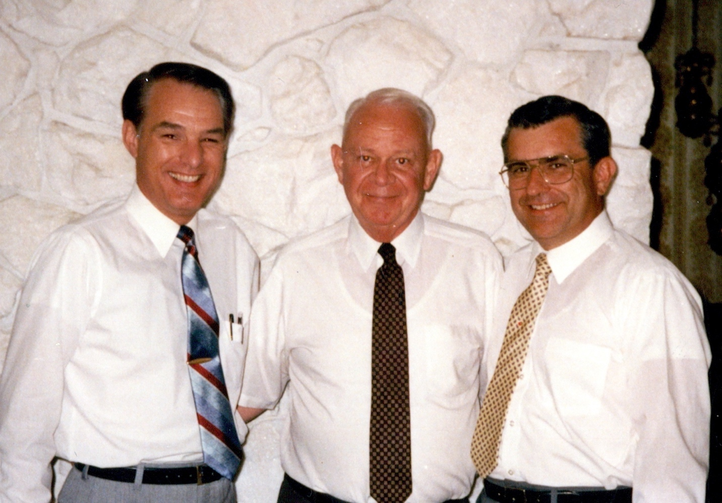
September 11, 1988 New Stake Presidency:
- President Joe L. Johnson
- President Richard Newton, 1st Counselor
- President Les Paskett, 2nd Counselor

September 12, 1993 Stake Presidency Reorganized:
- President Joe L. Johnson
- President Richard Newton, released as 1st Counselor
- President Les Paskett, 1st Counselor
- President C. Richard Chidester, 2nd Counselor

January 21, 1996 New Stake Presidency:
- President Randall M. Browning
- President C. Richard Chidester, 1st Counselor
- President Darwin F. Peterson, 2nd Counselor

February 18, 2001 Stake Presidency Reorganized:
- President Randall M. Browning
- President C. Richard Chidester, released as 1st Counselor
- President Darwin F. Peterson, 1st Counselor
- President John L. Robison, 2nd Counselor

August 29, 2004 New Stake Presidency:
- President Ralph R. Mabey
- President John L. Robison, 1st Counselor
- President Bruce L. Dibb, 2nd Counselor
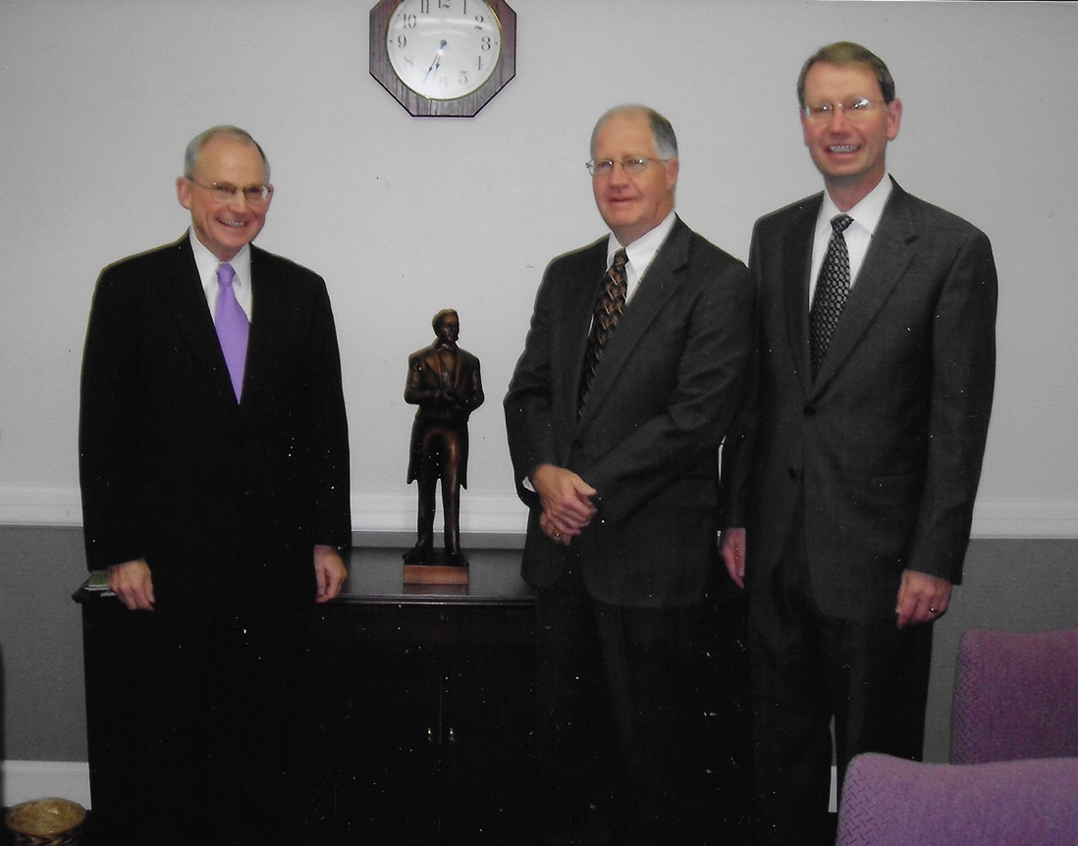
February 3, 2008 Stake Presidency reorganized:
- President Ralph R. Mabey
- President John L. Robison, released as 1st Counselor
- President Bruce L. Dibb, 1st Counselor
- President John R. Harding, 2nd Counselor

February 12, 2012 Stake Presidency Reorganized:
- President Ralph R. Mabey
- President John R. Harding, released as 2nd Counselor
- President Bruce L. Dibb, 1st Counselor
- President Daniel P. Lake, 2nd Counselor

February 10, 2013 Stake Presidency Reorganized:
- President Ralph R. Mabey
- President Bruce L. Dibb, released as 1st Counselor
- President Daniel P. Lake, 1st Counselor
- President Curtis K. Child, 2nd Counselor

August 25, 2013 New Stake Presidency:
- President Daniel P. Lake
- President Curtis K. Child, 1st Counselor
- President Barry A. Gibbons, 2nd Counselor
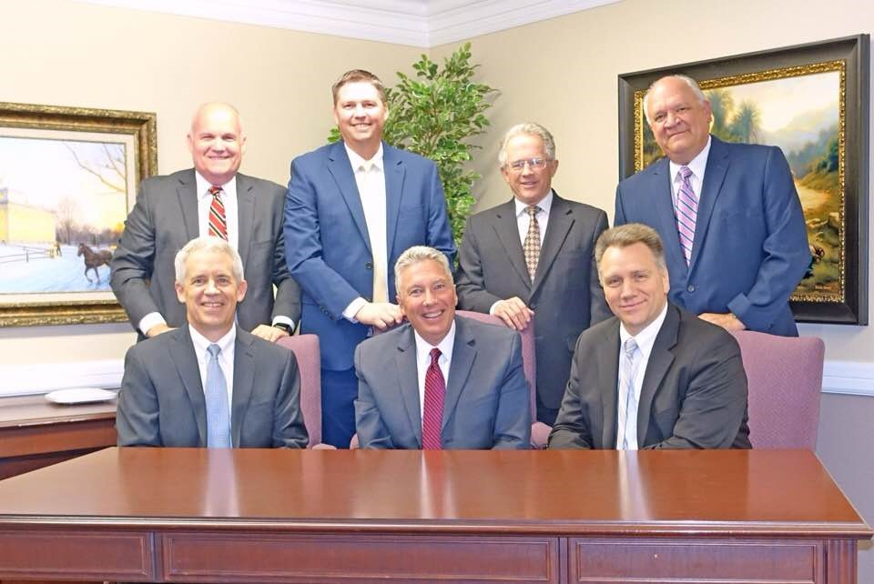
January 26, 2020 Stake Presidency reorganized:
- President Daniel P. Lake
- President Curtis K. Child, released as 1st Counselor
- President Barry A. Gibbons, 1st Counselor
- President Kevin G. Anderson, 2nd Counselor

July 4, 2021 Current Stake Presidency:
- President Daniel P. Lake
- President Barry A. Gibbons, 1st Counselor
- President Kevin G. Anderson, 2nd Counselor

Our Stake Patriarchs
Stake Patriarchs are critical to the spiritual progress of the youth, and also the adults, in our Stake. A Patriarch is a life-long Priesthood office. Although a Patriarch may be released from active service, he will always hold that Priesthood office and will permanently retain the authority to give blessings to family members. Our Stake has been blessed with an unbroken line of Patriarchs. In some cases, there were two active Patriarchs serving at the same time. The following is the list of Patriarchs who have lived in our Stake, some of whom did not actively serve in the Stake:
- Thomas Briggs 1958 - 1983
- George L. Scott 1966 – 1981
- J. Bruce Smart 1975 – 2015
- J. Paul Barlow 1975 – 1990
- Jesse Godfrey 1981- 1994
- Glen Behling 1993 – 2007
- Richard Newton 1997 – 1999
- Joseph Cutler 1999 - 2019
- Randall Browning 2019 - Present

Patriarch Cutler’s Thoughts
"When the Bountiful Heights Stake was organized in 1996, only J. Bruce Smart and Richard Newton were in the new Stake. Bruce continued to serve for several years. He was given Non-functioning status a few years after I was called to be the Patriarch. I was called and ordained by President Randall Browning on May 16, 1999. Richard Newton had moved out of the Stake a couple of months before. At the time it was felt that with the large membership of the Stake two Patriarchs were needed. When Bruce Smart was stopped serving, the Stake Presidency decided that only one Patriarch was needed, I was given Non-functioning status at the August 2019 Stake Conference. Interestingly Pres. Browning was called to serve as Stake Patriarch at the same time."
Brother Joseph Cutler, Patriarch

Mission Presidents from the Stake
The Stake has been a rich resource to the Church for Mission Presidents who have served around the world. The following couples from our Stake have served in this trusted capacity:
Name Mission Years Served
- Colin and Nancy Miller MTC Columbia Bogota To be confirmed
- Colin and Nancy Miller Spain Bilbao To be confirmed
- Jack and Connie Bangerter Nebraska Omaha 1994-1997
- Joe and LaVon Johnson Ohio Columbus 1996-1999
- Bruce and Dororthy Smart England Leeds 1978-1981
- V. Brent & Nelda Bangerter Micronesia Guam 2000-2003
- Richard and Cathy Chidester Czechoslovkia Prague 2001-2004
- Danny and Kelly Brock South Africa Durban 2004-2007
- Randall and Marty Browning Georgia Atlanta North 2005-2008
- Darwin and Nola Petersen Argentina Neuquen 2006-2009
- John and Joan Robison Texas Lubbock 2008-2011
- John and Deborah Harding Atlanta Georgia 2012-2015
- Bruce and Colleen Dibb Italy Milan 2013-2016
- Dennis and Jan James North Carolina North 2015-2018.
- Reid and Shelly Neilson Washington DC North 2019-2022
- Curtis and Jackie Child Texas Lubbock 2020-2023

Jack and Connie Bangerter | Curtis and Jackie Child
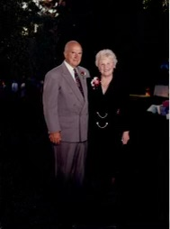 | 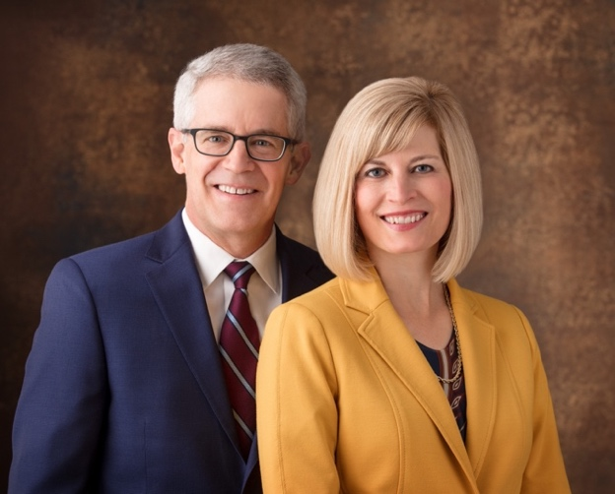
Randall and Marty Browning | Joe and LaVon Johnson
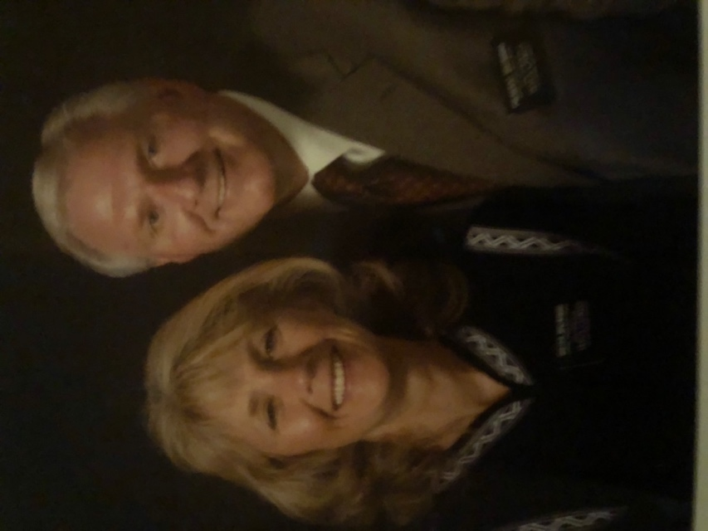 | 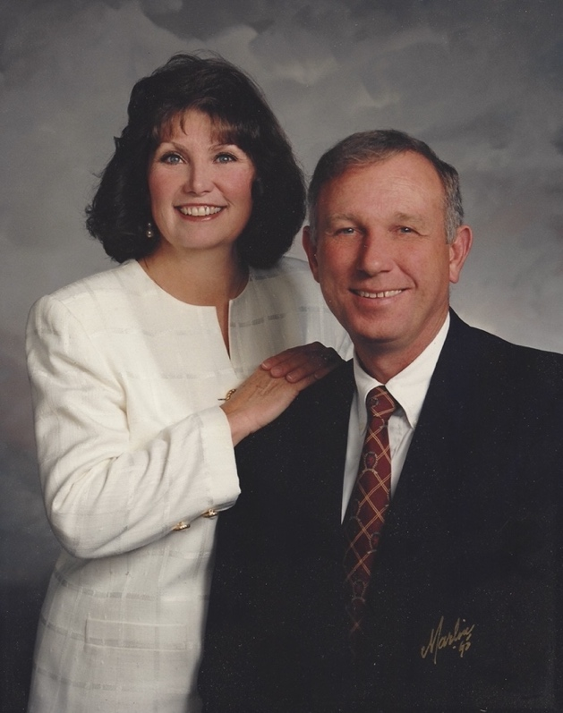
Danny and Kelly Brock | Bruce Colleen Dibb
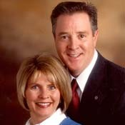 | 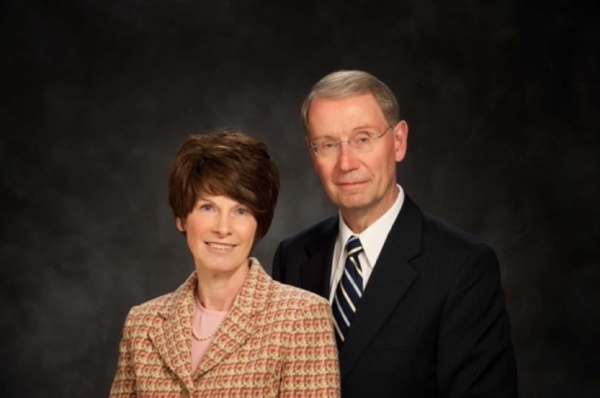
John and Joan Robison
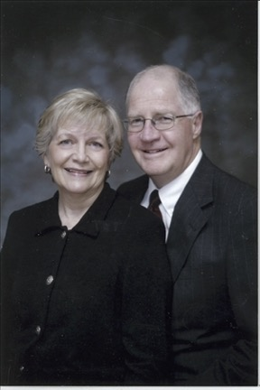 | 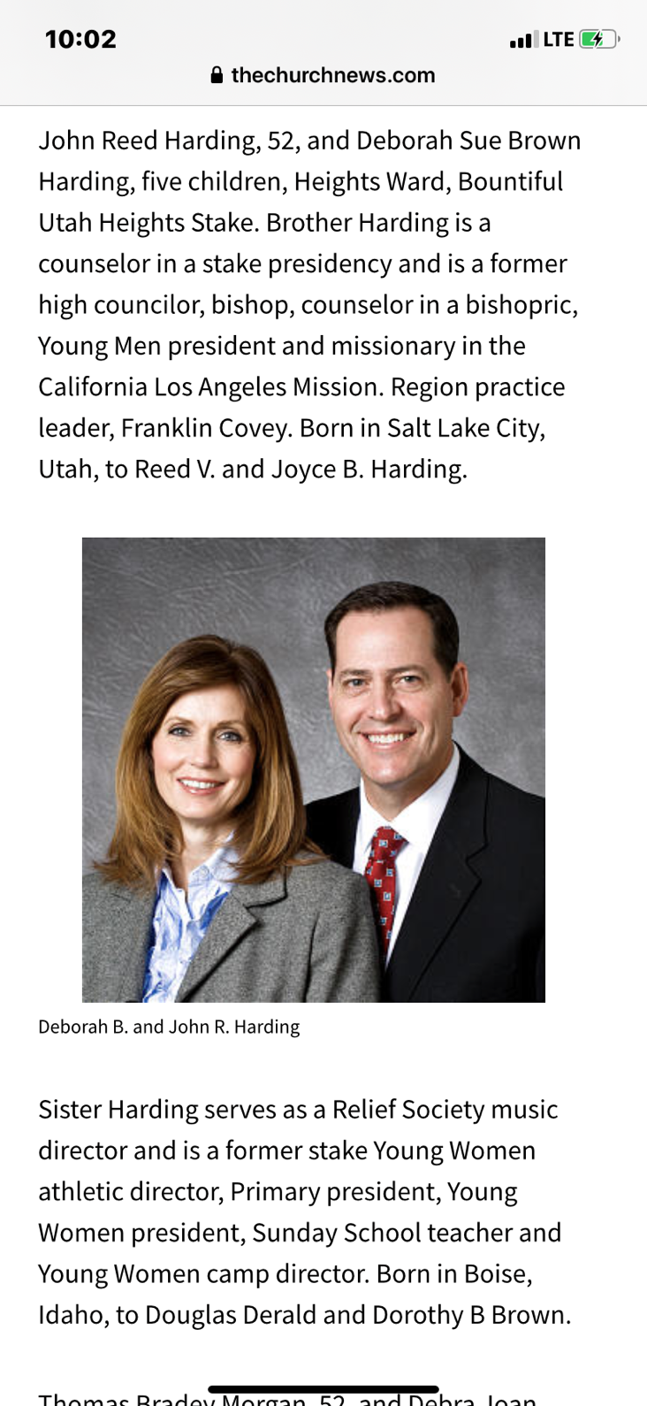

Stake Young Women’s Presidency
1979-1984
Norma Gephart (President)
Faye Thomas (1st Councilor)
Doreen Cluff (2nd Councilor)
Gayle Fawcett (Secretary)
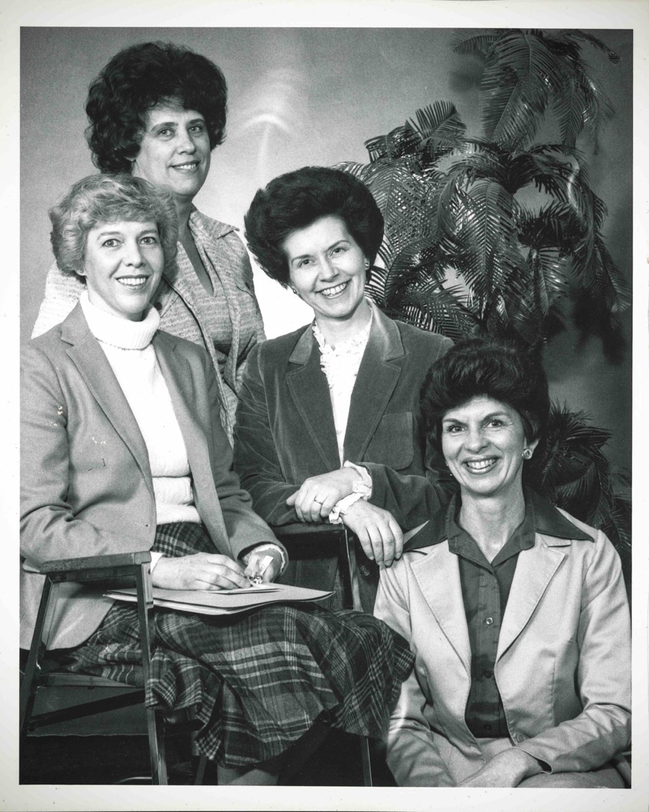

First Baptism -
Brother Steven Barnett, who still resides in the Stake, was the first person baptized in the new Stake.

1971 Organization

1971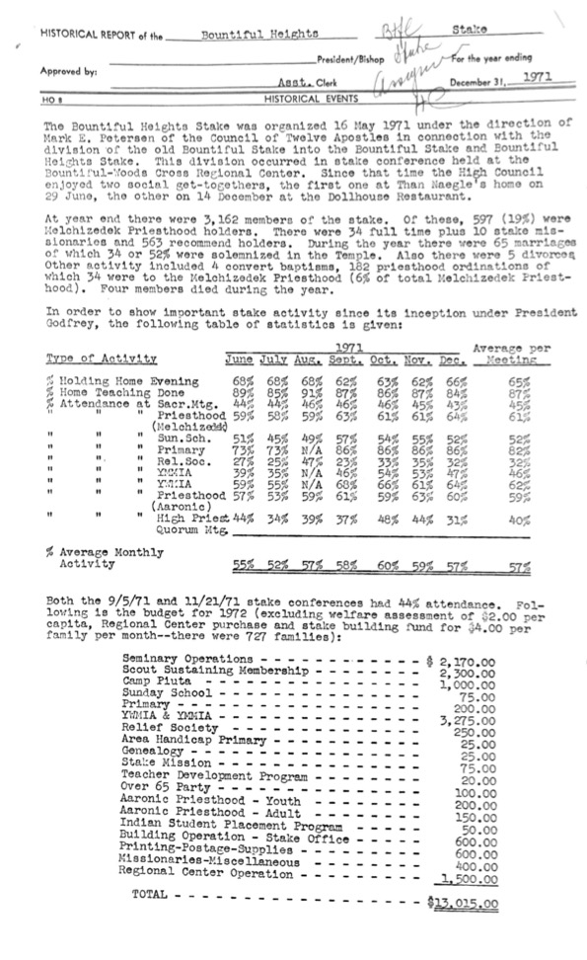 Historical Report

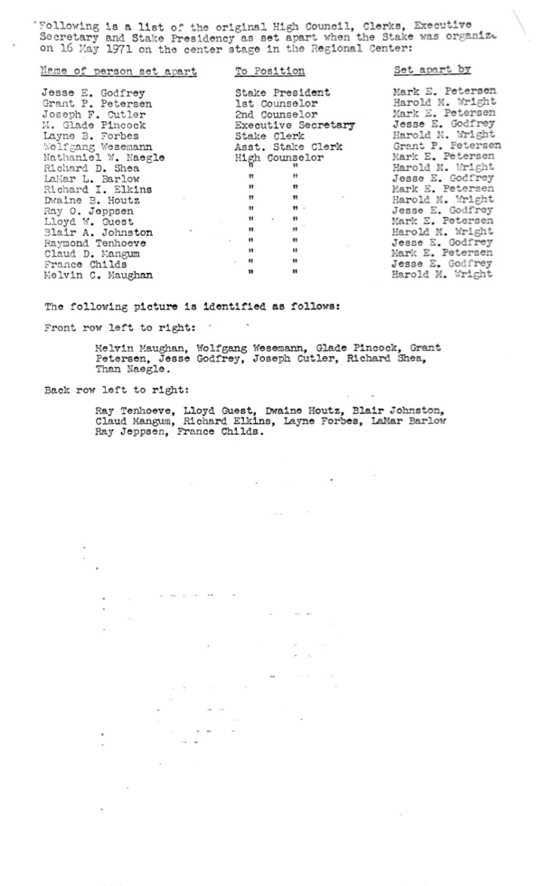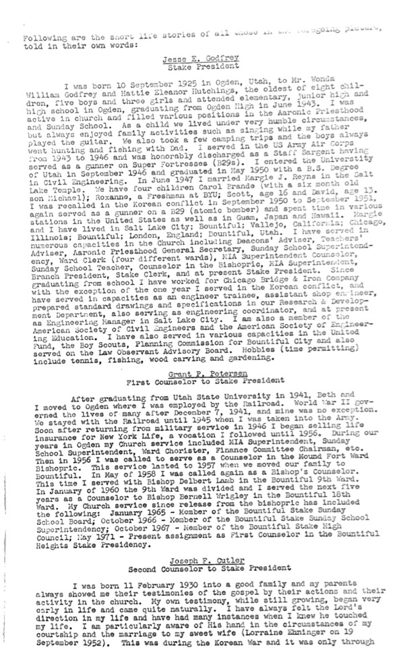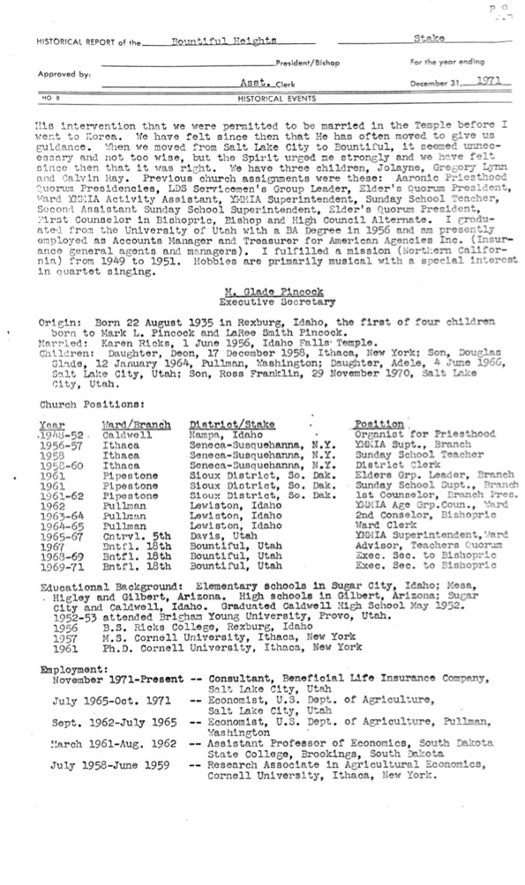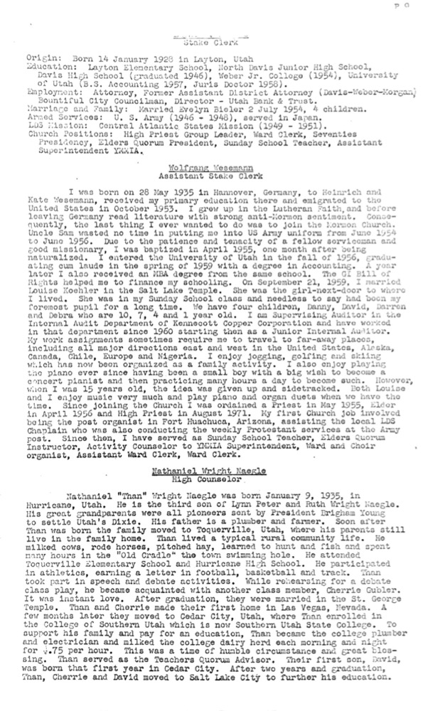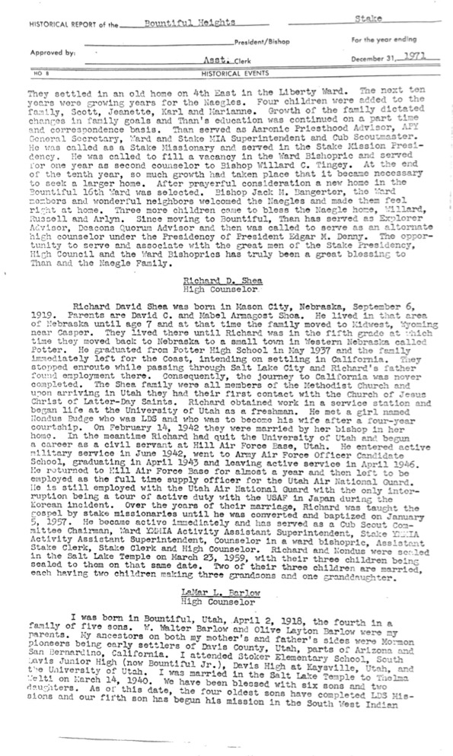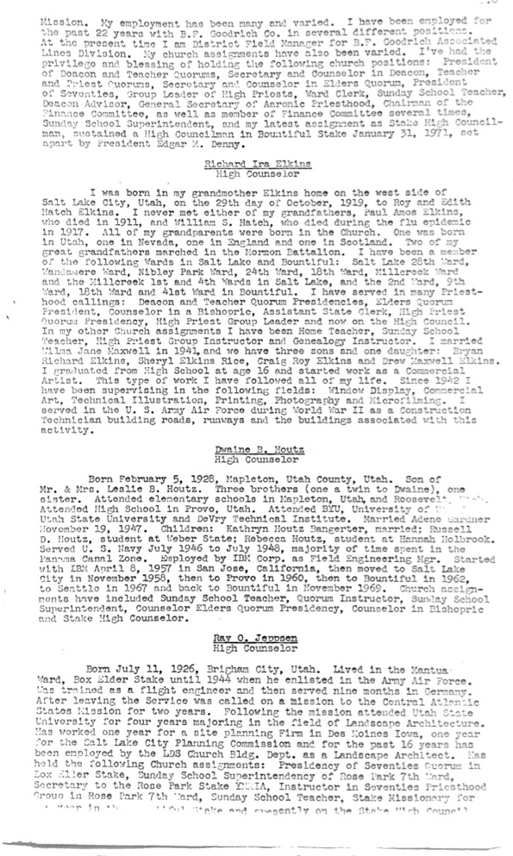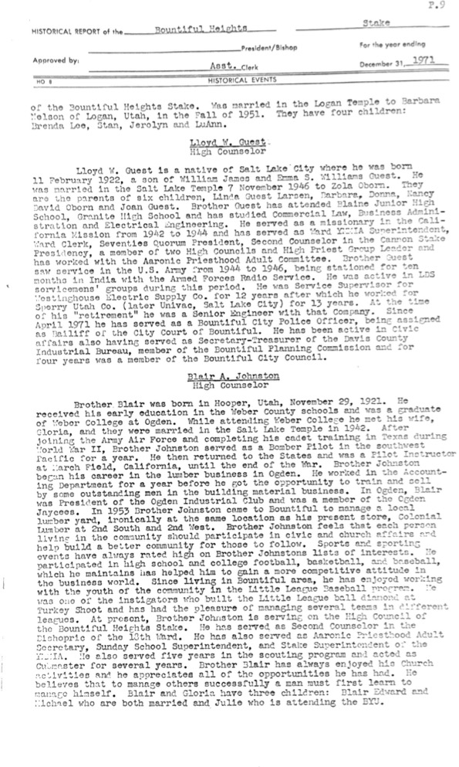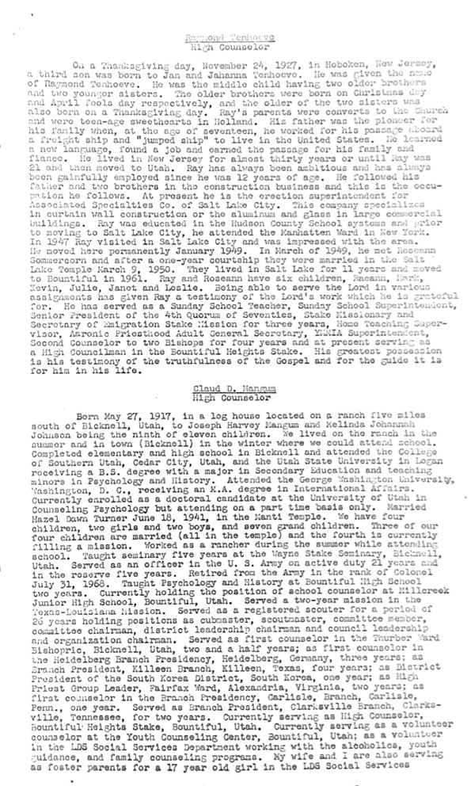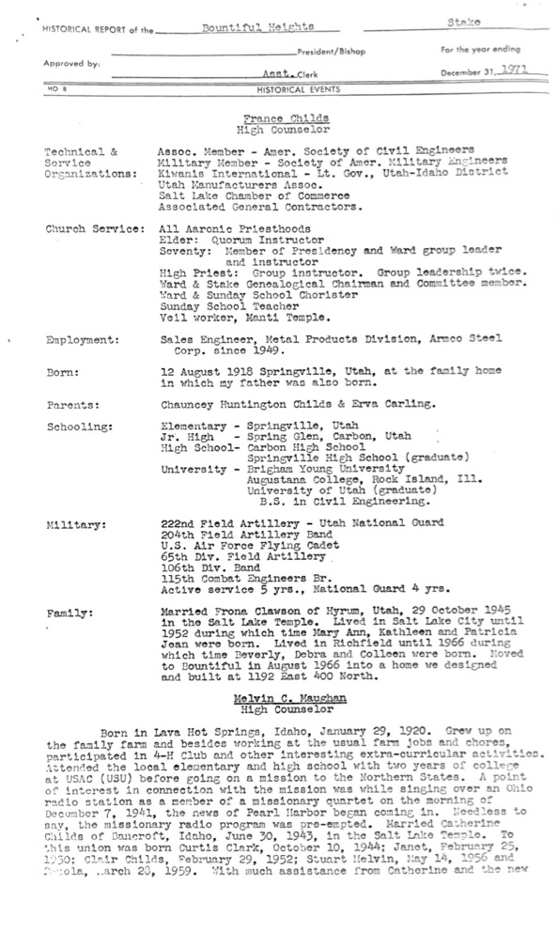

2021 Organization

Stake Officers
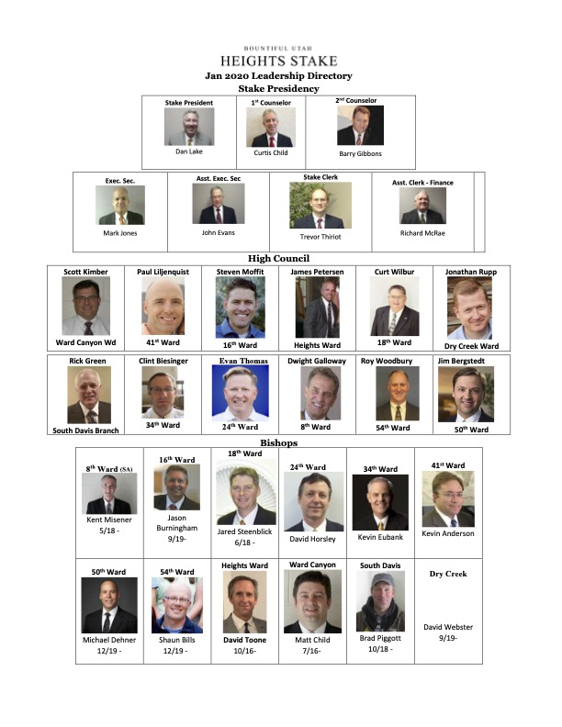

Bishops
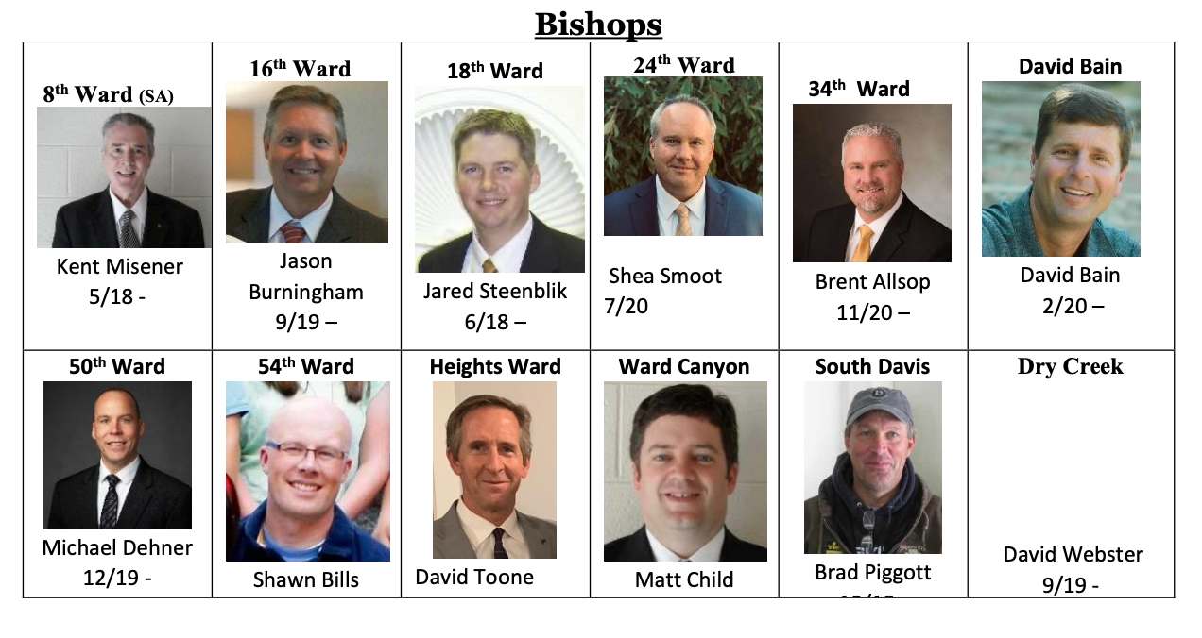

2020 Message from President Dan Lake:
"I felt impressed this morning that it is very important that we teach our members the significance of tithes and offerings, and to teach the law of the fast as found in Isaiah 58:6-14 and to encourage them to give a generous fast offering. The Lord promises significant and subtle blessings for those in need and for those that give. This is a great opportunity to take care of each other and be "willing to bear one another's burdens, that they may be light; willing to mourn with those that mourn; comfort those that stand in need of comfort." (Mosiah 18:8-9) Alma also taught "And again Alma commanded that the people of the church should impart of their substance, every one according to that which he had; if he have more abundantly he should impart more abundantly; and of him that had but little, but little should be required; and to him that had not should be given. And thus they should impart of their substance of their own free will and good desires towards God (Mosiah 18:27-28)"

- President Dan Lake

2020 Message from President Barry Gibbons
Our Beloved Friends,
Our thoughts and prayers have been constant for each of you as we’ve experienced rapid changes over the past many days. We have missed renewing sacred covenants and singing the songs of redeeming love with you in our weekly sacrament meetings. We’ve been reminded how much we treasure being with and strengthened by you.
Our hearts have been “knit together in unity and love” over the years by meeting challenges together. How humbling it was to witness the generous fast offerings of our people during the Great Recession in the late 2000s. Many were blessed and have since been prospered because our people were “imparting to one another both temporally and spiritually according to their needs and their wants”.
We recall the hurricane-force winds of 2011. What a miracle it was to see our people labor together, removing trees and other debris, fixing fences and repairing our dwellings. The warmth of hearts and homes were offered freely to those who had lost services. Authorities were amazed at our response.
More recently we have observed the remarkable faith of those who stood and watched the fierce wildfires threaten to devour their homes only to be turned back by the hand of divine
providence. Many were warmly welcomed by neighbors and friends while waiting to return to their homes.
We were all startled this past week when the earthquake shook our homes and further shook our sense of wellbeing. Not long after the quake we began receiving reports from our wards that our people were well and the damage minimal.
Through earth, wind and fire we have seen the Lord’s hand and his blessings upon us. We feel a deep sense of his continued blessings with us through this worldwide health pandemic. May we continue to bless and lift one another. May we see with the eye of faith the wonderful days that lie ahead and walk with pioneer-like faith in every footstep.
We invite all to prepare for and enjoy the promised “memorable” and “unforgettable” General Conference season coming up. We marvel at the inspired wisdom of our Prophet as we enjoy Home Centered Church. We truly see the wisdom of ministering in higher and
holier ways to one another at a time when prescribed gatherings would not have been best.
At this time, we are filled with love for our Heavenly Father, his son, Jesus Christ, and the comforting and revelatory presence of the Holy Ghost in our lives. We are in the hands of the Good Shepherd. We know his voice and gratefully recognize his redeeming love.
We pray “the peace of God, which passeth all understanding, shall keep your hearts and minds through Christ Jesus”. May his richest blessings rest upon you.
We have included a link to a talk given by Elder Jeffery R. Holland and hope it will bring you confidence, peace and a sense of gratitude for being blessed to live in this wonderful last dispensation. https://speeches.byu.edu/talks/jeffrey-r-holland/terror-triumph-wedding- feast/
With great love and deep appreciation for your faithfulness,
The Stake Presidency

2020 Easter Message from Bountiful Heights Stake Presidency
Dear Fellow Stake Members,
We wanted to take the opportunity to express our love and appreciation to each one of you on this Easter Sunday. We pray for your happiness and well-being every day. We miss being together with you in our meetings and our in-person associations with you. We know this situation is temporary and that everything will work out in process of time.
Below is an excerpt from Joseph B. Wirthlin’s talk given in October 2006 General Conference – titled, “Sunday Will Come”
“In all the history of the world there have been many great and wise souls, many of whom claimed special knowledge of God. But when the Savior rose from the tomb, He did something no one had ever done. He did something no one else could do. He broke the bonds of death, not only for Himself but for all who have ever lived—the just and the unjust.
When Christ rose from the grave, becoming the first fruits of the Resurrection, He made that gift available to all. And with that sublime act, He softened the devastating, consuming sorrow that gnaws at the souls of those who have lost precious loved ones.
I think of how dark that Friday was when Christ was lifted up on the cross.
On that terrible Friday the earth shook and grew dark. Frightful storms lashed at the earth.
Those evil men who sought His life rejoiced. Now that Jesus was no more, surely those who followed Him would disperse. On that day they stood triumphant.
On that day the veil of the temple was rent in twain.
Mary Magdalene and Mary, the mother of Jesus, were both overcome with grief and despair. The superb man they had loved and honored hung lifeless upon the cross.
On that Friday the Apostles were devastated. Jesus, their Savior—the man who had walked on water and raised the dead—was Himself at the mercy of wicked men. They watched helplessly as He was overcome by His enemies.
On that Friday the Savior of mankind was humiliated and bruised, abused and reviled.
It was a Friday filled with devastating, consuming sorrow that gnawed at the souls of those who loved and honored the Son of God.
I think that of all the days since the beginning of this world’s history, that Friday was the
darkest.
But the doom of that day did not endure.
The despair did not linger because on Sunday, the resurrected Lord burst the bonds of death. He ascended from the grave and appeared gloriously triumphant as the Savior of all mankind.
And in an instant the eyes that had been filled with ever-flowing tears dried. The lips that had whispered prayers of distress and grief now filled the air with wondrous praise, for Jesus the Christ, the Son of the living God, stood before them as the first fruits of the Resurrection, the proof that death is merely the beginning of a new and wondrous existence.
Each of us will have our own Fridays—those days when the universe itself seems shattered and the shards of our world lie littered about us in pieces. We all will experience those broken times when it seems we can never be put together again. We will all have our Fridays.
But I testify to you in the name of the One who conquered death—Sunday will come. In the darkness of our sorrow, Sunday will come.
No matter our desperation, no matter our grief, Sunday will come. In this life or the next, Sunday will come.”
We add our testimonies to Elder Wirthlin’s that Jesus Christ was resurrected and lives today. He directs His Church through living prophets and apostles today. We know as Alma knew, that if we put our trust in God, we will be delivered out of our trials, and our troubles, and our afflictions, and shall be lifted up at the last day. (Alma 38:5) And that “Sunday will come.”
With much love,

Dan Lake, Barry Gibbons, Kevin Anderson

Wards in the Stake

Timeline of Ward Formations and Building Dedications
Date | Event | Comments
May 19, 1957 | Formation of 16th Ward | Split from 3rd Ward
January 24, 1960 | Formation of 18th Ward | Split from 9th Ward
July 15, 1963 | Formation of 24th Ward | Split from 16th Ward
November 5, 1967 | Dedication of Stake Center (a.k.a. “Old Stake Center”) | 16th and 24th Wards occupied the Stake Center after dedication
June 23, 1968 | Formation of 33rd Ward | Moved out of our Stake into Bountiful Stake in 1980’s
June 30, 1968 | Formation of 34th Ward | Split from 16th Ward
May 16, 1971 | Formation of Bountiful Heights Stake | Split from Bountiful Stake
September 5, 1971 | Formation of 41st Ward | Split from 18th Ward
May 1, 1973 | Dedication of 1000 East Building
October 14, 1979 | Formation of 50th Ward | Split from 41st Ward
1981 | Dedication of 34/54/WCW Building | Dedicatory prayer by Elder Mark E. Peterson. Exact date yet to be confirmed
April 11, 1982 | Formation of 54th Ward | Split from 34th Ward
January 30, 1983 | Formation of 57th Ward (a.k.a. Bountiful SA Ward) | This ward was discontinued for a time, dates not confirmed. Later reformed as 8th Ward
October 23, 1988 | Formation of Heights Ward | Created from the 18th and 41st Wards
August 15, 1989 | Formation of Heights 2 Ward | YSA Ward. Name later changed to Millstream Ward. This ward later left the Stake to join the YSA Stake
February 2, 1992 | Dedication of new Stake Center
May 26, 1996 | Formation of South Davis Care Center Branch | Formed to serve residents of the South Davis Care Center
September 10, 2006 | Formation of Ward Canyon Ward | Created from portions of the 34th, 41st, 50th, 54th, and Heights Wards
April 27, 2014 | Bountiful 8th Ward entered the Stake | Name later changed to Bountiful SA Ward
August 24, 2014 | Formation of Dry Creek Ward | Created from the 16th and 24th Wards
January 24, 2021 | Bountiful 8th Ward split to form Ricks Creek SA Ward (outside of Heights Stake) | 8th Ward renamed Bountiful SA Ward

Bountiful 33rd Ward
At the time of the creation of the Stake the Bountiful 33rd ward was part of the stake. It originally was located in the church building at the intersection of 400 North and Orchard Drive. Later, the Bountiful and Heights Stakes realigned their boundaries, at which time the 33rd Ward was moved into the Bountiful Stake.

Bountiful 34th Ward
It was in April, 1976, when Bishop Glen Evans of the 34th Ward spoke in Sacrament meeting that he shared with us the Parable of the Talents. He then informed us that the stake had received word that a new chapel had been approved and that we could start collecting money for the 30 % required by our congregation. He then asked for a member of 10 families to come forward and stand in front of the pulpit. Our family was named and Clay did as requested. Bishop Evans then came off the stand and presented each of the ten people a $20 bill. We were told this was to be our talent for the next 60 days to multiply as best we could.
Upon returning home, we gathered for a family meeting including our 5th child who had just been born in January. Clay told us of our new challenge to multiply our “talents” and that he wanted it to be done by the entire family if possible. We discussed several options until Doris mentioned that a member of our ward, Louis Hill, made sucker molds. We decided to try it because Doris could make them, Clay could wrap them and the children could sell them.
On Monday, when Clay returned home from work, Doris had made two batches which made 36 suckers. They were wrapped in cellophane, tied with a bow and the children went door to door around the homes near Hannah Holbrook Elementary. It took two hours to sell them for 10 cents apiece. We tried again on Tuesday without greater success. It was then suggested for the kids to take them to school and try and sell them. By the end of the second week, children were coming to our house to buy them during recess. But unfortunately, the principal announced over the PA system that the students were not to leave the school grounds during recess. Sucker sticks were becoming too prevalent on the school grounds.
By the end of the third week, parents were driving their children to our home before and after school to buy suckers. Shortly thereafter, Bishop Evans announced that the church had requested that the new Jordan River Temple would be financed by members along the Wasatch front and asked us to donate 10 % of our previous year’s tithing in addition to the temple construction. Thus the money for the new meetinghouse would be put on hold.
This turned out to be a blessing in disguise. School would end before the 60 days had transpired and we worried about selling more suckers. But now wards starting raising money for the temple. Employees in the church office building heard about our suckers and asked Clay if he would sell them for 10 cents so they would sell them for 25. Clay agreed but had to go to work at 6 AM because he was spending 2 hours a day taking and delivering orders.
On the 60th day which was the middle of June, the families gathered in Bishop Evans’ office. He informed us that the Parable of the Talents was alive and well even in our day. Immediately following Sacrament meeting back in April, one family returned their $20 and said they did not want to participate. Two other families gave him their personal check for $40 and said “We have doubled our talents” but had they really?
He then went around the room and asked each family to tell what they had done and how much they had garnered. It became obvious that most had made money making bread, cookies, cakes, pies and suckers. One family put on a full Hawaiian Luau including a roasted pig. Another lady ironed all items which could be stuffed in a pillowcase. From the $140 given to the 7 families, together we had made around $2,185. Our family had earned $1,000 by selling over 20,000 suckers in 14 flavors which covered our commitment for both the temple and the ward.
A reporter from the Church News called and said they had been asked to write an article about our success but said they would decline for three reasons. First, the State Tax Commission would want us to pay sales tax. Second, the Health Department would want to inspect our kitchen. And third, Bountiful would probably issue us a citation for not having a business license.
Because we had been so blessed, we decided to continue to earn more money. We went to the Freedom Festival parade in Provo with our baby stroller filled with boxes of suckers. We did the same for the Handcart Days in Bountiful. We then went to the Days of ‘47 parade in Salt Lake City. As we were crossing through the parking lot of the Church Office Building, President Kimball exited from the Administration Building. Since we looked a little out of the ordinary because Clay was wearing a straw hat with suckers stuck into the headband, President Kimball approached and inquired what we were doing. We explained that we were raising money for the Jordan River Temple. He complimented us and gave each of us a big hug. How special that moment was which we will never forget nor can we forget how the Lord helped us with our talents in this endeavor. We were able to contribute an additional $600.
-Clay and Doris Crowley, 34th Ward

The “Old Stake Center”
The Bountiful 16th Ward was born from the division of the Bountiful 3rd Ward in May 1957, prior to the formation of the Heights Stake. The Bountiful 24th Ward was created with the division of the Bountiful 16th Ward in July 1963, also prior to the Stake organization. The “Old Stake Center” building (as it is commonly referred to in the Stake) was dedicated, by Elder Thomas S. Monson, on November 5, 1967, to be the home of the Bountiful 16th and 24th Wards. Both of these wards had previously resided in the former meetinghouse on 400 North and Orchard Drive.
In the late 1940s, my family lived in a small house at approximately 700 East 400 North. 400 North was then known as Tuttles Hill because most of the land on the north side was owned and farmed by the Tuttle family who lived at 705 East 400 North. That home is reported to be the first in Bountiful to have inside plumbing and bathroom. It is now occupied by the Ken Tuttle family of the 16th Ward. The 16th, 24th, Dry Creek Ward Chapel and the Stake ball field are on land that was acquired from the Tuttle family. It has been my blessing to have worked on the Tuttle farm as a young boy; then built my home on part of it, helped build a chapel on it, and finally worshiped on it for a major part of my life.
-V. Brent Bangerter, 24th Ward

34th Ward Split to Form the 54th Ward
In 1976, my wife, Linda and I built a new home on Northern Hills Drive, which was then part of the very large 34th ward. The 34th ward was so large that I recall during my calling in 1979 as the ward’s YM president that we had about 180 youth attending the combined YM/YW activities. We anticipated that a split of the ward would happen soon, but I was indeed surprised one night in 1981 to be called as the 2nd counselor in the first bishopric of the brand new 54th ward, with Don Cluff as bishop and Duane Nichols as first counselor.
The new 54th ward had approximately 240 members. Not only was the 54th ward new, but we moved into a brand new building just below 13th East. In the week following our sustaining as the bishopric of the new 54th ward, we met each evening until midnight, and made all of the callings to fully staff the entire ward. I have never forgotten how the spirit was so strong and led us in those callings, and how all the callings extended in the ward were accepted except for one. We were amazed how the activity level in our small new ward increased weekly, and members who had been less active before the split became more active in their new callings. It was truly a testimony building experience.
-Paul Child, 50th Ward

The Stake Center Construction
Here’s some background about how we started thinking about a new stake center in the Bountiful Heights Stake. President Les Paskett and President Dick Newton and I talked about the possibility of building a cultural center on the grounds of the present stake house for the purpose of dances, dinners and athletic events. We had enough ground and space to build it and we submitted the idea to the church. Unbelievable to us, we received a letter back informing us that we already had land that was purchased years before and their suggestion was to build a whole new stake center with a full-sized cultural center in it. We thought that was a wonderful idea and a blessing to our stake. On June 6, 1990 approval was granted for the construction for our new multi ward and stake facility. Ground breaking ceremony was held at 50 South Moss Hill Drive, Bountiful, UT. The dedication was Sunday, February 2, 1992 by Malcolm S. Jeppsen 2nd quorum of the Seventy. It was an exciting time in our stake. It was also our privilege to be a part of the approval and creation of two new wards. The Bountiful Heights Ward was created on October 6, 1988 and the Bountiful Heights 2nd Ward was created on August 7, 1989.
Joe Johnson, 41st Ward

“Scout Building” or Family History Center
This building, originally dedicated by President Browning, is located on the south side of the 34/54/WCW property) and was dedicated by President Browning. Prior to the construction of the current Bountiful Heights Stake Center the 34th, 50th, and 54th wards all shared a building. At some point the three Relief Society presidents approached the three bishops and informed them that the Boy Scouts should not be allowed to be in the building while Relief Society functions were taking place. The Boy Scouts were too disruptive.
The bishops got together and came up with a plan to build a building on a portion of the ward building property that was not used by any structures. A building was designed that included a basement with an open room with a fireplace, bathrooms, and showers. The top of the building included three closets for storage of equipment and a covered pavilion area with a fireplace and built-in grills.
This was back in the day when the church used to assess building fees to wards and stakes and families would be assessed an amount to contribute to whatever the project was. Each of the wards were assessed a third of the cost of the building. Two of the wards then divided up this assessment among ward members while the bishop of one of the wards just paid his entire ward’s assessment himself.
The building was constructed. The three Relief Society presidents were happy, and the scouts used the facility for many years.
At some point in time the basement began leak. I do not recall any young man ever complaining about wet carpet or musty odors, but it was decided that the leak needed to be fixed. The bishops at this time probably were not aware of the history of the building and the approached church headquarters about getting money to fix the leaks for the scout building. The response from the church was, What scout building? There is no such building on the south side of the ward lot on any approved church plans. As it turns out, the three bishops who had the scout building constructed did not seek approval from church headquarters and did not inform the church that a structure was built. Over the years nobody ever questioned the legitimacy of the building. It existed and therefore must have been approved.
Due to it not being an official church approved structure the wards could not get money to fix the leak. The only way they could get money was to convert the use of the building into something approved by the church, so the basement scout room was converted into a family history center. The leak was fixed, the bathrooms renovated into Men’s and Women’s, and the fireplace covered with sheetrock. The closets are still used by the wards for storage of camping equipment for young men and young women’s activities, except that the space in one of them is partially taken up by the furnace for the family history center, and the covered pavilion is used for various functions.
Tom Ball, 54th Ward (story related to him, as he recalls it)

400 North 400 East Building
As a young boy we lived in the boundaries of the Bountiful 3rd ward in the Bountiful Stake. We went to church in the building located at the corner of 400 North and 400 East that is now a Baptist church.
In 1971, I was seven years old. I vaguely remember the 3rd ward being divided and the 33rd ward being created. Our family, along with all the families on the south side of 400 North from 400 East to Main Street were included in the new 33rd ward. As a kid I never really understood this. The school boundary was 400 North and because 400 North was a busy street, we were not allowed to cross it. Due to the different boundaries I went to school with a completely different set of kids than I went to church with.
As I recall the first bishop of the 33rd ward was J. Paul Barlow who went on to become a Stake Patriarch later. Some of the other bishops I recall are Richard Shea, Kay Barlow, and Layne Forbes.
Until I was a teenager we still went to church at the 3rd and 33rd ward building on 400 North and 400 East. The building had a basement, main floor, and an upstairs. Most of the basement was storage and mechanical rooms. The scouts had a basement room under the stage with an outside access door, bathroom, and shower. The cultural hall had a projection booth that was accessed from the second floor of the building. I remember going to primary movie parties. The Relief Society room was located on the main floor on the southeast end of the building. It had its own kitchen separate from the building kitchen. The bishops’ and clerks’ offices were located on the main floor with a few classrooms. Most of the classrooms were located on the second floor.
The chapel did not have a flat floor. The floor sloped down to the front so that each row of benches did not block the view of the row behind. The front of the chapel was divided into two sections; choir seats rising up on the left and the raised pulpit and seats for ward leadership and speakers on the right with an organ and piano in between. The organ was a true pipe organ with a pipe room behind the front of the chapel. The sacrament preparation room was down some stairs behind the pulpit.
The overflow door at the back of the chapel was a solid, wooden door that slid up into the wall between the chapel and the cultural hall. Being strong enough to lift the door was considered a rite-of-passage as a young man.
Junior Sunday School had its own chapel that was upstairs. As an Aaronic priesthood holder, you lived for the assignment to bless or pass the sacrament in Junior Sunday School.
The building had these old, single pane, tilt windows. Many young men would attempt to leave the window in one of the bathrooms slightly ajar so that they could sneak into the building to play basketball at night.
I, along with three other young men my age, were often called on by Sister Evelyn Forbes to sing in sacrament meetings. This building had a baptismal font that was no longer in use and, somehow, as young men we found that the font, with the door open, had some cool acoustics and we would often practice our songs while standing in the font.
When I was a priest, the church decided that the building was too old and too costly to maintain or renovate and the 3rd ward was moved to the Bountiful Tabernacle and the 33rd ward was moved to what was the stake center at the time just off 400 North at about 700 East.
I was preparing to leave on my mission the year that the mudslide occurred in Bountiful. I spent several days filling, hauling, and stacking sandbags before the mudslide occurred. Houses on the south side of 400 North in the 33rd ward were not impacted by the mudslide while nearly all the rest of the ward was. One of our neighbors, a lifetime resident of Bountiful from the 1930s said that the mud followed the natural path of Stonecreek before it was diverted for houses. I remember being evacuated. We were initially told to evacuate to the Stake Center until my dad informed them that we were on the other side of the mudslide. Then they sent us to Bountiful High School. With a friend of mine we left the shelter and made our way back to our neighborhood and witnessed the forces of nature as the mud and water went everywhere, filing basement after basement with mud. I spent the three weeks helping to move mud and destroyed belongings out of basements before I left on my mission. I drove my Bishops’ pickup truck to the dump countless times. My mission farewell was originally scheduled for May 29th was postponed for two weeks because you could not get to the church. We held sacrament meeting the Bishops’ backyard one Sunday. We were all working to clean up the mud, so everyone came in their working clothes.
As a returned missionary I was the first ward clerk for the Young Adult Ward that was formed in the Heights Stake. Richard Chidester was the first bishop of this ward. To encourage people to attend the ward it was given the start time of 10 AM and it never changed. The other wards in the building rotated their schedules around the Young Adult Ward. I met Kim in this ward. We had a great men’s softball team.
When we got married, we settled in Farmington and lived there for about four years but returned to Bountiful and the Heights stake shortly before McKinely was born. We have lived in the 54th ward ever since.
I have served in many callings. Serving with Young Men has been my most enjoyable. Whether it was as a member of the Young Men’s Presidency, Scoutmaster or in the Bishopric,
I have always served with the Deacon age young men. I served for about 12 years as the Scoutmaster. I was serving as the Scoutmaster when the Ward Canyon Ward was formed from the 34th, 54th, and 41st wards. We went from 15 Deacons to 4 overnight.
-Tom Ball, 54th Ward

Alfalfa Field
The Don and Jessie Milligan family moved into the Bountiful 34th Ward during the summer of 1972. Tom was 12 years old and the oldest of six kids. Walt Gadd was the Bishop of the 34th Ward and Roden Shumway was the President of the newly formed Bountiful Heights Stake. I was a newly ordained Deacon when we moved from Seattle into the Bountiful 34th Ward. One of my fondest memories as a new Deacon in my new Deacons Quorum was the opportunity to fulfill a Priesthood assignment to irrigate the alfalfa field. In those days the current location of the church where the 34th, 54th and Ward Canyon Ward (WCW) meet was a gently sloped field where alfalfa (hay) had been planted. There were no paved streets or homes around the field as there are now. Each week two deacons were assigned to irrigate the field. The assignment required moving approximately 16 lengths of 20 foot by 4 inch aluminum pipe to a different location every day. It took two Deacons about an hour each day to move the pipes. As a 12-year old Deacon, I felt a deep sense of responsibility to move the pipes and the keep the Alfalfa watered. On occasion the pipes would break or become decoupled and members of the Deacons Quorum would be notified; it was our job to go up to the field and address the issue. While I’m sure I did not appreciate the opportunity to serve at that age, I’m grateful for the many life lessons that this service taught. I’m grateful for inspired Priesthood leaders who taught Aaronic Priesthood holders how to serve and gave us the opportunity to learn and work.
As a current member of the WCW and having the opportunity to be in this building where the alphalfa used to grow on a regular basis, I often think with much fondness about my days as a Deacon, moving the pipes, getting muddy and keeping the alphalfa alive. What a blessing this assignment was then and continues to be nearly 50 years later.
I returned from serving a mission in 1981; the alphalfa was gone and the construction of the church building was almost complete. As an Elder and again, as a Priesthood assignment, I had the opportunity to plant the evergreen plants that adorn the west facing slope west of the church. We planted hundreds of one gallon “tam” type plants that continue to grow today.
In 1984 Kathy Lawson, a fellow 34th wardie and I were sealed in the Salt Lake Temple and held our wedding reception in the Cultural Hall of the 34th church building. Since then, we’ve raised our three children while being members of the 34th, 54th and WCW wards. What a blessing it has been to be members of these wards and to meet in the building (and on the grounds) that has been part of our lives for half a century.
-Don Milligan, Ward Canyon Ward

Bountiful Temple
The Bountiful Utah Temple, located adjacent to our Stake, groundbreaking was held on May 2, 1992. The Temple was dedicated on January 8, 1995. Brother Lloyd Hayes, of the Stake was a Counselor in the original Temple Presidency. Many Stake members were blessed with the opportunity to assist with the Open House, conducted in the weeks leading up to the Dedication. Jesse Godfrey was the second counselor to Harold Yancey in the first temple presidency in 1995. President Hayes was in a subsequent presidency.
Over the years, many Stake member have also had the opportunity to serve as Ordinance Workers in the Temple.

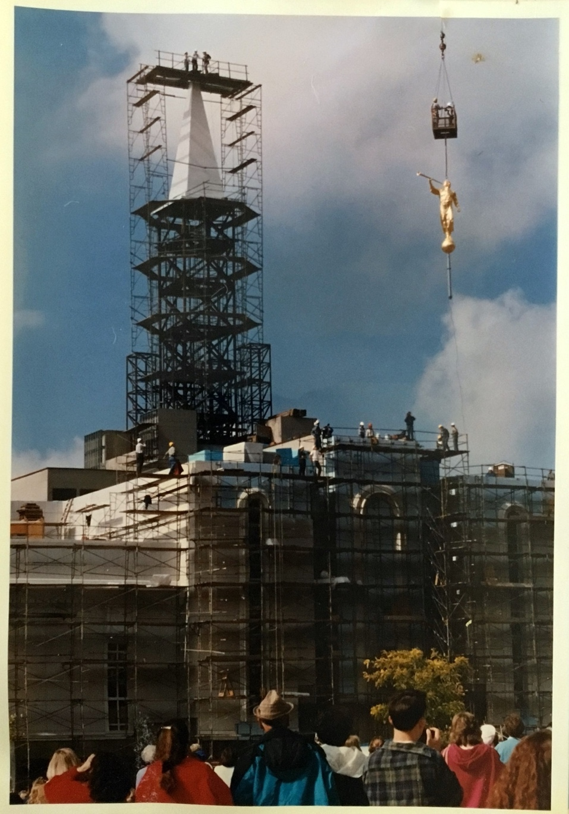

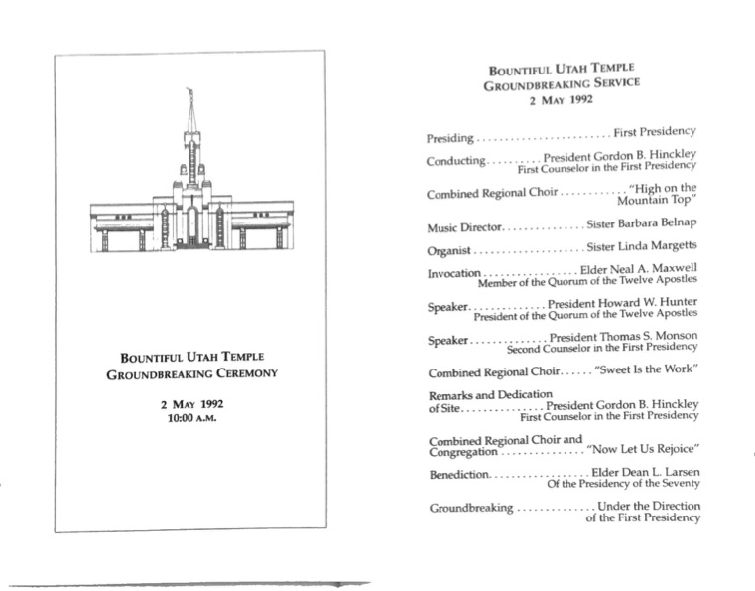
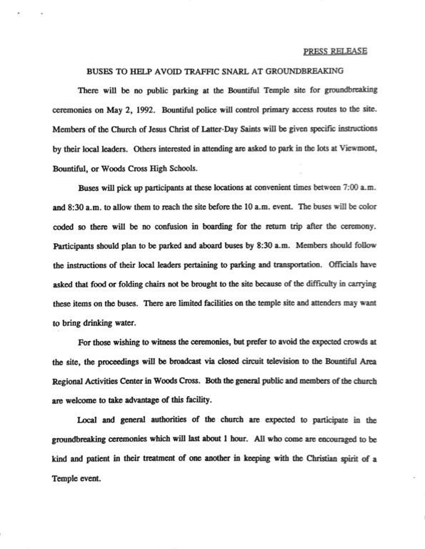

South Davis Branch
When I received the call to be the Branch President of the South Davis Branch, I made it a point to meet all the residents and learn their name. I had heard so much about a young boy on the 3rd floor called “Baby James”. When I first met James, he was everything I had heard and more. If they ever had a vote on the most popular person in the hospital, it would be,
without a doubt, this young boy they called “Baby James”.
Here was a young boy, challenged physically, but spiritually, he was a giant among all men. All ages, young and old were attracted to James. He had a certain something that was beyond words. I kept saying to myself, “He is a true angel, I am blessed to be in his presence.”
When young people were struggling spiritually, it was our opportunity to have them go to the room of James and be in the presence of an angel. Many times, James taught them spiritually to be a better person. James was a great missionary, he touched so many lives. Many young men and young women visiting the branch, loved being around James and would feel his goodness.
At a graveside service for James, it was hard for me not to come and take the microphone and tell everyone in attendance how James touched the lives of so many people at the South Davis Branch. I wanted to tell everyone there that James was one of the most powerful missionaries I have ever known. He taught in a spiritual way that I had never experienced. I wanted to let everyone know that he passed into the next life and would be teaching some of the great men who had lived on the earth, humility and spirituality.
I think I have told the story over a hundred times about a young boy we called, “Baby James” that taught us so much. I will always remember James and I will continue to tell people about his goodness. It was an honor to know him and to have been in his presence. Thanks for sharing him with us.
Melvin J. Mills, Heights Ward

Building Construction
We moved into our Bountiful Utah Heights home at 422 North 1200 East in August 1967. This home is on the corner of 400 N and 1200 E. The pavement of 4th North stopped at our back property line. Bishop Jack Bangerter was the Bishop of the 16th Ward to which we belonged. He and his counselors came to our home within the first two weeks of our arrival. The ward met in the white building on the corner of 4th North and Orchard with a new chapel under construction. We expected to be asked for a building fund donation, since back then the wards had to pay for a significant fraction of the cost of a new building. Bishop Bangerter told us the wards share was paid in full. We were shocked, since every ward we had lived in in California had ongoing building funds. Members did much of the work on the building. The “new” 16th ward building was almost complete, but I was able to put some hours in hanging the basketball backboards. To be able to walk to church was such a treat after moving from California.
The 34th ward was divided from the 16th. Collin Miller was the Bishop and tasked to build the building on 1200 East. The policy at that time was to contract out the total construction of all new buildings. The area continued to grow up the mountain and more wards were split off.
We have been blessed to live with wonderful people led by outstanding inspired leaders. In 1983 when rains and ensuing floods came to Davis County, this stake rallied around the members living along Stone Creek, whose houses were flooded. Thousands of hours of service were rendered. We were privileged to attend the groundbreaking of the Bountiful Temple which President Benson conducted. He acknowledged King Green and his son, Roger, who were on the horses high up on the mountain providing security. We were able to later help with the open house and attend the dedication with family members. That was a very sweet experience.
It has been the people who have made this a great place to live and raise our family. Many have passed on and others moved on. It will be wonderful to see them again when we all meet on the other side of the veil.
Don & Peggy Hokanson

The Bountiful 50th Ward
The Bountiful 50th ward was created on September 20, 1979 with Mark Eubank as Bishop. In Leviticus 25:8-17 each 50th year is designated the Jubilee year, where debts are forgiven, all things rest, and people return home. Bishop Eubank named the new ward, the “Jubilee Ward” where there would be rest, freedom, forgiveness, friendship and love for each person.
His counselors were Steve Clark and Ed Ridges, Clark Harrison was the ward clerk and Doug Graham the executive secretary. The first chapel for the 50th ward was at 165 South and 1000 East. There was no office space for the new ward, so a classroom was converted into a bishop’s office.
The ward was small. Steve Clark remembers everyone had at least two or three jobs. Everyone was about the same age and incredibly there were no families of other faiths in the ward boundaries and only two part-member families.
Carolyn Nelson says “the 50th ward was friendly. Neighbors and ward members were sociable. The ward was growing and people reached out to each other. People had parties, watched one another’s children, carpooled to school, and helped put in yards.”
In September of 1980, Bishop Eubank was called into the Stake Presidency to be first counselor to President Roden Shumway. Steve Clark was called to be the next bishop, and at the time, he and all of his brothers were serving as bishops. Ed Ridges, Ken Hill, Doug Graham, Steve Dixon, and Steve Nielsen were all in that bishopric. Their theme was “joy in serving the Lord.”
At a primary activity, Bishop Clark showed he truly was the shepherd of the ward by re-enacting the Sermon on the Mount. Jill Peterson was the Relief Society President.
The spring of 1983 was especially snowy. On one day in March, 22" of wet snow fell and roofs had to be shoveled. Later in May, when all that snow had to come out of the mountains there was severe flooding throughout northern Utah. The 50th ward escaped the flooding but members helped throughout the county.
Doug Graham was called as bishop in October of 1983. Les Paskett, Gary Matern, Sherm Peterson and Brent Bryson were his counselors. Don Ostler and Floyd Asher were clerks and Baird Evans was the Executive Secretary.
Linda Graham remembers sitting on the back row with their little children while Doug was conducting sacrament meeting. Two year old JD reached up to the light switch and plunged the chapel into darkness. When he turned the lights back on, the entire congregation swiveled around to see JD grinning and then turned back to smile up at Doug who was frozen at the pulpit.
When the Graham’s little Cari was born early, the ward had a fast for her. Many sisters in the ward became certified in infant CPR training so they could give Linda a break from the constant care Cari required. Linda was a MIA MAID teacher and her class of Tracy Weaver, Stacy Colton, Marley Eubank, Stacy Allen, and Stacy Bigelow made a quilt for the new baby. She still has the quilt today.
During the summer of 1986, 105 girls from the 50th ward went to Camp! Sue Kjar was the camp director of this small army. There were more girls from the 50th ward than the rest of the stake put together. Sister Kjar taught that if you are called to a calling, you do whatever you can to teach yourself the things you might need to know to fulfill that calling.
In September of 1987, a helicopter crashed on the east side of Bountiful Blvd. and Vineyard Drive. All those summer camps paid off when boy scouts Mark and Gary Nelson helped rescue the pilot and his son from the crash.
In February of 1988, Leland Barber was called to be the new bishop. He and his wife Faye were beloved from the very beginning. His counselors were Garth Nelson, Chris Bigelow, John Cawley, Paul Child, Steve Paxton, Bill Starkweather, and Bruce Dibb.
Garth Nelson recalls how he was called as a counselor: “I had no idea the ward was changing bishoprics when we moved in. I got a call from the stake to come and meet the stake presidency. I thought, being new to Utah, it was a tradition for the stake president to meet new members, especially in a stake that was so active and functioning better than any stake I had ever been in before. I thought the stake presidency had nothing better to do! Surprise! I was asked to serve with Bishop Barber as his second counselor.”
Colleen Dibb says: “There were so many young people in the ward who had been born in 1974/75, that they made up 10% of the graduating class of ‘93 Bountiful High School -- and 15% of the graduating Seminary class.” Between 1990-1992, there were enough Young Women to have five basketball teams, four volleyball teams, and two softball teams. The other wards didn’t have a chance!
Bruce Dibb recalls, “One of the most inspirational examples during Bishop Barber’s service was the tremendous closeness he had with each of the priests. I believe that contributed to the large number of them who went on to serve missions”.
Bishop Barber had a Christmas tradition of reading aloud Christmas greetings and testimonies from missionaries serving in the field. Many ward members have said how they remember the great love and example this special Christmas worship service generated.
Bishop Barber always kept candy in his pocket to give to the little kids. This was the time of youth. Those enormous primaries had grown up to be teenagers and prospective missionaries. Bishop Barber held outstanding Youth Leadership Workshops where he taught how to apply life skills and the gospel through stories and posters.
To give you an idea of the caliber of people we have living in the neighborhood, Lawrence Gibb actually volunteered to be a nursery leader.
In 1981 when a new chapel was built at 540 N and 1200 E, the Bountiful 50th ward moved to its new home. The building was shared with the Bountiful 34th and 54th wards. We have always had fabulous musicians in our ward. Connie Cawley said she still remembers being in Jim Bevan’s ward choir. “He could get music from a stone.” Charmain Hatch even put on a pageant of original music.
Around June 21, 1990, Elder Mark E. Peterson, of the Council of the Twelve, dedicated a site for a new chapel and it was in the boundaries of the 50th ward! This site used to be a vineyard and was to become the Bountiful Utah Heights Stake Center and the present home of the Bountiful 50th ward.
In 1991 there was a stay-at-home Youth Conference and among other things the youth floated the Jordan River. For part of the activities, the Young Men and Women hiked over Bountiful Peak and camped on the east slope of “our mountain”. Ralph Mabey was the campfire speaker and he talked about the passage in 1 Nephi 1:1 “...having seen many afflictions in the course of my days, nevertheless, having been highly favored of the Lord in all my days”. He compared life to long distance running, and he ran in place by the campfire as he delivered his message. Later the youth gathered on Antelope Island. They sat down on a hill overlooking the lake and Chris Bigelow walked up out of a ravine, dressed as Christ, and delivered the Sermon on the Mount. It was a spiritual conclusion to the youth conference.
Groundbreaking for the Bountiful Temple took place on May 2, 1992 with most members of our neighborhood in attendance. Many took lawn chairs and walked to the site.
Blaine Colton was called to be bishop on February 13, 1994. Counselors were Chris Bigelow, Mark Hutchings, and later Gary Keddington. Many of the kids that were little when the ward was first created became missionaries during Bishop Colton’s tenure. At one point there were 39 missionaries serving from our ward! Remarkably, there were 107 missionaries called from the Bountiful 50th ward between 1994 and 1999.
Bishop Colton was a wonderful bishop with remarkable faith. One day he found Julie Weaver up on her roof trying to replace the entire thing by herself. He promised Julie if she would come down, others would come to do the job. The next day dozens of neighbors showed up and within 72 hours the house was re-roofed. The first snow of the season fell one day later!
Ralph Mabey received a call to serve as the next bishop of the ward in April of 1999. Luke Ong and Allen Alexander were counselors. Bishop Mabey showed by his creative leadership and sensitivity to be yet another outstanding bishop. The bishop’s office was papered with 2000 post-it notes as the youth listed 2000 acts of kindness that they had done in the year 2000.
A Christmas project in 2000 was an angel tree with a little different twist. Angels were taken from the tree by ward members. The angel listed someone’s gender and age and a ward member was to provide a suitable gift for under $20. Sixty needy families were selected by an elementary school principal in the Salt Lake central city area. Members of the ward including youth and their advisors met at the school where the needy families had dinner, and “shopped” for Christmas presents. Cards were made, presents wrapped, food baskets were selected, and Santa visited each child. Ward members felt the joy of giving and the children felt the same joy as they were able to give presents to their families.
In the twenty plus years that the Bountiful 50th ward has been in existence it has been a “Jubilee Ward” where rest, freedom, forgiveness, friendship and love have been in abundance for all. Truly this is a millennial neighborhood.
December 29, 2000

- By Jean Eubank

Bountiful 50th Ward Bishoprics
updated thru Jan 2020

Bountiful 50th ward created from the Bountiful 41st ward
September 20, 1979
Bishop Mark E. Eubank
1st Counselor Steve Clark
2nd Counselor Ed Ridges
Executive Secretary Doug Graham
Ward Clerk Clark Harrison
Primary Pres Marsha Paxton

September 1980
Bishop Steven D. Clark
1st Counselor Ed Ridges
2nd Counselor Ken Hill
Doug Graham
Steve Dixon
Steve Nielsen

October 16, 1983
Bishop Doug Graham
1st Counselor Les Paskett
2nd Counselor Gary Matern
Sherm Peterson
Brent Bryson
Executive Secretary Baird Evans
Ward Clerk Don Ostler
Ward Clerk Floyd Asher

February 1988
Bishop Leland Barber
1st Counselor Garth Nelson
2nd Counselor Chris Bigelow
John Cawley
Paul Child
Steve Paxton
Bill Starkweather
Bruce Dibb

February 1994
Bishop Blaine Colton
1st Counselor Chris Bigelow
2nd Counselor Mark Hutchings
2nd Counselor Gary Keddington
ES
Ward Clerk Mark Eubank

April 1999
Bishop Ralph Mabey
1st Counselor Luke Ong
2nd Counselor Allen Alexander
ES John Cawley
Ward Clerk Mark Eubank

2004
Bishop Curtis Child
1st Counselor Alan Lake
2nd Counselor Ken Redding
ES Keith Shupe
Ward Clerk Mark Eubank

2009
Bishop Mark Taylor
1st Counselor Jon Duke
2nd Counselor David Stevens
ES Rick Green
Ward Clerk Willie Chan

Oct 2014
Bishop Ken Redding
1st Counselor Keith Shupe
2nd Counselor James Derrick
ES Rick Green
Ward Clerk Willie Chan

Dec 2019
Bishop Michael Dehner
1st Counselor Dan Stevenson
2nd Counselor Matt Whitney
ES Brian Hess
Ward Clerk Dan Frei

Bishops Summary As of January 2020
Bishop Mark Eubank 1979 retired, mission St. George & Hawaii
Bishop Steven Clark 1980 working
Bishop Doug Graham 1983 retired, mission Africa
Bishop Leland Barber 1988 retired, mission Philippines, deceased
Bishop Blaine Colton 1994 working
Bishop Ralph Mabey 1999 working
Bishop Curtis Child 2004 working
Bishop Mark Taylor 2009 working
Bishop Ken Redding 2014 working
Bishop Michael Dehner 2019 working

The Bountiful 50th ward was created on September 20, 1979. The first chapel for the 50th ward was at 165 South and 1000 East

In 1981 when a new chapel was built at 540 N and 1200 E, the Bountiful 50th ward moved to that new location.

In approximately late 1991 a three ward Stake Center was built at 33 S Moss Hill Drive. This is the current home of the Bountiful 50th ward.

Part of the ward was removed and put into the newly created Heights Ward.

In Dec 2019 another part of the 50th ward was removed and put into the Heights Ward.

Heights 1st Ward Creation Letter - First Presidency
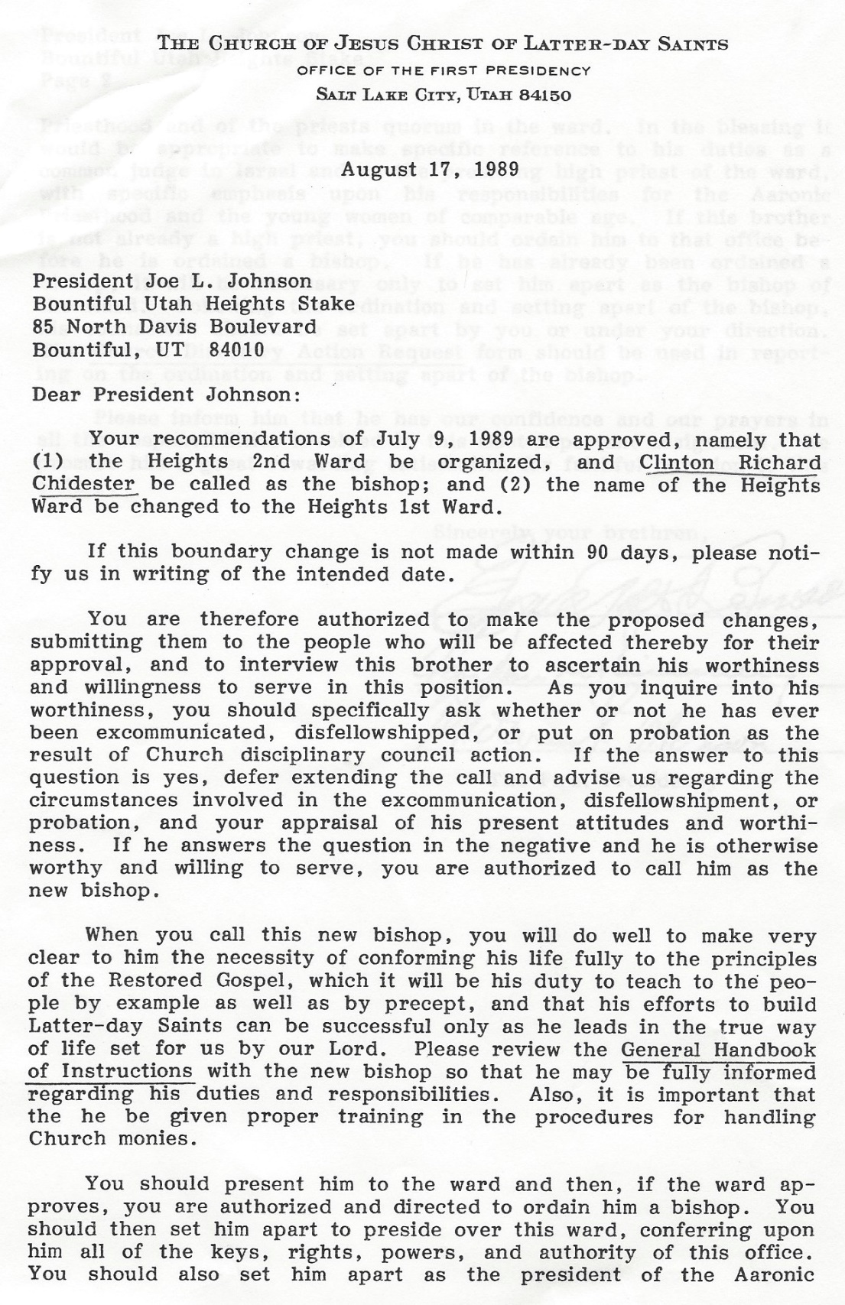
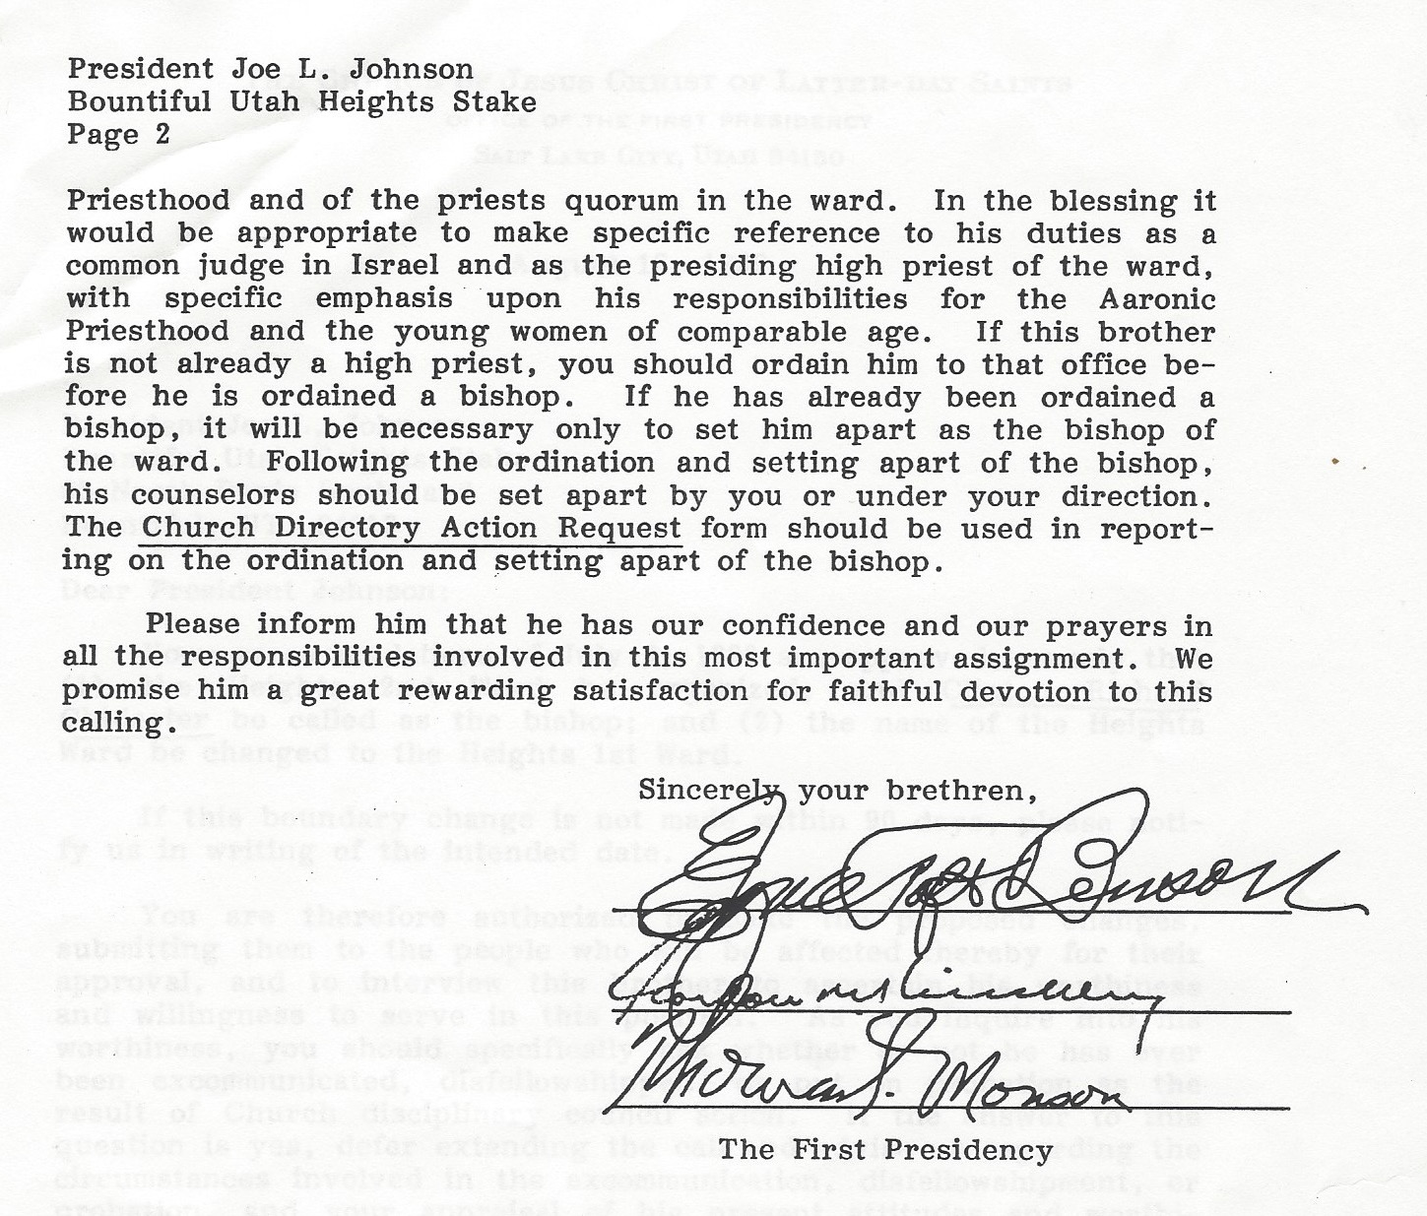

Heights 2nd Ward – History
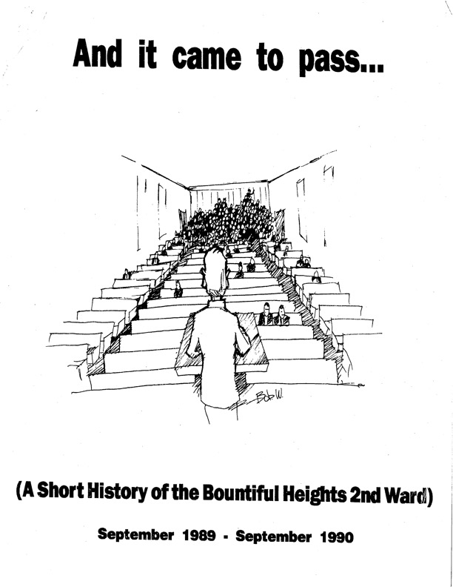
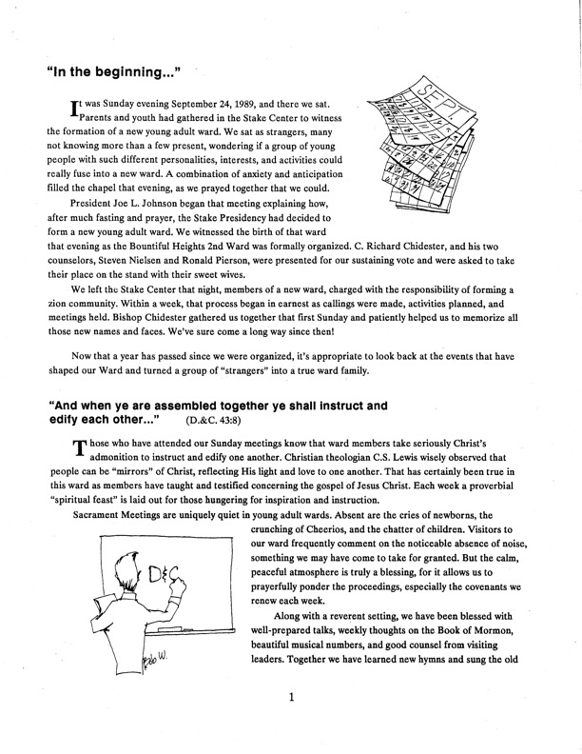
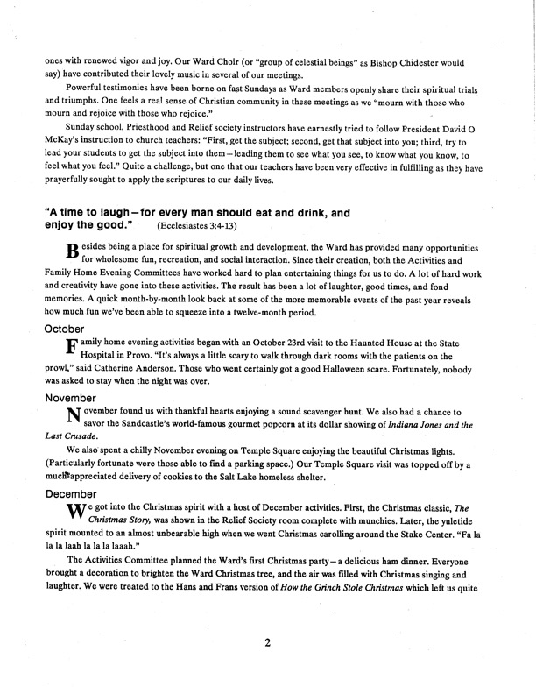
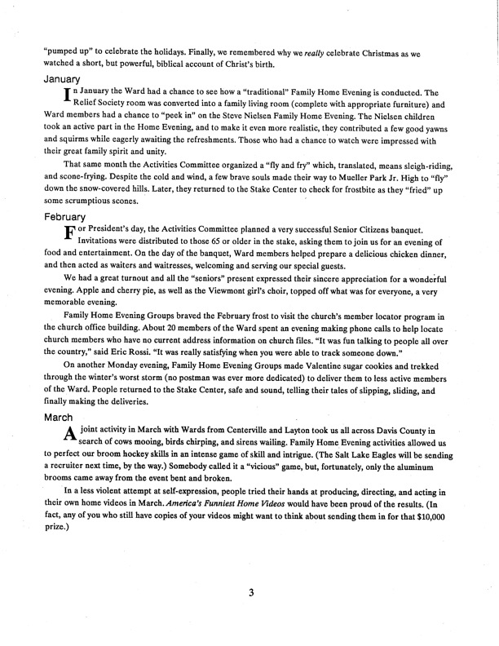
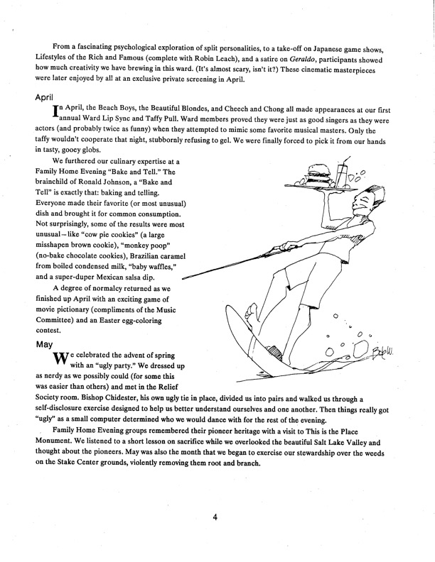
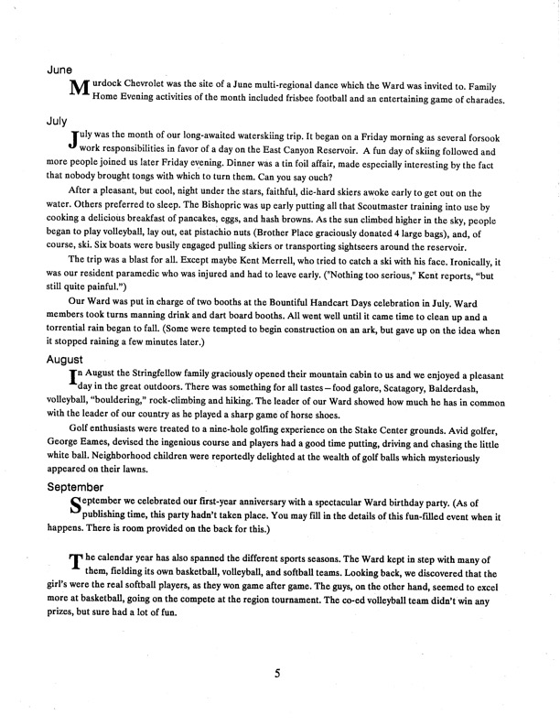

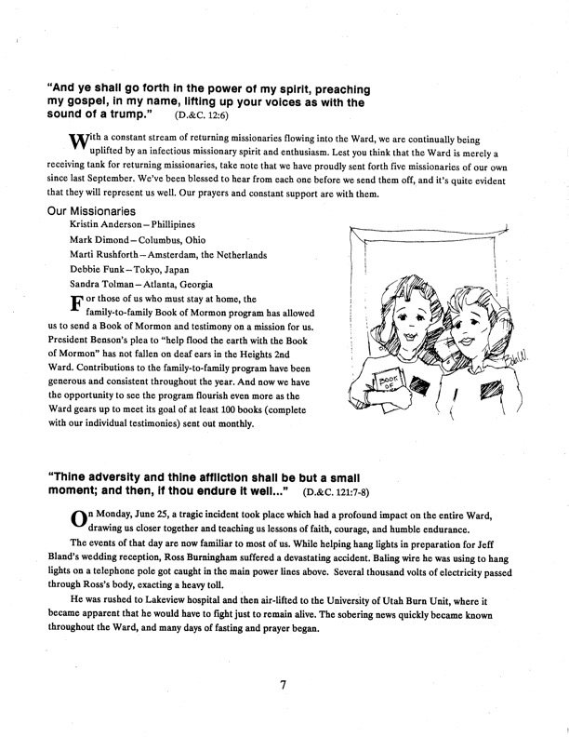
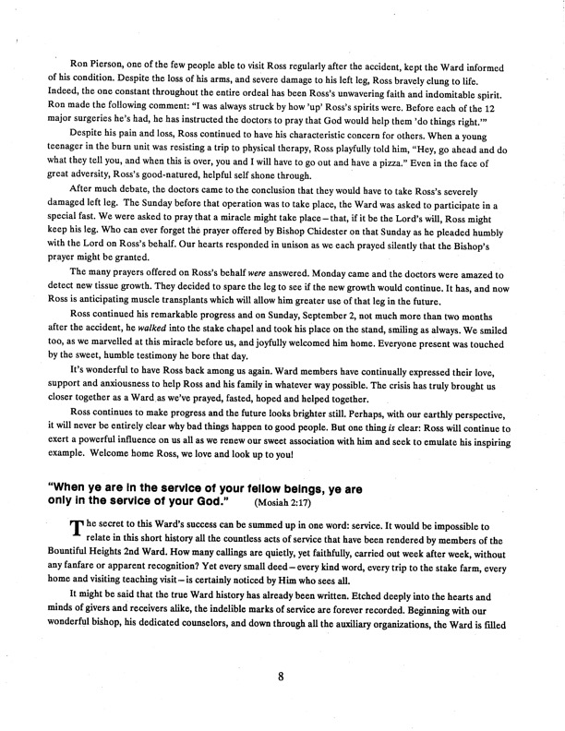
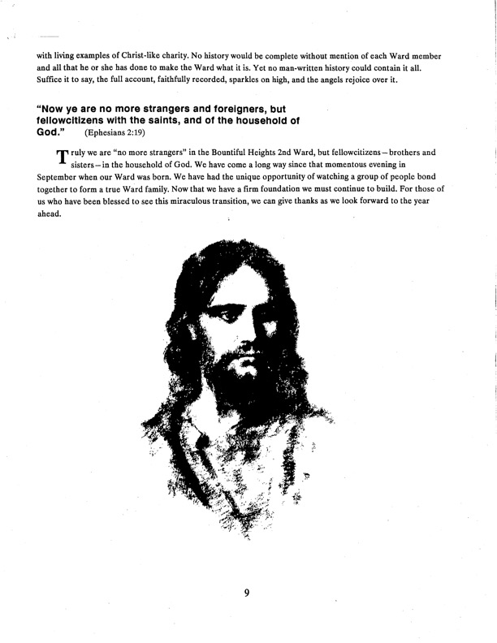

The Floods of 1983

The Floods of 1983
This closeness and love for each other became quite evident in the spring of 1983 when our ward as well as a large part of the stake was ravaged by flooding streams from the canyons to the east.
One home in the ward was completely demolished and several others were severely damaged. 400 North was blocked at 700 East by water, mud and debris preventing east and west travel within the ward without first going several blocks to the north or south.
Property and infrastructure damage was extensive and one man was seriously injured when he was swept from his front door down Stone Creek. There were numerous others injured and some homes were rendered uninhabitable.
We were fortunate to escape unscathed. Nelda was a Registered Nurse; I was an EMT and we were both trained in disaster response, so our front yard became the ward first aid station.
Other homes on our block became distribution points for food, tools, cleaning materials, etc.
It didn’t take long before mutual assistance became the rule of the day. Suddenly 72 hour kits, emergency food and supplies, and disaster preparedness became very important to us.
With time, physical, emotional, and material wounds were bound and healed as we learned to help one another in whatever way we could. In some cases that took days; in others it is ongoing.
Building upon the experiences of those days, the Church and local officials have developed a disaster response program that now gives most in our community a comfortable sense of security.
-V. Brent Bangerter, 24th Ward
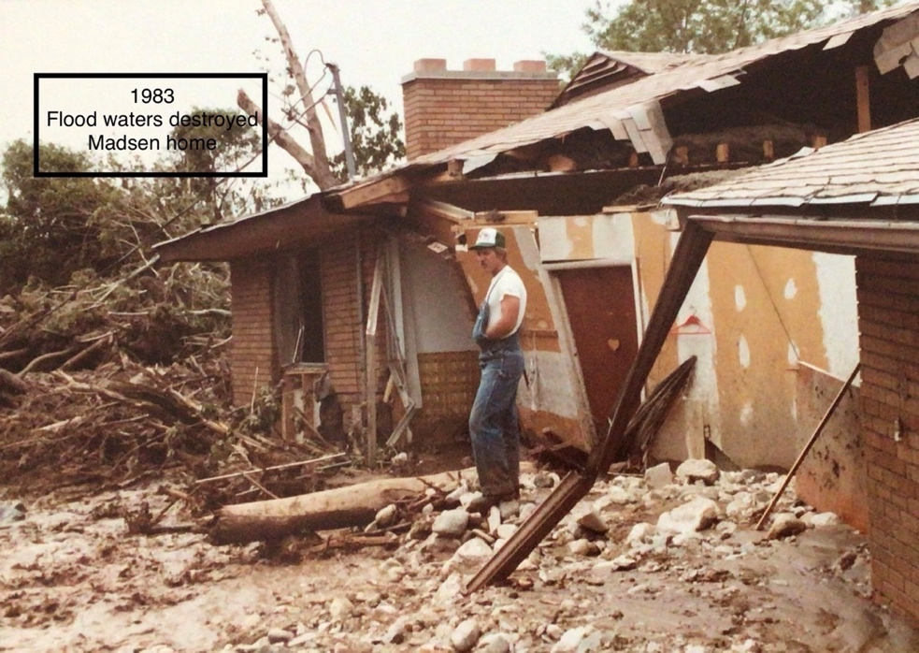

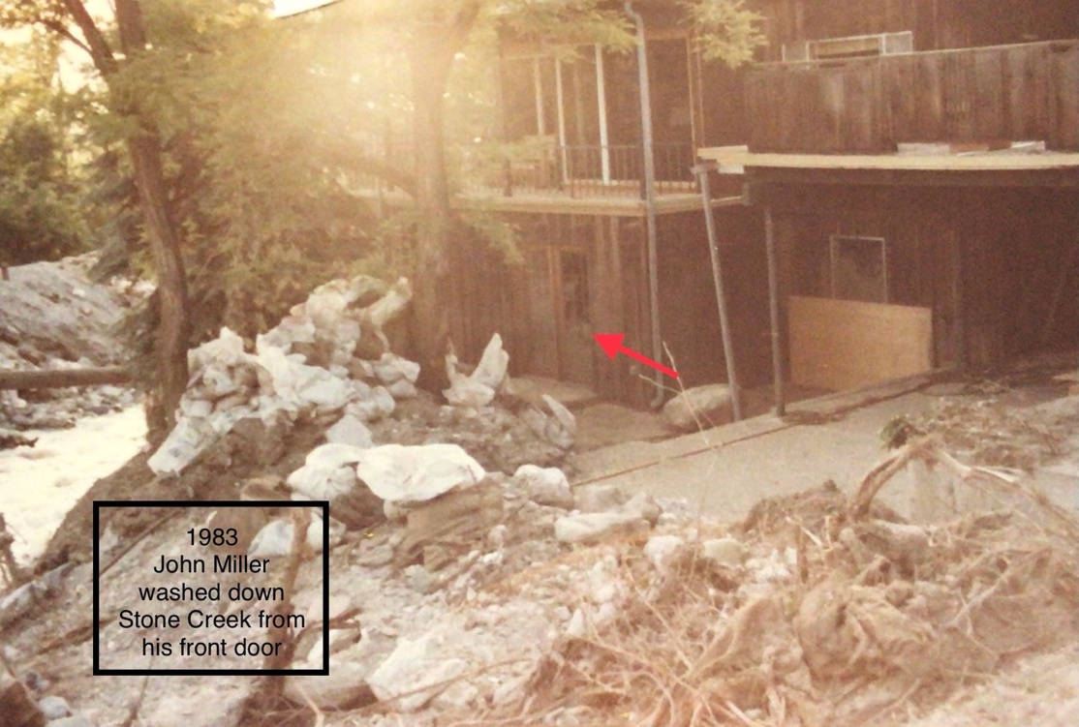

Stone Creek Mud Slide
The Steele adventure began Saturday evening, April 28th, 1983. Rog and I had been to Pocatello and Logan to put flowers on family graves for Memorial Day. Steve was working at Lagoon.
About 11 p.m., while waiting for Steve to get home, I took the dog out and saw neighbors across the street where Stone Creek goes under 800 East to the Pump House on the creek by the reservoir. Lorene Harrison’s home is right by the creek and she and others were outside talking and I joined them.
While standing there on the sidewalk we noticed our feet getting wet and more water was coming than the culvert could handle and started running across the street to the gutter in front of our home. I rushed into the house to wake Rog and tell him what was happening and his comment was "so" (he was tired). So I went back out and the water was halfway up our driveway — and when I told him that — he was up and we had to decide what to do.
We got some sandbags ( and I don’t remember where we got them) and blocked our driveway and patrolled most of the night. The water just kept coming over the road from the culvert.
The next morning was Sunday. Church was canceled (it was to be a missionary farewell for Lisa Holbrook). More and more water kept coming, along with dirt, mud and rocks. It was going down 800 East to 400 North and then down the hill.
Brother Frank George brought in a large steam shovel to the middle of the creek and started to build up the sides of the creek with mud and lots and lots of sandbags — the creek sides were built up south of the Harrison house.
So much water was coming that they built at sandbag dike across 800 East to the pump house that was over the creek by the reservoir. They wanted to stop the water from going down to 400 North and down the hill. They eventually had to build a dike across 400 North so the water would go down the creek.
Sunday was a day of sandbagging, watching, and worrying by many members of the ward.
Monday, the 30th, was the same. Day and night. Different men were assigned to patrol the creek, especially during the night. Monday, the gas company turned off the gas line along 800 East.
Tuesday, April 31st — the same process - the dike was growing taller to keep the water in check as much as possible. I asked Rog to sandbag the two small air openings under our front porch to the fruit room in the basement and he also sandbagged the basement bedroom window well.
That evening, the ward called a special prayer meeting at the church at 9 p.m. Rog went and when he returned we packed a large, hard sided suitcase with a change of clothes and shoes for Rog, Steve and me. They had requested us to do so at the prayer meeting. Resting, watching Mash on TV and as soon as it was over at exactly, the power went out. There was a pounding on the front door from the two boys patrolling the creek. They told us to get out as soon as possible.
It was so dark and Rog couldn’t find his shoes, so he was stocking-footed. I grabbed my purse and we picked up the dog and went out and locked the door —wondering if we would have a house when we returned.
Our truck was parked on 900 East, but the water was so swift coming down 400 North that we couldn’t cross it — so we continued down to 700 East. The two young men who were on patrol were with us. Rog was struggling to hold the suitcase and Steve was helping me and one of the boys had our dog, Dani. The boy holding her slipped and fell and I thought we had lost her — but he held her tight and was able to get up along with us.
We walked down to the Stubbs home and Steve went in and woke them up. Water was starting to come through the Jensen’s and Holbrook’s yards across the street. I ran and pounded on their doors. Byron drove Rog and Steve up to our truck and then came back. He told me to get in the back of the truck and I did, along with the suitcase and the dog. MarJean was hurrying to gather Jared and Glenn and their dog and items for a bag. I remember sitting the the truck, holding the dog and saying, "I’m ready to go now, Byron" — over and over again while he was putting sandbags in his driveway.
He finally drove us up to Rog and Steve and we ALL sat in the front seat of the pickup: Rog, Steve, Dani (the dog), me, MarJean and Jared. Glenn and Brownie, their dog, were in the back of the truck. All of us were wet and smelly with mud up to our knees.
After sitting for awhile, MarJean went down to check on Byron. When she got to the house water and mud were coming in the window wells so he finally just opened the sliding glass door and just let the water and mud run through and on out the door.
When they could do no more, they came back to our truck and picked up the children and dog. I then went to the Barker house to use their phone to call Ken, Rog’s brother in Rose Park and we went there to stay for the night.
It was then that I realized that my purse was missing. It must have slipped down off my shoulder and was hanging on my arm as we left the house and perhaps the fast rushing water carried it off my arm down the hill. No wallet, no driver’s license, and no money (checkbook was in the purse). Rog’s wallet was left in the house. I called my brother, Edward, and we met him in Salt Lake the next morning and got some money from him to tide us over until we could get things organized.
We went and checked on our house —our neighbor, Kim Jackson, was driving a bulldozer to clear the street and he scraped out our driveway so we could get our car out of the garage.
The next day I drove the truck back and checked the house. I put records, pictures, etc. in boxes and carried them and the cello out to the truck. I put the a cedar chest on a bed and the other one on the couch if more water came down.
We were asked not to stay in the house for a couple of days as they were not sure if more water and mud would come down. Helicopters were going day and night checking the canyon. The National Guard were patrolling the area.
We found out that the Madsen home had been destroyed. (The Madsen’s had a son in the MTC at that time ) It was along the creek a block up from us. The house was right next to the creek and a few feet away was a bridge over the creek to their neighbor’s house. During the slide, that bridge was clogged with trees and debris so when the water hit there, it shot around that house and down, across the street to the creek by the reservoir (next to our) house. So much water and mud came down that it went over the reservoir, then down into our yard taking out two fruit trees and digging a huge gully through the pea patch, and filling Holbrook’s basement in 30 minutes, we found out later.
When we were finally able to come back to the house, we had power and water, but no gas.
The creek divided our ward in half — on our side (north), the Merrrill Tuttle’s carport was filled with tables and benches. Grocery stores, and wards in the stake brought food for those in the area for meals — breakfast, lunch and dinner. It was a good place to rest and talk after hours of cleaning, etc. all day.
Now the work began — clearing the sidewalks, driveways, and street. Dried mud was everywhere. We also had sightseers, which was very annoying.
By Sunday, June 5th, we were told to come to an early Sacrament Meeting in our work clothes.
It was Lisa’s farewell and we also had some national media in attendance. (Lisa had all her mission clothing and supplies she was taking to Australia in her room in the basement. All that was now buried in mud in the Holbrook basement. They began again that week to buy what was needed so she could leave on the next Thursday.)
After Sacrament Meeting, we went to the cultural hall where there were tables and chairs completely filling the room and the stage. The stake had prepared the meal for us. We then went home and many workers from all over —even from Idaho, came to help clear the mud from our yards. We even found pancakes (from someone’s trash) in front of our basement
window sandbag pile.
My brother , who was a Bishop in Sandy, missed church and brought his family to work for the day. Rog’s brothers came. We were able to replant the peach tree (and it survived) and filled the deep gorge in the pea patch with mud from the front yard. Many kind people came and were willing to help. The only green in the front yard was a small patch of grass on the center mound.
When I lost my purse, I also lost Rog’s watch his mother had given him for graduation from high school. I was going to get a new watchband for it.
Time passed — the work of cleaning our yard - going to houses to help them clear out the mud - went on for months. For a month or more I would never leave the dog home alone when I had to run errands, I always took her with me. The sound of helicopters above the house makes me nervous still and brings back memories.
-Elaine Steele, 16th Ward

Battle of Bountiful: Utah’s worst flood? -
BOUNTIFUL, Utah – The mudslides and floods caused millions in damage to hundreds of homes last week and it may be only the beginning of the worst weather destruction in Utah history.
An unlucky weather pattern caused mudslides to smother parts of Farmington, floods to batter sections of Bountiful and rivers to run down the main streets of Salt Lake City.
A severe hot spell over several days near the end of May quickly melted the record snowpack in the Wasatch Mountains, sending torrents of water into the valleys at a much faster rate than canyon streams could handle.
The runoff hit a peak last weekend and, by mid-week, water and chocolate-colored mud from the mountains had ravaged nearly every community from the Idaho border to the desert areas of southwestern Utah.
Gov. Scott Matheson estimated the cleanup costs at about $200 million and declared 13 of Utah’s 29 counties disaster areas. About 3,000 residents were forced to evacuate, although most were back home by the end of the week.
Bountiful has had the worst of it so far.
’This is the worst property damage I’ve seen in Utah,’ Matheson said after touring floodravaged community 12 miles north of Salt Lake City. ’It’s just unimaginable until you see it.’
The ’Battle of Bountiful’ began shortly after midnight Wednesday, when Stone Creek broke through an earlier mudslide and sent a 30-foot-high wall of water crashing into the quiet, sleeping neighborhoods.
Luckily, nobody was killed as the furious flood sent families scurrying from houses in their night clothes. Seven people were slightly injured, the most serious casualty being a broken leg.
Kent Servoss, a Bountiful Power Co. worker, had the closest call when the flood lifted his pickup truck like a toy and slammed it against a utility substation. He was checking sandbags the city had placed around a utility substation to protect it from flooding when the creek broke through just above him.
’All of a sudden I heard a terrible noise behind me and I turned around to see a 30-foot wall of water coming right at me,’ Servoss said. ’I turned on the ignition, slammed it into reverse and
got about two feet before the water lifted the truck about 30 feet and carried it about 60 feet.
’I thought, ’Oh boy, this is it. I’m either going to be electrocuted or crushed.”
The wall of water pushed the truck against the substation and the trailing mud and debris lodged it near the building’s roof. Servoss opened the car door and climbed out uninjured.
The flood twisted one home off its foundation and cut it in half. Three others were considered total losses and hundreds of homes suffered severe water and mud damage.
Officials evacuated a 24-square-block area and emergency shelters were established at area schools. Most residents were back in their homes by Thursday.
In Farmington, more than 500 residents were forced out of their homes and another 1,500 prepared to flee after a massive mudslide triggered by the moist, unstable mountains unleashed its fury on the community of 6,000.
’I looked over the top of my house and saw trees falling one after another like dominoes,’ said Don Sims, who lost his home to the Farmington slide Monday night.
’You could hear the crashing of trees. You could hear the wood breaking,’ said Paul Ward, another Farmington victim. ’I thought the reservoir behind my house had broken. People were runnng everywhere, so I went outside and then I could see the river of mud coming down the canyon.
’I ran up the street just as the slide hit the back of my house.’
Utah got a brief respite by mid-week as temperatures cooled to the 60s, slowing what the National Weather Service called the heaviest spring runoff in the state’s history.
But officials said as soon as another high pressure ridge hits the state and sends temperatures soaring back into the 90s, a second wave of destruction could crash down from the towering mountains.
’The flooding conditions are the most severe the valley has encountered,’ said Salt Lake County Flood Director Terry Holzworth. ’We are in for the worst flooding in history for the next three weeks on Big and Little Cotonwood and Mill creeks.’
Salt Lake County evacuated 200 people from a mobile home in Murray, in the south part of the county, when flooding in Big Cottonwood Creek flowed into the valleys. Several communities in the county were told to boil their water as mudslides and floods knocked out treatment plants in the canyons.
Salt Lake City officials diverted water from flooded streams into some of the city’s main streets, creating rivers running down the middle of the city to relieve pressure on the creek banks.
City flood control official John Hiskey said thousands of volunteers filled more than a million sandbags throughout the week to protect homes and businesses from the floods.
All 1,100 residents of Fairview were evacuated after a mudslide in Fairview Canyon blocked Cottonwood Creek above the town, threatening the community with a flash flood potential.
The residents were shuttled by buses to nearby Mt. Pleasant, but were allowed back to the town 80 miles south of Salt Lake when the situation stabilized.
Utah’s weather problems began last September, when severe thundershowers dumped nine inches of water in northern Utah, causing millions of dollars in damage from flooding.
’The ground was saturated then,’ said National Weather Service Meteorologist Dean Jackman. ’And it has never had a chance to dry up.’
The state had one of the wettest winters ever and Jackman said Alta Ski resort received a record 805 inches of snow during the season. To compound the problem, temperatures remained cool in March, April and first half of May, delaying the normal springrunoff.
When the temperatures reached into the 90s May 21, Jackman said, the heavy runoff became relentless. He said that more than half the snow is still in the mountains, ready to come down
with the next hot spell.
Jackman said one of the theories to explain the strange weather pattern is the ’El Ni o’ phenomenon – in which west-to-east trade winds off the West Coast of Peru stop blowing and the high temperatures over the sea build up huge amounts of precipitation.
’Storm fronts carry that moisture to the western United States and cause very wet seasons, according to the theory,’ Jackman said.
Other theorists, he said, claim the unusual number of volcanoes erupting in the world affected weather patterns this year and abnormal amount of sunspots created the havoc.
-PAUL ROLLY (Salt Lake Tribune Columnist)

Deseret News – Bountiful Flood
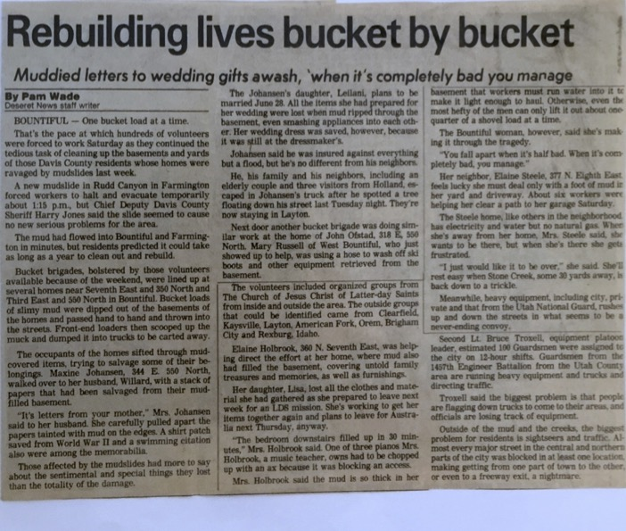

Flood – Davis Clipper Photo
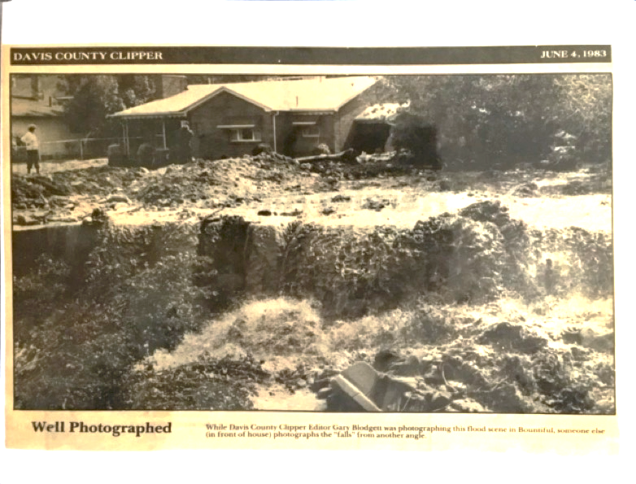

The Fires of 2019
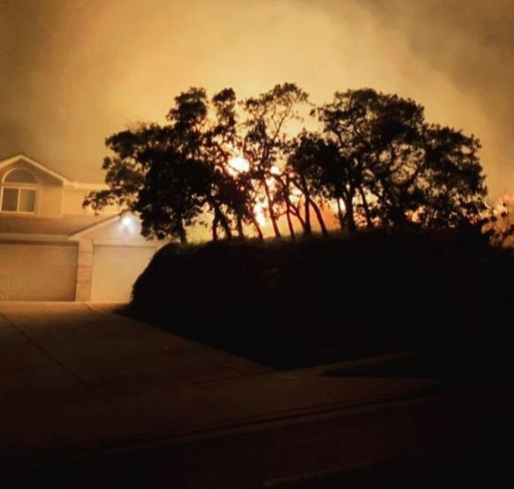

The Gun Range Fire – Asay Family
On Thursday night we saw the fury of what man created and then we saw God’s grace. We were not lucky, we were blessed. Blessed by the people who God put in our path that night. By winds that suddenly stopped. Our home and many others should have burned.
The Fire Fighters came to our home the next day to review the damage to our home. I indicated we had no damage done to our home. He said what about your eves and shingles, etc. there had to be damage. I again said we had no damage. He did what any good fire fighter would do, he went out back and asked my husband. Receiving the same answer he shook his head and left.
The fire smell in our home was gone within a week. Why did my home and many of my neighbors go untouched and others burned, I am not sure why. I think he still wanted us to know that he is still a God of miracles. That trial was not ours to have.
We came together as neighbors that week. We were blessed by those that lead us in our stake and ward who were with us throughout the night. Checking off the names of each home, making sure they were safe. We will always be grateful for their leadership.
-Jill and Clair Asay, 54th Ward
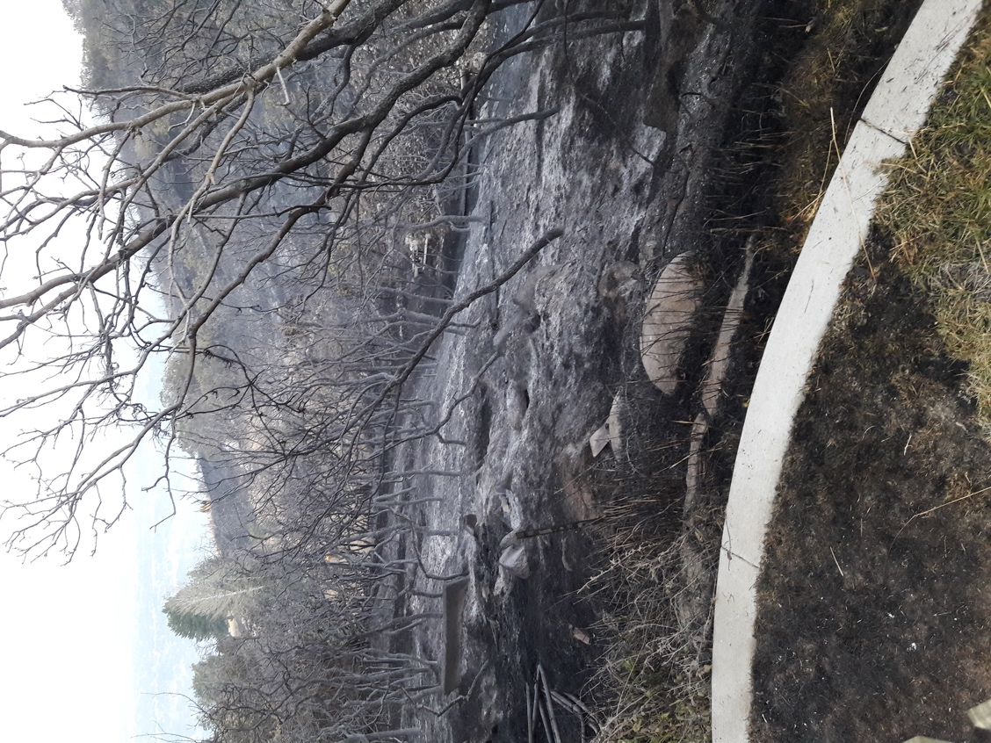

Angelic Help – Steve Gulbrandsen
I believe we had angelic help in the fire. It burned bags of mulch leaning against our house. The following morning there were still flames underneath a pine tree, which if it had caught fire would have taken the house. There were 2 significant indications that angels had been present – including my son Mikey because something was left in a certain way that only he would have known about. I feel it is too sacred to mention the two things that occurred, but am profoundly grateful for the protection to us and other members of the ward.
-Steve Gulbrandsen, 54th Ward

Gun Range Fire – June Gulbrandsen

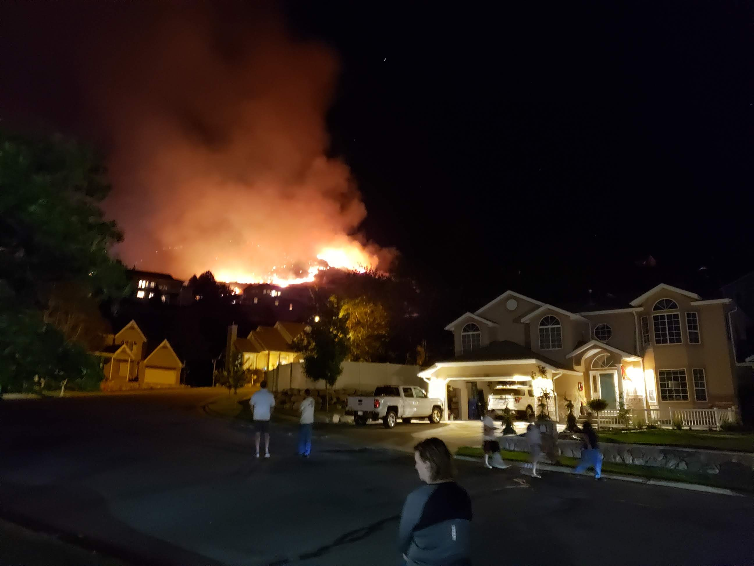
The Gun Range fire of August 29, 2019 impacted our entire ward. As for myself, I left my home fully anticipating that it would be gone when I returned. Only miracles prevented such an outcome……miracles and generous service rendered by truly selfless mortal angels.
Perhaps the first miracle was that Steve Swenson was even awake when it occurred due to a late-night birthday celebration for his daughter. As he trudged off to bed around 1:00 am, he looked out his bedroom window and saw an eerie glow on the mountainside behind my home. He and his wife, Emily, jumped into their car and drove up the hill to see what was happening. They began knocking on our doors telling everyone on our street to evacuate. They were assisted in this endeavor by a police officer and a passing motorist. (I believe the motorist was Sister Gibbons, but I’m not certain.) Those four people performed the first miracle of the evening, successfully evacuating our entire street as the eerie glow rapidly turned into a blazing inferno rushing toward our homes. The wind was aiding the racing flames and it seemed nothing, save a miracle could stop the annihilation of every home on our street.
There really wasn’t time to save anything from the approaching fire. I left with an armful of clothes and my medications, Steve grabbed his computer, and a couple of files. I remember thinking as I fled, that the things in my home were just that, “THINGS”, and just feeling immense gratitude that we were all safe and uninjured. As I drove away, there were already a few patrol cars lining the street down the hill from our home but no sign of a fire truck yet. I did not even hear their sirens as I left around 1:20 am, just 20 short minutes after the fire was first spotted.
Miraculously, within the next 15 minutes, fire trucks flooded our street. The fire had a life of its own as the brave firefighters fearlessly fought it. The fire was in the process of burning our yard and burning the empty lot just west of us, effectively surrounding two sides of our home, when the second miracle of the night occurred. The winds which had been driving the fire in the direction of our homes suddenly reversed and began blowing away from our home. I can’t help but believe a chorus of heavenly angels formed a brigade protecting our home. This was truly a miracle.
Many other miracles occurred associated with the fire. Among those which directly impacted us are the following:
We had several bags of mulch leaning against our home which were still smoldering the next day. As the firefighters continued to check the vacant lot next door and the top part of our property for hot spots, Steve came outside and noticed the burning embers in these bags of mulch and they were promptly put out.
One bush within 3 feet of our home burned all the way to the ground. This particular bush had a large pine tree right next to it. Just a month prior to the fire I had pruned back all of the lower branches of this pine tree so that none hung over this particular plant. Had the branches of the pine tree remained hanging over that bush, the pine tree most definitely would have caught fire and potentially fallen into our home.
While the fire burned the “naturalized portion” of our lot, the landscaped portion remained largely untouched in spite of the fact that the fence surrounding it was charred and the sprinkler system was melted.
Not only were there heavenly miracles which protected both us and our homes but there were truly amazing examples of angelic service during this event. I’ve already mentioned the role Steve and Emily Swenson played in notifying our neighbors. I was also deeply touched that Kathleen Bailey watered the vacant lot between our home and the Asay home much of that night and I believe her angel hands were instrumental in saving both of our homes. The east wall of the Asay home was burned but left no mark. The fire burned all the way to the street between our two homes. That night, the Clinton fire department was assigned to the task of saving my home and three others. They were mighty warriors in that fight and performed amazing service with surgical precision as they stopped the advancing flames at the very edge of our home. There were firefighters from all over Salt Lake and Davis County and Hotshot crews from as far away as Idaho tirelessly combing through our yard and the hill behind our home for several days after that first night. Police protected our evacuated neighborhood in our absence from potential intruders. I watched as one selfless firefighter, suffering from heat exhaustion and/or smoke inhalation, was triaged in an ambulance after his tireless efforts to protect our homes.
It is impossible to express the depth of gratitude I feel and I know others feel for the responders and volunteers involved in fighting this fire. I can’t possibly do justice to the miracles that occurred surrounding this inferno. But I do know that this fire was a blessing in many ways. The sweet fellowship within our ward was intensified and our ward family grew measurably closer as a result. Testimonies of God’s power to save us against impossible odds were strengthened. Knowing and seeing how the hand of God could save us from this fire helps us to see the power He has to save us from our weaknesses and sins! And all of us feel a daily sense of gratitude for blessings that we can no longer take for granted….commonplace activities such as sleeping in our own beds, sitting around our own kitchen tables and enjoying a meal together and chatting with one another in our living rooms are all deeply appreciated and our prayers are much fuller of gratitude subsequent to the fire. Ultimately, the gun range fire brought many blessing to me personally and to our ward family.
-June Gulbrandsen, 54th Ward

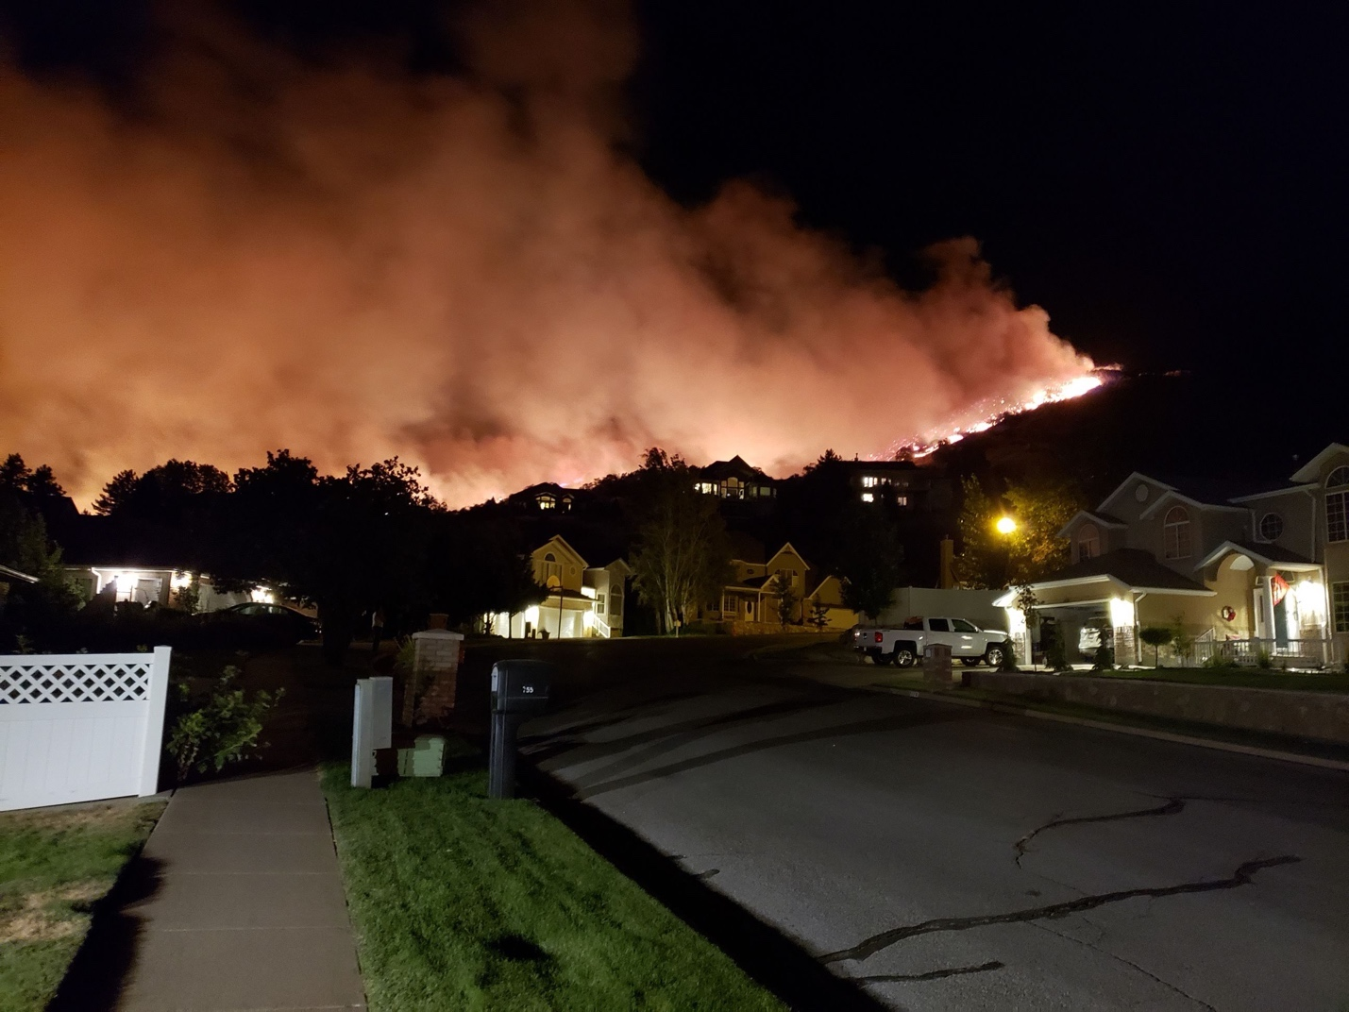

Gun Range Fire – George Family
Kathleen George’s journal entry written on Tuesday, September 3, 2019 regarding the “Gun Range Fire” that started after midnight early in the morning of August 30, 2019. This was taken from a journal she was keeping for her husband, unbeknownst to him, while he was serving as the bishop of the 54th ward. “You/your” refers to her husband since she was recounting the experience for him.
I don’t even know how to begin to summarize the past few days. It is truly unbelievable what can occur in such a short amount of time. Before I share this story, I will share the conclusion: Our ward experienced a miracle…one great miracle and many individual miracles. The miracles were wrought by God (and angels) and humans who acted.
Around 1:15 a.m., we were awakened to the most terrifying sound…it still causes chills to run up and down my spine: pounding on our front door with simultaneous doorbell ringing. It was at such a frantic rate that I was sure someone was fearing for their life on the other side. It was horrifying to be awakened like that. You and I ran together down the hall to the door…panicking out loud together. You opened the door and there stood Steve and Emily Swensen screaming, “The mountain is on fire! Get out of your house now! You have to leave! Hurry!!” We couldn’t believe it but knew it was true at the same time. You ran to wake up the kids. You yelled something to me about this being real and to hurry. I remember I got dressed and started gathering journals. The kids came up the stairs frantic. I yelled it will be ok, to get shoes, and get to the car. A policeman came right then and said, “Grab shoes, kids, pets, and leave now!” He said we didn’t have time for anything else! That made it even more real to me. The fact that professionals were already aware of it just scared me to death!
What does it say about me that I grabbed journals and photos anyway? This journal was at the forefront of my mind. I was scared that you would discover it. I had three binders to grab. That is how I am currently storing it right now. One (the latest section) is kept in my top drawer, and two other sections in our closet. You saw me gathering them but didn’t question me. I grabbed my Mommy journals, most recent journal, external hard drive, laptop, our wedding album, trip albums, and a box of photos that were not backed up digitally. Also, contact solution, make-up, charging cords, and my purse. It made me so sick to not be able to get all of our photo albums. You were chomping at the bit- frantic for me to get out. I ran to the garage and you were putting your bike and mine on the car bike rack. Priorities, priorities. 😊
The sky was orange! I drove the big car with the kids and you followed behind me. We saw orange above our home (north east) to the side of our home (north) and below our home (north west). That was horrifying! The kids were crying. I was trying to be positive and calm for them but it was hard! As I drove down the driveway and turned down our street (with you following behind us in your car) I really felt our house would most likely burn down. I couldn’t believe that my life story would now include this…the burning down of our home. And what solidified this thought? Your patriarchal blessing. I had feared a moment like this the entire time you had been the bishop: You will have “the gift to organize yourself and others and be able to respond to emergencies and the unexpected…” Here it was! The unexpected emergency. And what is so sad is that I pictured you helping others after the fire…not right then. (I have guilt over this now.) Does that make me a terrible person? (I cried about it later that I only saw you as my husband and our children’s father in that moment- I forgot you were the bishop for that particular moment.) You didn’t forget. As the kids and I slowly drove down Northern Hills drive (due to traffic!) while crying and speaking frantically that it would be ok and that we had each other and that was all that mattered, I noticed your car was no longer behind us. The orange flames were- but you weren’t. That really panicked me! It was such a horrific time and now you weren’t there. At the time, we didn’t know how quickly it was spreading or which direction it was going. I kept thinking of the Paradise, California fire and remembered that many people waited too long and were killed. I called you and you told me you were outside the Bills’ home calling the ward- making sure everybody was out. You felt so worried and responsible. I could hear it in your voice. It was so hard to hang up and trust you that you would be careful and not stay too long. Just then, Jessica Whittaker called me and told me to come to her in-law’s home- that their house was empty due to them being out of town. I was so flustered I couldn’t commit. I didn’t know whether to leave you and part of me didn’t want to be far from our neighborhood. Looking back, I see that I was blessed by her thoughtful invitation right when you left us to make calls. I think He (Heavenly Father) was watching out for me and our kids. It was a difficult time to not have you with us. The kids and I drove to Pages Lane and 400 east and sat in the dry cleaners’ parking lot and watched the fire. We prayed. Jessica Whittaker called again and said, “Just come!” I reluctantly left our neighborhood and you. On our way, we pulled over on 400 east and prayed again. Once I got to the Whittaker’s home (Scott and Jan…off of 1800 south) I called you and remembered saying, “I know you’re the bishop, but you’re a Daddy too. Please, please, don’t wait too long.” Two homes had already burned down just below firebreak road, you heard them when you were outside the Bills’- they must have had ammunition because of the type of explosion you heard. The winds that night had been 30 mph. How did they die down and shift? Our kids were scared yet distracted at the Whittakers’ home. Justin gave them IBC Rootbeer at about 2:20 a.m. They loved that! I was so sad without you. I was ready to be very emotional but I noticed a sign in the t.v. room that read, “It is what it is”. O.k. I could adopt that attitude and try to relax except I remembered I hadn’t grabbed the bin of baby books, the scrapbooks, and the old Hi-8 videotapes of Ethan’s and Abbie’s baby/toddler days. Their albums aren’t digital. That made me sick. My heart quivered and my insides shook just like they did before my Mom passed away. The same anxiety filled me.
Meanwhile, you, Steve, and Emily Swensen accounted for 95 % of our ward. (You later said the list of 12 or so names that you didn’t have accurate phone numbers for, haunts you.) I found out later that after every phone call you made, you told whomever you were talking to,
“I love you”. That really touched Steve and Emily. Steve said, “Perfect love casteth out fear.” And he felt that as he listened to you share your love for each person.
You went to the church and stayed with many members and neighbors that were gathered there. Your view was so scary! I was told, later, that your presence brought so much comfort. You stayed all night. The winds shifted. It burned north and the wind died down around 8:00 a.m., I believe. You hurried home and grabbed those items that had been weighing heavy on my mind and heart. I felt so grateful! And then you came to the Whittakers.
The Stake Presidency asked for an accounting of your ward. I’m so glad you could give it. I saw the mantle on you. You felt as responsible for your ward as you did your family. I watched the news all night/morning. Dale Weathers and the Sebrings were interviewed. When you joined us, we tried to sleep. It didn’t work. Too much anxiety. The kids slept for a couple hours.
While the flames had shifted direction, and the winds had decreased from approximately 30 mph to 12 mph, then to 7 mph, the fire was still not “contained”, and we were unable to go home officially. Around 2 or 3 p.m. we drove to the Kearls’ area and parked. A police officer was standing at the corner of Northern Hills and Northridge. Cars were not allowed past that point…west or east or north. He said we could walk home to gather things but the evacuation order was still in place.
That was a strange experience…Coming back home for a short time. It smelled like smoke. Our street had an eerie, lifeless feel to it. The fire could pick back up again at any moment if the winds came back. So… were we to be casual and think ahh nothing will happen tonight, or, were we to look at it as a second chance to gather those things that were most valuable? We got rolling suitcases and packed them full of albums, baby books, Hi-8 tapes, journals, the kids’ scrapbooks, whatever they chose (stuffed animals, etc.). We had to pull everything up Northern Hills Drive in the scorching heat!
We got some groceries and then went and slept at the Whittaker’s in-law’s again. The evacuation order was lifted at 1:00 p.m. the next day (Sat.) Coming back home felt so nice yet so strange and full of anxiety for me.
Testimony meeting the next day was incredible. The feeling of gratitude and love was so strong. Our ward had experienced miracles and we knew it.
- Steve Swensen- being touched by your expressions of love for each member you called. His joke about seeing everyone in their underwear.
- President Gibbons’ amazing testimony about Heavenly Father hearing our prayers because of our fast and offerings. He read from Isaiah 58.
- The Asay’s tears. Their home truly almost burned down. The burn shows right next to their home. The Gulbrandson’s, the Jones’, the Mortenson’s, the Whitehead’s, Bacon’s, Summers’,
- Browning’s, etc. Truly miraculous! Firefighters saved them. So did garden hoses. (Kathleen Bailey, among others, helped with their garden hoses.)
- Feeling close to the Websters, Stonemans, Guftasons, and Adams. (Our neighbors who aren’t active or members.)
- -The primary singing, “The Miracle” in primary and Sunday and crying as I accompanied it.
- -The gathering on Monday night at the church to process. Stonemans, Adams, and Websters came! People’s hearts were so soft that night.
- Steve Gulbrandson finding smoldering mulch right next to his home! Bags on fire. Another miracle!
- -The burn scar looking like an outline was drawn all around our ward. One home was burned on Northridge Dr. It was vacant.
It is truly miraculous how it all turned out. The key is not to forget how He watched over us.
-Kathleen George, 54th Ward

Gun Range Fire – Bowen Family
At 12:50 am on the morning of Saturday, August 30th, a fire was reported in to the Bountiful Police Department dispatch center by an officer who happened to be patrolling the residential area above the “B” in the Bountiful Heights Stakes 54th Ward. That evening was already noteworthy for having strong winds with gusts up to 30 and 40 miles per hour coming out of the east and down the hillside, one of our strong east canyon winds.
By 1:10 am due to the direction of the fire and the speed at which it was moving, Bountiful City officials had called for their command center, and the Bountiful Neighborhood Emergency Preparedness Council’s Emergency Operations Center to be opened up.
Calls went out to local Priesthood leaders about the fire and the need to evacuate, as the fire was rapidly burning down the hillside. This responder, a member of the Emergency Operations Center, was called out at 1:10 am. When leaving my house, I could see bright orange flames from my home as I was leaving (at least 30 to 40 feet high), and when leaving I was uncertain that my home would be here when I returned. On the way to open up the Emergency Operations Center (EOC) for the city, I stopped on the way to alert my daughter and son in law who lived on 900 North as to the danger and to evacuate their newly born twins who had just been brought back from the hospital. They started alerting their neighborhood that they were directly in the path of the flames. The sky was bright orange to the east.
Driving to the police department to open the EOC, I was listening to the police dispatch frequency. All police officers had been called out, and all South Davis fire units had responded. One exchange with officers and dispatch is permanently etched in my memory. “… I can’t get anyone to respond. The door is locked and I can’t break it down. Get someone with the ability to breach this door here fast! The flames are at the back of the house”! Also, “The smoke is too thick, I can hardly breathe, but we’ve got them awake and are getting them out of the house”.
The fire was rapidly moving down the hillside, and threatening homes in the 54th and 34th wards. Fire units were now responding from other fire departments in the area. Farmington, Layton, Kaysville, Syracuse, South Weber were directed to areas in the path of the fire to set up a defense of residences.
At 1:20 am President Gibbons, the second councilor in the stake presidency was contacted by phone from the EOC. He had become aware of the fire about 1 am, as he was returning home from a BYU football game in Provo and noticed the flames. He had alerted rest of the stake presidency and bishoprics of the 34th and 54th wards and gotten them started on alerting and evacuating members who bordered or were in the path of the fire.
A brief note on our Stake Presidency. I personally know two of them from having served with them and been able to experience their relationships with the Lord. I know that they do not just pray to God, they speak with Him on a personal, one on one basis. And I know, that in this moment of need, when they went to Him in diligent, fervent prayer, He listened to them and responded to our stake members need.
More fire equipment continued to arrive to help battle the fire. All total, over 84 fire units were stationed along the path of the fire to form a perimeter to protect homes. The fire continued to advance rapidly. With winds that fierce in a fire, what you have literally is a fire storm blowing towards you. The fire units on the front line try to wet down an area that the fire can’t advance through, but are themselves threatened by the fire. I can’t imagine having the courage to face that conflagration that our firefighters have. The firefighters were just barely able to hold the line against advancing firestorm, and then: Calm. The winds just died. Abruptly. Cut off completely. And just in case you don’t believe me, I have pasted the wind chart from the local weather station closest to the fire, located at one of the few houses directly next to the fire. The time stamp where it goes to zero read 2:29 am, the gusts maxed out at 38 mph according to the chart.
The abrupt cessation of the wind is just one aspect of the help we received.
Another, which is less noticed, is the time of the fire. If this fire had happened at any other time in the day, we would have lost more residences. Because the fire was so late at night, the freeways and local streets were clear. Fire units were able to get to Bountiful at speed, with no traffic, and be directly staged against the fire. 84 fire engines were able to place themselves so that there were no gaps in the fire line. The furthest away responding unit was a national hotspot team from Tahoe, Nevada, who just happened to be passing through from fighting a fire down south for the federal government, heard what was going on, and responded to our need.
Also, it is a miracle that there were no deaths, and the only injuries were relatively minor. A couple of police officers were treated for smoke inhalation, and pulled off the fire response (with strong protestations that they needed to remain helping). Also a few firefighters had minor injuries. Two homes that were evacuated while the back of the homes were on fire, burned to the ground. A third was burned so badly that it was a total loss. A few other homes were damaged from the fire on their exterior, but had no inside damage.
Both homes that were burned to the ground were covered by insurance, and a local builder who happened to be a neighbor to the two homes, has offered to rebuild their homes with his crews at cost. One of those home owners, who is not a member of the church, has directly had positive experiences with the church. Members have rallied around him, helping to provide for his immediate needs, and his bishop helped him locate a furnished house to rent in the ward boundaries the very day of his loss. He has reported that the response and help he has had is overwhelming.
This is a faith promoting experience where the Lord has intervened that ranks in my opinion up there with the miracles reported done by the Lord in the Book of Mormon. I am greatly thankful for his love and care for us here in Bountiful.
-Casey Bowen, 18th Ward member and Incident Commander for the Bountiful EOC for this emergency.

The Youth
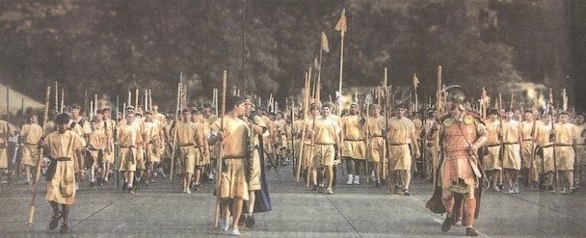


Sons of Helaman - 2000 Stripling Warrior Parade
https://youtu.be/3KKoM0Nb-eo

Sons of Helaman March - Meridian Magazine
In the July 2012, the young men from the Stake participated, with young men from the other Bountiful-area Stakes, in the Bountiful Handcart Days “Sons of Helaman” March. Bishop Danny Brock, who played a pivotal role in the planning and implementation of the “March”, later gave a talk describing how the idea was born…

In a subsequent talk, Bishop Brock shared the following story about the “March”:
In 1996, late on a Friday night, the Brock’s and the Hanks’, and the Murray’s, and the Winegar’s, and the Bensons’, and a few others, were at Baskin Robbins Ice Cream parlor on Main Street in Bountiful after going to the temple. You all know the story of the dream that President Hanks had of marching with the Stripling Warriors happened at about that time. It was on our minds a lot. President Hanks was the Elder’s Quorum President; I was my ward’s Scoutmaster. President Hanks looked at me and motioned with his head for me to follow him. We walked out into the road! We started pacing off distances and making mental calculations. We spoke a bit and just started to get serious when we got the evil eye from our wives who said…”get out of the road and come re-join the group!” As the group of friends started to leave that night…President Hanks worked his way over to me and in a low voice asked me… “did the Lord just whisper to you that we need to get serious about the Sons of Helaman march”? With goose bumps and tears welling up in my eyes, I said “that’s exactly what He said.”
God is in the details.
It was a B I G dream. But we knew we had to do it. President Spencer W. Kimball said… “Make no small plans. They have no magic to stir men’s souls…” When he said that he was quoting Daniel Burnham, a Chicago architect who said… “Make no little plans. They have no magic to stir men’s blood and probably themselves will not be realized. Make big plans; aim high in hope and work, remembering that a noble, logical plan once recorded will never die, but long after we are gone will be a living thing, asserting itself with ever-growing insistency. Remember that our sons and grandsons are going to do things that would stagger us. Let your watchword be order and your beacon beauty. Think big.”
God thinks big. God is in the details.
From that night at Baskin Robbins, to now, lots of things have happened, things that had to happen. Many experiences have taken place. Many callings have been fulfilled. Many people have come across our paths and relationships have formed.
God is in the details.
Those of us involved in this Sons of Helaman march, all of us involved in this Sons of Helaman march, were divinely positioned. You’ve heard the stories and testimonies this very night! God has a plan for us. Elder Neal A. Maxwell has said…quote… “God has placed you here and now at this time to serve in his kingdom; I believe with all my heart that because God loves us there are some particularized challenges that he will deliver to each of us. He will customize the curriculum for each of us in order to teach us the things we most need to know. He will set before us in life what we need, and this will require us to accept with all our hearts the truth that there is divine design in each of our lives that you have a rendezvous to keep, individually and collectively. God knows even now what the future holds for each of us. He knows what it is he wishes to bring to pass in your life. No one was foreordained to fall or be wicked. Let us remember that we were measured before and were found equal to our tasks; therefore, let us continue, but with a more determined discipleship. When we feel overwhelmed, let us recall the assurance that God will not over-program us; he will not press upon us more than we can bear.”
God does know us. God is in the details.
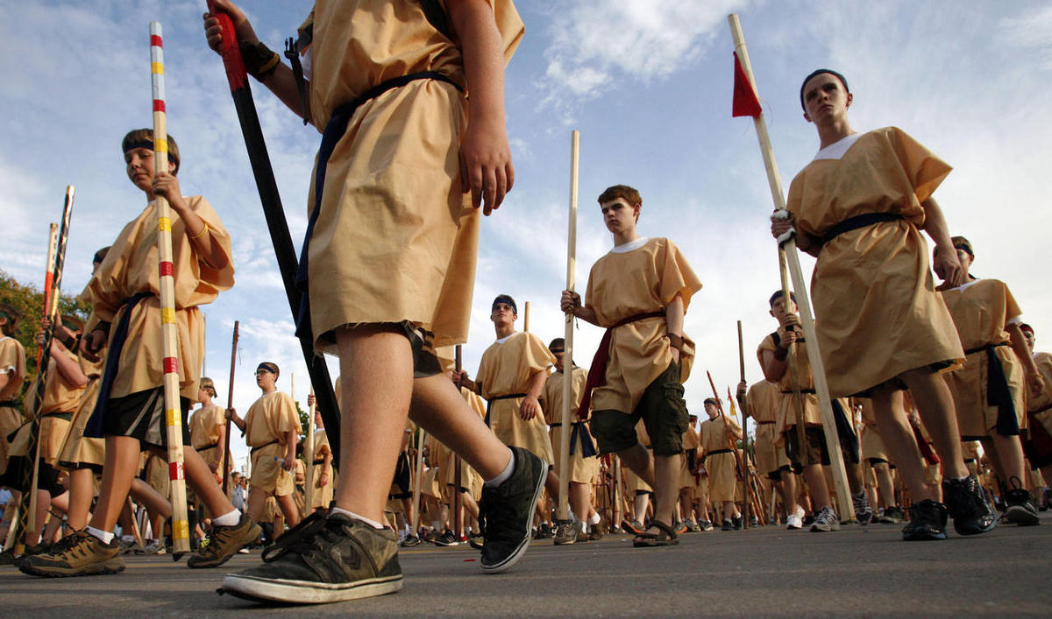

Bishop Brock shares the following story about the Genesis of the March….
For years President Hanks [Bountiful South Stake] has been asked to visit youth groups to tell the story of Captain Helaman and his 2000. He would, on occasion, come into their camps dressed as the ancient warrior while the young men were having an activity. Slowly, a hush would come over his audience as they turned to see the rather strange sight. Captain Helaman would then begin telling them of what was going on just over the hill. He would tell them about his young sons and the protection of the priesthood that they had been promised them by their mothers.
At the end of his story he would always tell them the same thing: they too were in a battle, right this day, in enemy territory. He would tell them that the enemy is all around them, and the fight is urgent. Then the question would be, “will you come with me to fight? Will you be one of my sons?” Tears would fill the young men’s eyes as they anxiously would volunteer to be a warrior as well. 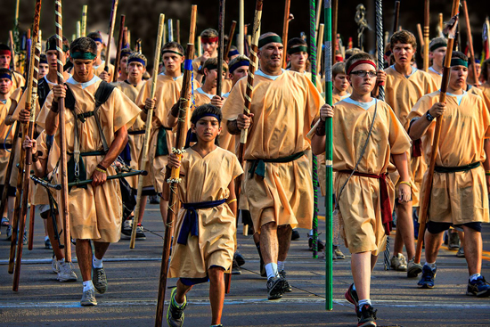
One night, after speaking at one of these youth groups, he turned to his friend, Danny Brock and asked what he thought that 2000 warriors looked like. Brother Brock tried to imagine. It was then that President Hanks told him that he wanted to try to gather 2000 young men together, perhaps to march in a parade. That was 12 years ago. President Hanks was then Bishop Hanks. Finally when he was called as a Stake President, his wife, who knew of his dream, told him, “If you are ever going to do this, now is the time!”
In 2011, President Hanks presented the idea of the 2000 young men dressed as Helaman’s sons to the 13 stake presidencies that sit on the Board of Directors for Bountiful Handcart Days and they accepted it for 2012. So come January, they went to work. Danny Brock was in charge, since President Hanks had heavy responsibilities as Stake President and he knew that Danny Brock had the vision of this idea. They called a wonderful committee that also had the vision. Costumes, wood staffs for the warriors, communications, publicity, logistics, even porta-potties and water for the 2000 boys waiting 3-4 hours for their parade entry to start. It was difficult, but they never doubted that heaven was watching and waiting for this to happen. President Hanks made it clear that it wasn’t about the March. He suggested that every boy and young man write his testimony in the cover of a Book of Mormon, tell the story of Helaman and his stripling warriors, give it to a non-member or less-active friend, and then invite them to come march. Several wards followed those instructions and one ward had 3 non-member boys march, one of whom asked for the missionaries.
Meridian Magazine, August 2012

“Redeem the Cousins” Heights Ward Young Women Project – 2015
In February of 2015, I was the Young Women’s President in the Heights Ward of the Utah Heights Stake. As part of the Personal Progress Program, our Young Woman decided to work on a 10-hour project as a group.
Our project named “Redeem the Cousins”, ended up taking a lot more than 10 hours! We included the Young Men in some of our activities.
We started in February when the Bishop called three of our youth to be trained as Youth Family History Consultants (YFHC). Nate Bleazard, Lindsey Richard, and Katie Adams were called and trained to “find the cousins”. Finding the cousins is a way to find ancestor names using Family Search that was encouraged by Elder Neil A. Anderson of the Quorum of the Twelve Apostles that year.
We started with a special fast in March that all the youth of the Heights Ward would be able to find their ancestor’s names and take them to the temple to do proxy baptisms. Then we went and did baptisms at the Salt Lake Temple with names found be the YFHC.
Over the next six months, the YFHC trained each youth in the Heights Ward to find their cousins and print out temple-ready cards to take with them to the temple. During the following six months, we had a family history minute each week on Sunday where the girls took turns sharing family history stories. We had special family history lessons in Young Womens and had a special fifth Sunday Combined Lesson with the Young Men where we talked about family history and temple work.
As we accumulated temple names, we started doing the proxy baptisms at different temples including Logan, Brigham City, Ogden, Bountiful, Jordan River, Oquirrh Mountain, Draper, Mount Timpanogos, Provo, and Payson. We had a bulletin board in the hallway of the Stake Center where we would post our progress with pictures of all our different temple trips.
Youth members of the ward would share their experiences in Sacrament Meetings when they were asked to be the Youth Speakers. For our Youth Conference that year, we planned a special trip that included doing baptisms in the Manti and St. George temples. In total, we ended up doing proxy baptisms for over 300 “cousins” in 14 temples!
Our last activity was a special “Young Women in Excellence” night. Around the room, we strung a garland of paper dolls dressed in white representing each cousin that was baptized. We had three women in the ward come dressed in white representing three of the cousins whose names were taken to the temple.
Each of these sisters shared their life stories and how glad they were to finally have their temple work done. Each of the young woman shared their testimonies about their personal experiences in family history and temple work during the project. Over the next three years, the Heights Ward adults completed the remaining ordinances for all the cousins that were found by the youth. It was an unforgettable experience
-Becky Adams, Heights Ward

Middle Teton Climb Tradition
A longtime member of the Heights Stake lived and raised his family on 1000 East. Over the years while living in the same home and due to ward boundary changes his family was members of the 18th, 41st and Heights Wards. His name is William “Bill” Rosqvist. He passed away in 2013. What is noteworthy and includable in the 50th year anniversary history of the Bountiful Utah Heights Stake about Bill is that he was responsible, starting in the late 1980’s, for guiding many young men, their fathers, some young women and their mothers and many of their leaders to the summit of the Middle Teton in Grand Teton National Park. Mountaineering skills were taught by Bill for over 30 years to hundreds of members of the Heights Stake.
Climbing Middle Teton became a tradition for the wards Bill lived in and other wards in the Heights Stake who were interested in participating. Under Bill’s leadership, the Varsity Scout Team would plan and execute this climb each year for their high-adventure activity.
Training hikes to prepare climbers were conducted in advance on nearby mountains along the
Wasatch. Cave Peak, Bountiful Peak, and Timpanogos were some of them. The climb would happen in early June of each year, right after the school year ended. Bill was generous with his belongings. He often outfitted many climbers with gear that he provided from his own personal inventory. Boots, gaiters, ice-axes, ropes, gloves, and coats were often loaned out so those interested in going without those people having to invest in needed equipment that might only be used once.
The climb up Middle Teton starts at Lupine Meadows in Grand Teton National Park, elevation approximately 6,775 feet. The round trip distance is 16 miles. Over half of that distance is on snow and ice. The Middle Teton summit is at 12,804 feet. Loaded backpacks weigh between 45 and 80 pounds. The ascent requires climbers to know and be able to safely perform an ice-axe arrest in case of a slip or fall on the snow or ice. Bill was a “safety first” climber. Climbers were properly roped up for added safety precautions at certain places on the mountain.
An engraved climber’s chock threaded with colorful 3mm cord was awarded by Bill to each climber on the summit. Glissading or simply sliding down on the snow and ice on one’s pants after summiting was thrilling.
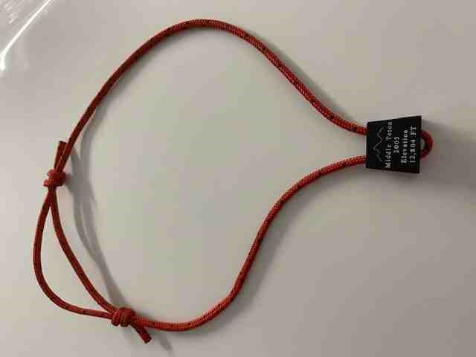
Climber’s Chock
Typically, the climbers slept overnight on the mountain. After arriving at base-camp, pitching tents and eating dinner, Bill would gather the climbing party together and a testimony meeting would be held. There in the snow covered meadows of Garnett Canyon in the shadows, grandeur and majesty of the mighty Tetons, personal and humble testimony of the Savior Jesus Christ and of truthfulness of His gospel would be shared by the youth and adults. Sacred experiences happen on mountains. They are recorded for us in scripture. The testimony meetings conducted by Bill on those Middle Teton Climbs were no less than that…sacred and life changing.
Much, much more could be detailed herein about this Middle Teton climb tradition. It is sufficient to say that each climb and each climber had its own special unique experience. Life changing. As each snowflake that accumulates is different from the other, so are the take-a-ways.
How many climbers did Bill guide to the summit of Middle Teton over those 30 plus years? It is estimated to be nearly 400. Each of them know that what Bill was able to do for them in their own personal lives by climbing Middle Teton was far greater than the 12,804 foot summit achieved.
-Bishop David Toone, Heights Ward

1981 Trek Flyer
The following flyer was provided by BYU for the 1981 Trek
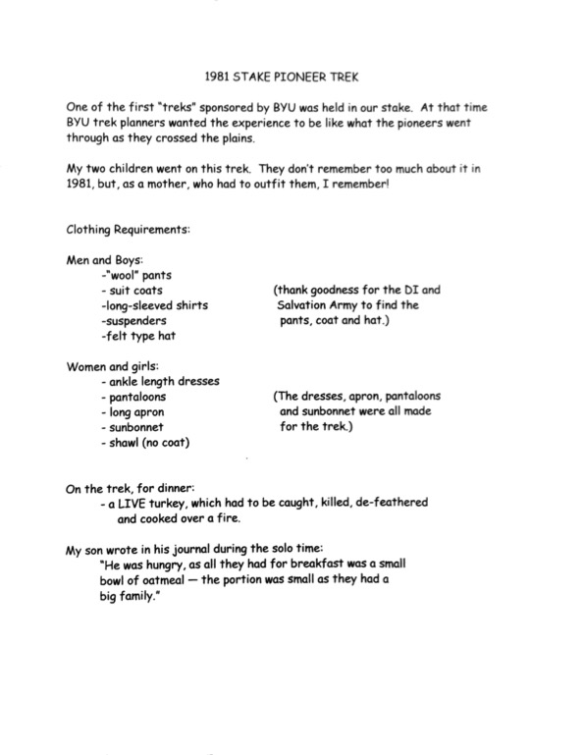

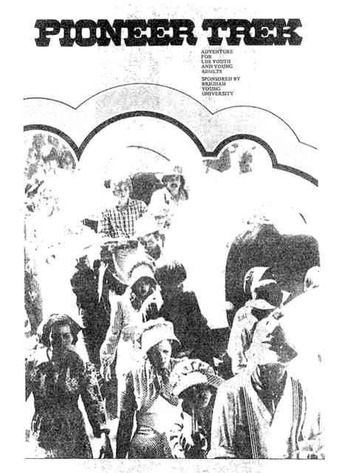

Trek – 1989 Bruce Dibb
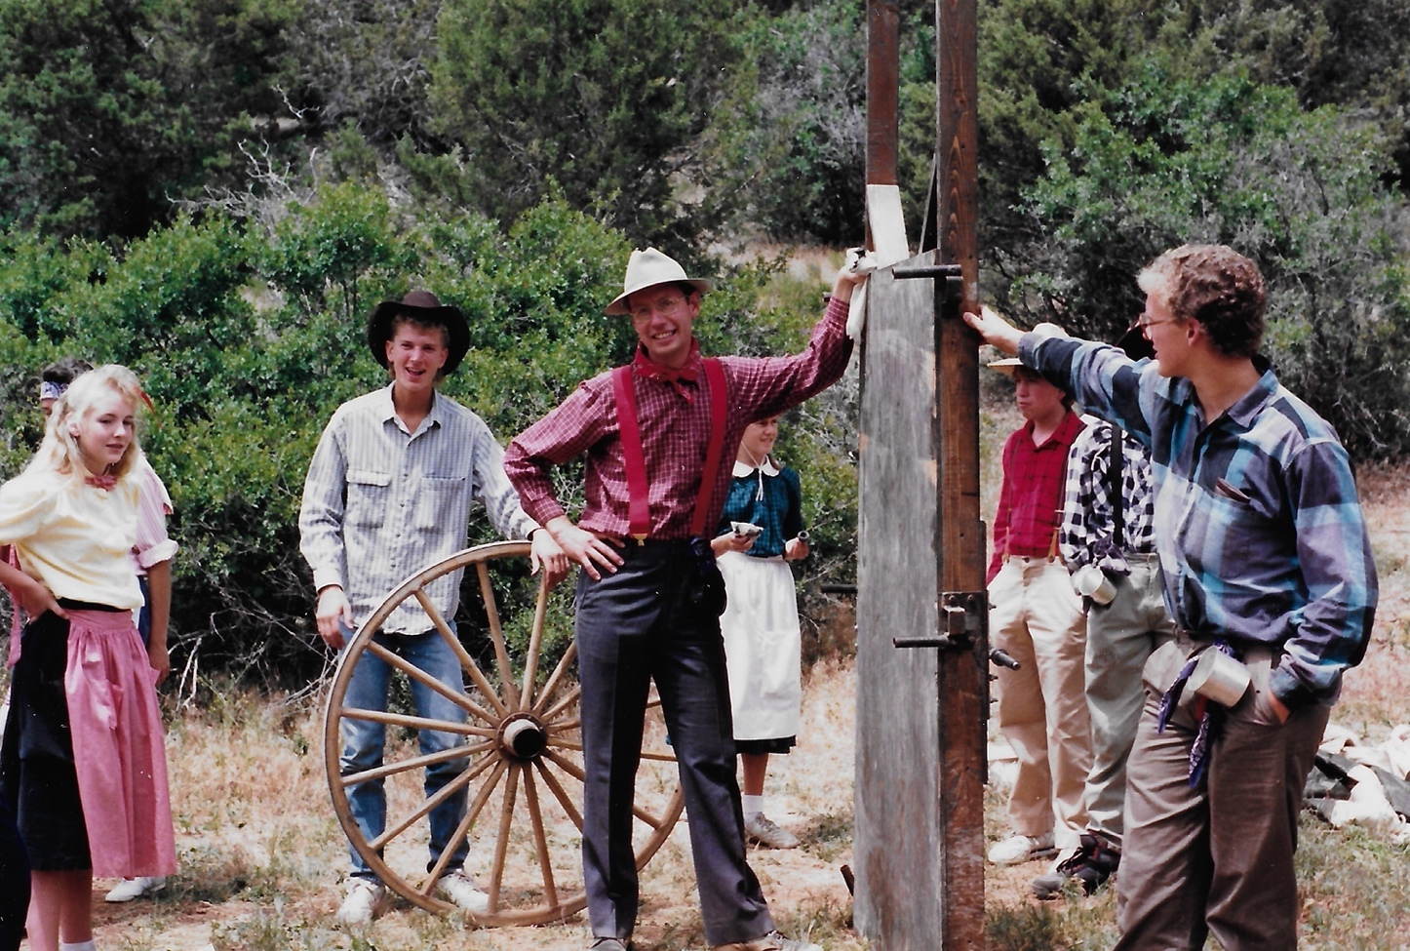

The Miracles of Trek - Pepper Murray
239 youth would leave home and family for a grueling journey through record breaking heat, eating less than normal food, sleeping on the ground with no sleeping pads, no showers, mirrors, toothpaste, makeup, flush toilets, and no running water. Pulled loaded handcarts twenty five miles through rough terrain with people they did not know well or know at all.
We did not pray for moderation of the elements as one would think with the hottest week in history looming ahead. Our stake president was inspired to ask for the courage and ability to face and overcome the elements that would test us, and we did overcome.
Out of 239 trekkers and 44 ma’s and pa’s and 23 support group people we did not have one leave the trek! Not one!
Three days before trek the James family had a daughter fall off a table during our last meeting at the church. Their son called and told them what had happened and that she was not moving, and was that a problem. The night before trek their son had acute appendicitis and was operated on. They still came as a Ma and Pa despite these obstacles.
An assistant trail boss (Barry McCann) was opening a new business on July 15th, yet he still came on scouting trips, training trek, and the real trek with never a complaint of verbalized concern about his business.
Another assistant trail boss (Steve Hobbs) was diagnosed with a large hernia the week before trek. He was fit with a truss and came anyway. He would not and could not be dragged off the trail no matter how miserable he became.
This same trail boss suffered from terrible blisters the first day requiring daily care and taping of his feet. However, he refused to give up, he walked every step of the trail and “Finished the Journey”
44 people, 22 mature couples would leave home, work and family to lead children they did not know for four days, sleep on the hard ground without a pillow and eat food that was much less that than were accustomed to, and never complain.
We had no serious injury despite one girl being run over by a loaded hand cart. She twisted her knee and fell in front of a wheel. Before the wagon could be stopped it had run up over her back and shoulder. Her only problem was her knee which was a problem before she had left on trek.
A handcart wheel broke just at the time our first heat exhaustion problem occurred. This wagon was unloaded and the contents distributed throughout the train just as we found this boy who was sick could go no further. The wagon was ready for him to ride in. His family carried him another two miles to where we had access to support vehicles.
This boy was truly in trouble from the heat. We cared for him for twenty minutes then stood him to walk to where the carts were stopped. He asked how far he would have to go. When he was told one hundred yards to the waiting carts he fell to the earth exclaiming that he would never make one hundred yards. We were two miles from the next stopping point and could have arranged for a support vehicle to reach us, but it would have wiped out the afternoon and we would have cut our first day pull in half. He kept repeating that he needed to go home.
A blessing was offered and given. The promises were so clear in my mind, and the words so forceful yet comforting that he would be healed and be able to finish the journey with his family if he would exercise his faith. He was counseled not to make the decision to leave or not until later when he regained his strength. Within the next two miles he started taking solids and only missed one five mile leg of the journey. He stayed on trek and ended up having a very positive experience.
We were toiling up a ridge in the burning afternoon sun when two large flat clouds drifted in from the west. There were no other clouds around. We exercised our faith and the clouds seem to settle over us and shaded us for almost twenty minutes leaving us after we had pulled the last difficult uphill of that leg.
We were informed that we could not use charcoal to cook on 48 hours before trek started. We were able to round up 14 propane gas stoves within 24 hours. The cooking went very smoothly and actually enhanced the experience by saving hours of cooking time, leaving more for processing and activities.
An errant trekker who chose to leave camp and hike up over the next hill was spotted by “chance” by one of the nurses (Carol Jensen). He was able to be headed off on the top of California ridge, the searchers were all recovered and we continued with our fireside as planned only 30 minutes late.
239 trekkers, 44 ma’s and pa’s, and 23 support personnel were given the opportunity to come closer to Jesus Christ by sharing an experience that induces spiritual sensitivity that cannot be recreated in a church gym, amusement park, classroom, one day service project, or any group or quorum meeting.
There is a track of land large enough to allow treks to occur that reproduces the feelings of real pioneer trekking. Thank you to whomever allowed the purchase of this piece of ground for this “special use”.
During the women’s pull one 18 year old was pulling like a mule, her other four sisters were some help as two of them did not want to be there at that point, and the other two were barely fourteen and small in stature. Three times this girl stumbled in the yoke, and three times she felt a push from behind. As she recovered, she would look over her shoulder to see who had pushed the cart for her and saw no one. She truly felt the prescence of angels.
Another trekker fell with heat illness but recovered enough to pull another mile after receiving a blessing from her Pa.
We postponed the hoedown for an hour and a half because of the heat. After the hoedown we received word that Kelly Brock was having heart surgery in the morning. We took Danny her husband to the gate at Wahsatch, just as Sean Jolley their son in law was coming through the gate in a wild attempt to find Danny. Had they not met at the gate, Sean could have been lost all night and perhaps more wandering around a very large ranch.
Differences of opinion were resolved by stick pulls. The winners and losers were immediately reconciled and there was no further discussion nor whining after that by either party.
239 letters from parents could be obtained, organized and distributed to every trekker for solo. The love and concern expressed in those letters brought families closer together. One young girl exclaimed that she did not know that anyone really cared or cared for her.
The love of the Lord was evident at every turn. His guiding hand was present while allowing us to struggle and grapple with situations and decisions, His loving presence was almost palpable.
Discipline problems were worked out in the Lord’s way, not the way of the world. Direction was given and received in a spirit of love and concern, not force nor coercion.
Solutions to problems and situations became quickly evident as prayers were offered and hearts softened trying to determine and listen to the will of the Lord.
-Pepper Murray

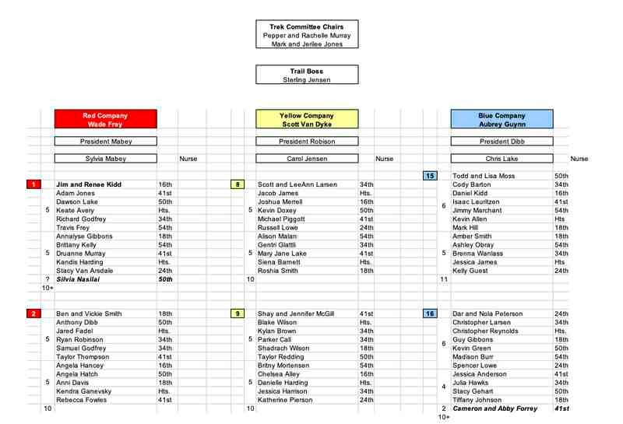
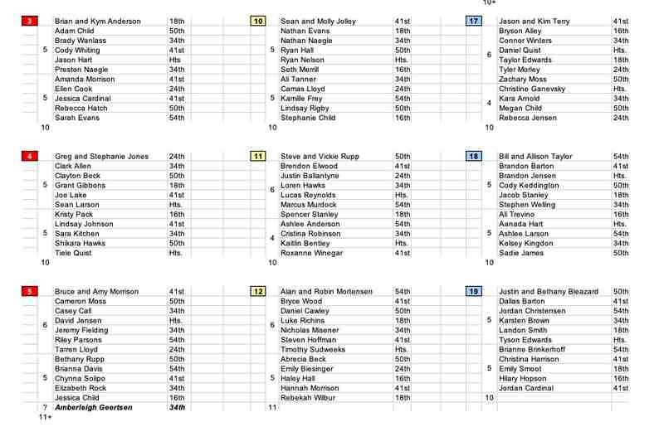
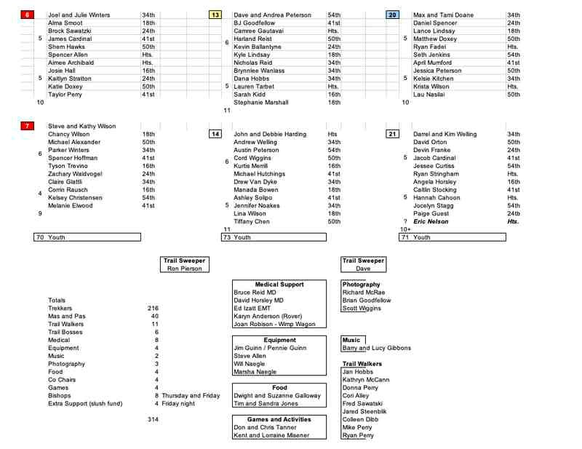

Lessons I learned from Trek 2002 - Pepper Murray
Finish the Journey
- The love that our Father in Heaven has for each of His children and His desire to bless them. He went to great effort and planning to create the earth, the plan of happiness etc. He gave us the ability to gain blessings that would greatly enhance our lives through prayer, fasting, living worthily. However, we must yield ourselves to Him to obtain these blessings. Just as we went through incredible planning and exertion spiritually and mentally and physically to create an environment of spiritual learning and we wanted so badly for all the trekkers to feel of this great spirit, they had to yield themselves and apply themselves to benefit from what was there for them.

- God’s plan is one of agency. We are free to choose good or evil, life or death. Satan’s plan is to obligate and force compliance. Each trekker was free to choose to participate fully and thus reap the blessings that came therefrom or to turn away and miss out on this wonderful blessing of trek.

- God’s motivating influence is that of love. Love can effect change better than force or obligation. It may take longer, but is more effective and of greater power than all the other options.

- It is never too late to repent and come unto Christ. During our last fireside, three days into trek, I felt those who had chosen to participate had really been defined, but as Pres Browning spoke he promised the youth that it was not too late to yield themselves to the spirit of the trek and still come away with a life changing experience. We had just that evening and a half day pull left, but I saw that promise come true as light shone from the eyes of many who decided late to throw themselves into the yokes and give themselves and all they had to the common good of their family. Lives were changed even on the last day.

- The light of the soul truly is the eye. As those women pulled up the hill and came onto the road, I saw eternity and power and strength burning in the eyes of those girls who had given everything they had to that pull and had truly experienced miracles. Ashley’s strength was incredible as I caught of glimpse of the greatness of her spirit as she finished the pull. I saw this in may other eyes at different times during trek.

- The Lord stands ready to bless us if we simply ask and are worthy of that blessing. He aches to give us all that He has and hurts when we turn away and follow a worldly course, yet He will not intervene or obligate us.

- The power of the priesthood is as real a power as any on earth. It is a privilege to possess it and even a greater privilege to exercise it.

- We have a great stake and ward and there are many, many choice spirits on earth at this time striving to live life worthy of Celestial blessings.

- There are many who would answer the call today, just as our pioneer ancestors did to leave home and comforts for the gospel sake. There are men and women on the earth now with faith and noble spirits akin to Eph Hanks, Levi Savage, Jacob Hamblin, Brigham Young, Alma, Nephi, and Samuel. They would rise to the challenge and be victorious over the challenges given them.

- Our youth are for the most part on the right track and growing up in truth and righteousness.

- The veil truly is thin and much activity is going on there on the other side of the veil. They are aware of our presence and many exert their faith on our behalf.

- R. Pepper Murray, Trailboss

Stake Pioneer Trek -
During our solo time, one of the youth in my family failed to return to camp when signaled. The leaders spread out and searched for him. Our family returned to our campsite to pray for his safe return. Soon word came that he had been found. This experience strengthened our testimony of prayer for everyone in our trek family.
-Jolaine Randall, Dry Creek Ward

Stake Pioneer Trek 2018
I have been blessed to be a part of 2 Trek Experiences in the Bountiful Heights Stake. The first Trek was to Martin’s Cove area. This was a special Trek to be a part of. Jim and I had the great opportunity to be Ma and Pa. We had a wonderful experience connecting with the youth. A Highlight of the Trek was the women’s pull and the square dancing. It was also a really neat experience to walk along the same trail that my Great Great Grandfather, John Greenleaf Holman traveled on. He was in the first company of saints that came west with Brigham Young. One day we were walking with Shae Smoot and both of us realized our Great Great Grandparents were in the same company together and then how neat it was that their posterity was walking together along the same trail. It was an amazing experience to feel the spirit of those pioneers that had gone before us and to gain a greater appreciation of all that they sacrificed to come west.
The second Trek was to Deseret Land and Livestock in Wyoming. It took place July 18-21, 2018. I was called as one of the sewing and clothing specialists. It was hard to go without Jim on this
Trek, but I had a great time learning more about the behind the scenes and all that is required to make a Trek work. It was a great experience to get to know the leaders and members of the Stake that I hadn’t had a chance to work with before.
-Andrea Davis, Dry Creek Ward

Pioneer Trek 2002
My wife Carol and I had the privilege of participating in the 1998 trek as Ma and Pa. During those few days on trek and during the training trek just a few weeks before we were blessed to come to know just how much we are loved and watched over by our Father in Heaven. Experiences with our new pioneer children made an indelible impact on our lives and our new expanded family of Trek Children. To this day we still see and celebrate the lives of these great young men and women who have gone on to be parents themselves.
We were humbled to be asked to participate again on trek in 2002, back again at Deseret Land and Livestock. Carol would be part of the medical support team and I along with Mike Perry of the 41st ward would be handling equipment and logistics (water and porta-potty transportation) along with whatever else was needed. We were thrilled for the chance to go again.
I remember heading up to the ranch the evening before trek began after Mike and I had loaded all the trailers with food boxes, camp chef stoves, propane bottles and other general needs for trek. Our idea was to get up there and preposition the equipment, get the water buffalo trailers filled with fresh water and have the porta-potty trailers in position and ready for the start of trek and the first stop location. It was a long busy night on the dark ranch but it was a wonderful night. On the training trek Pepper Murray, the trail boss for this year’s trek shared some of this great knowledge about the ranch as he had worked on the ranch as a youth and he seemed to know every canyon, gully, wash, lake, spring and creek there was. He knew what time the elk would be at a spring, where the deer would tend to be and where we could watch antelope graze if we had a free moment.
When the youth arrived on the ranch the next day we had things organized and ready. The families headed out on their way behind the Trail boss just after lunch. As the day went on the trek families moved on and pulled together and all seemed to be going well. As we had a large suburban Carol was driving the medical vehicle behind the group out of their sight but within range if there was a need for immediate help. The medical personnel treated the normal blisters, chafing, stretched and extended muscles throughout the day and were doing an amazing job keeping the families moving forward. Mike and I were busy keeping the families topped off with cold water, moving the potty trailers and helping to get things set for where they families would bed down for the night. At one point when they were in the middle of the women’s pull, which was around dusk, all you could hear was the creak of the handcarts, the clank of the steel rim of the handcart wheels as they hit rocks, and the sounds of exertion as the sisters pulled the handcarts through the ranch. It was a sight to behold. Not long after that I was returning from filling up one of the water buffalo’s and there was a call on the radio that we had a young woman who had collapsed from exertion and heat. That is always a concern. As support staff Mike and I had two radios. One radio that was tuned into the Trail Boss and Company leaders and medical staff. The other radio system was for the behind the scenes support staff so Pepper could make any on the trail changes or relay any important or emergency information that needed immediate attention. I remember getting a call on that radio system that the young woman who had collapsed was one of my daughters. My heart was full of emotion as I thought about that. I hurried as quickly as I could to get to the evening stopping point where they were going to take her to get her food and water and work to get her the attention she needed.
I recall very clearly as my truck neared the stopping point where my daughter was now seated in a chair and being attended to by medical help and her trek Ma and Pa. I could see that she was being helped. At that moment I had a very clear impression or thought that came in to my mind. The thought was conveyed with a feeling of love and concern and was, “Now you know how I feel. I send my children out on this earth to trek forth and I trust that you will watch over and care for them as I would if I could be there.” I think I just sat there in my truck on the road for a few moments thinking about this experience. I had clearly had one of those moments where I had a glimpse of how our Heavenly Father feels.
One last trek story. In 2006 we again participated in trek. This time I was the Trail Boss and Pepper and Rachelle Murray and Mark and Jerilee Jones were the Trek Chairpersons. Carol came along again as the ever important medical crew, this time walking. When we arrived up on the ranch our suburban (another trek and red dust coating) would not start once it had been parked. This was not good as it was again the emergency vehicle to pick up ill or injured trek participants. I remember opening the hood and just looking at the engine and checking the battery and other components and just having this prayer that went something along the lines of “Heavenly Father, we really need this vehicle to work without any problem. I can’t see what is causing the problem but I will just have to trust that things will work out.” After the trek families were organized we headed out and to my joy, the suburban started and we did not have any problems with it during trek.
Two weeks later we took our family on vacation up to Jackson Hole and Yellowstone. On the third day of vacation I got up early and went to go take care of some work in the area. On the way the same suburban we had on trek started having problems. I managed to limp the vehicle into the Chevrolet dealer in Jackson Hole as they opened and they took a look at it. The service technician came back and commented that the battery and alternator were shot and he wondered how we made it up there. He stated that it looked like the parts had failed two to three weeks ago. He then went on to break the bad news that they did not have an alternator in stock for this specific model of suburban and that it would take 2-3 days to get one delivered and installed. I knew it would be a long walk back to the place we were staying but it was vacation and I had time. Within about 5 minutes a truck from the dealer pulled up by the sidewalk I was walking on and called to me. As it turned out, somehow in the delivery of parts received the evening before there had been an alternator that matched our vehicle loaded by accident in the shipping container. If I would jump in the truck the driver would take me back to the dealer were I could wait for them to finish installing the new alternator and battery.
It is a car story but it goes to show that our Heavenly Father is very aware of the great things that happen on trek and that he blesses those that go along as support staff. I will always fondly remember Pioneer Trek in the Bountiful Heights Stake.

Sterling N. Jensen

Service

2021 Service Project - Pierce Property
1675 W Crystal – WVC
There were 2 wards who helped with this project: The 24th Ward led by Jesse Larsen and the Canyon Ward led by Bruce Morison. LaVee Pierce is an older lady who cannot take care of her yard anymore. She has a handicap ramp that needed to be sealed. They finished sealing the railings and the balusters. Then they ran out of the sealer. This project will be completed the week of June 28 by one of the OMH volunteers.

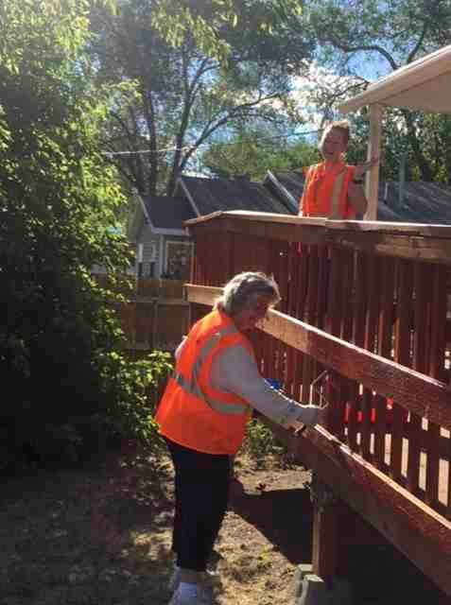
Earlier in the week, a large tree was cut down. One of the biggest branches had fallen off of the tree and almost hit a car. The ward helped cut the tree into pieces and put them in the dumpster. They emptied and removed an old shed, piles of wood, and lots of debris in the back yard. In the process, 3 baby kittens were found under a piece of wood. They put them in a box hoping the mother would come back for them, but she didn’t. The kittens were taken by Joyce and Scott Harker. They gave them to their mama cat who promptly started nursing them. Steel poles were pulled from an old fence on the property as well. The dumpster was filled to the top with debris. This will be an ongoing project because there are several more trees and sheds that need to come down.
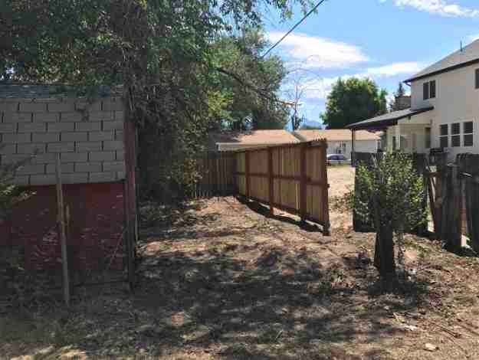
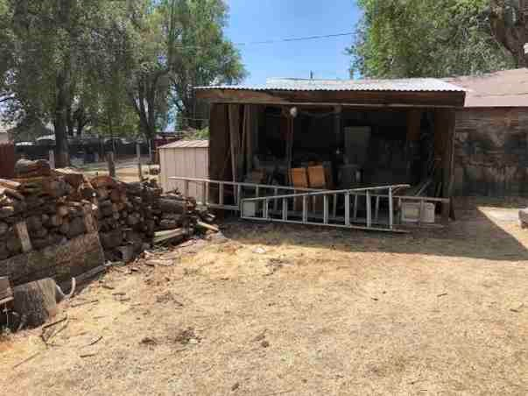
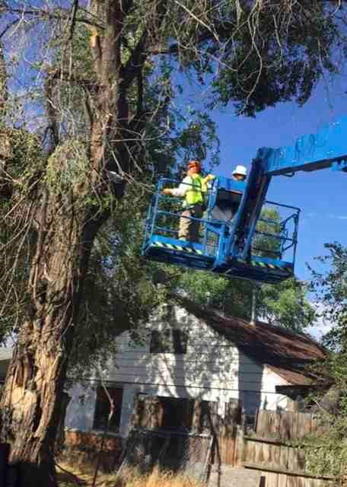
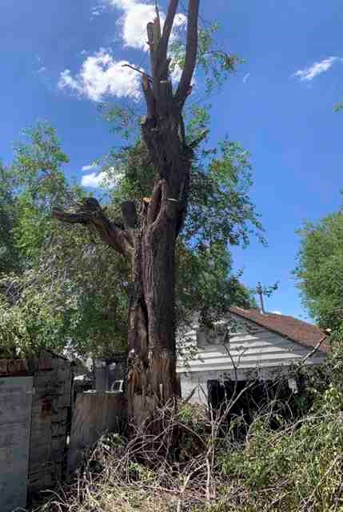

2021 Service Project - Hardman Property
Hardman Property – 1450 W Parkway Ave. WVC
This project was completed by the Heights Ward led by Steve Barnett. Mont Hardman is the kind of man who helps everyone else before he takes care of the things that he needs. The Heights Ward helped by rototilling the front yard area. They pulled weeds and cleared the east side of the lot between the house and the fence. Large rocks were placed in a pattern throughout his garden area. Pavers were added as a front walkway. Brother Hardman is very grateful.
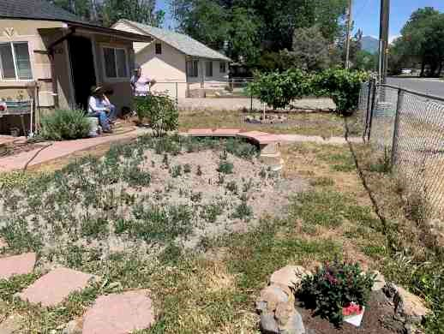
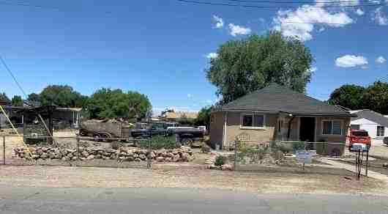
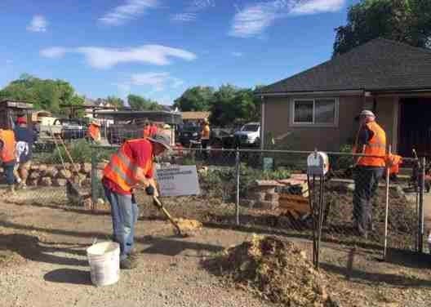
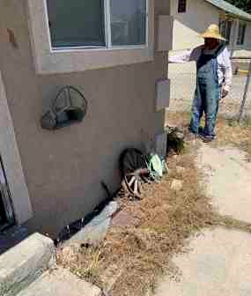
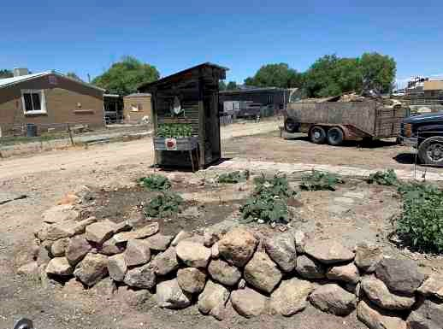
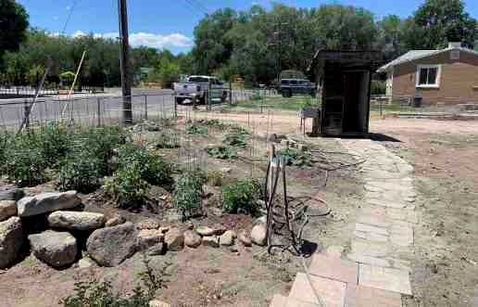

2021 Service Project - Scott Property
– 1622 W. Russett Ave. WVC
The Scott project was completed by 4 wards. The 50th Ward led by Jason Lloyd, the 54th Ward led by Rodger Peck and the Singles Ward. Other people who helped at the Harward project also came here to help when they were finished. This was a huge project.
The area on the east and west sides of the garage were scraped. The front yard and triangular area next to the driveway were scraped by a My Home Town volunteer. Then the dirt was leveled. Weed barrier was put down, and then covered with gravel. The homeowner’s son, Chris, brought the gravel and pushed it close to where it needed to go. In the front yard, after the weed barrier was put down, plants were placed to be planted. Then a drip system was installed to keep the plants watered. A timer was attached to the spigot which caused the faucet to leak. Someone came back later and replaced the faucet so that it doesn’t leak. Gravel was carefully placed in the area around and between the plants with other rocks placed in a pattern that looks like a path. The triangular area had two junipers planted in it and then petrified wood and drift wood were arranged artistically with some other things that the homeowner had.
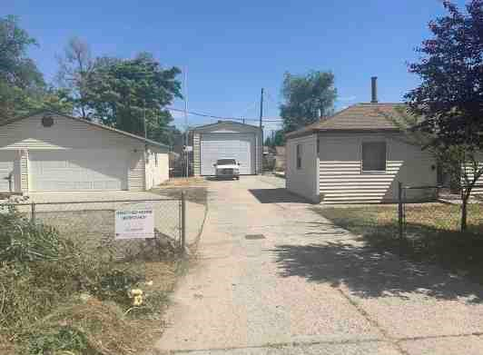
Before:
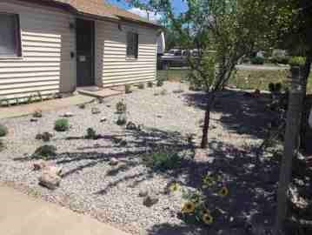
After:

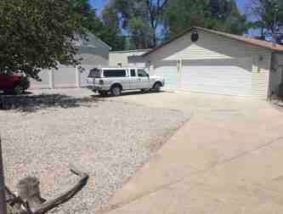
After
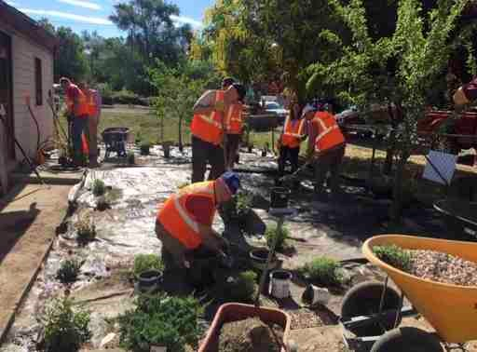
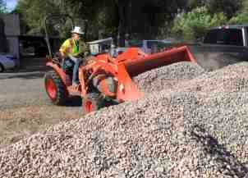
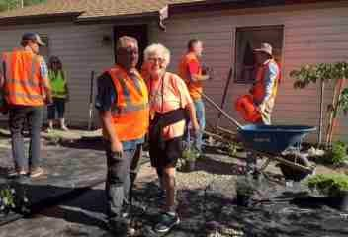
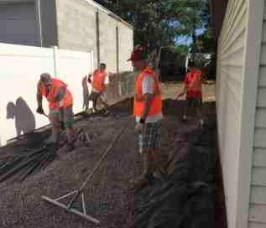

2021 Service - Hernandez Property
– 1621 W Shelley. WVC
The 54th Ward led by Rodger Peck also completed this project. Guadalupe was afraid that branches were falling and damaging property and maybe even her children. Several old trees were cut down ahead of time.. The ward used chainsaws, etc. to cut the wood into pieces and then haul it into the dumpster on site. Other debris such as an old oven, bookshelves, tires, etc. were also hauled away. Its nice and neat! Thanks to the 54th Ward!
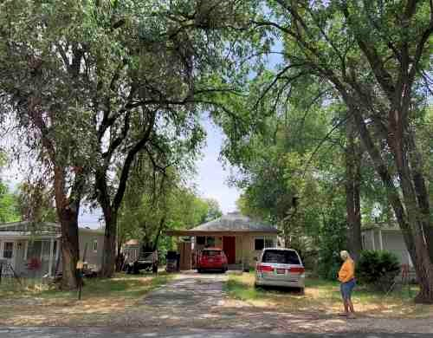
Before
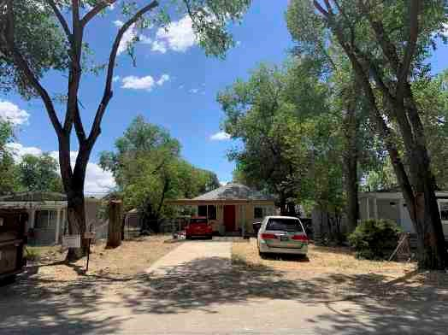
After

2021 Service Project - Radmall Property
– 1509 West Claybourne Ave. WVC
The Canyon Ward led by Bruce Morison completed this project. They used an auger to dig 7 post holes 24” deep. The homeowner showed them where to dig the holes. The owner will complete the fence. A tree stump was also removed along with some t-posts by Paul Ballstaedt and his Back Hoe. Paul also helped with trees at the Pierce and Hernandez properties.

Personal Stories

Mary Alice Galt, Dry Creek Ward
Stake Pioneer Trek
I went as medical person, I slept alone in the back of someone’s SUV. Took people off the mountain three times. First a girl who sitting under cart for shade and hit her head, supposedly every time she stood, she would pass out. Second, someone who hurt her ankle and parents wanted her brought down. Third, a young man who got heat exhaustion and we could not get him to warm up. He, on the last day, met his Trek Family at the end of the trail.
Stake Service Projects
Kaysville Mill, Centerville Dry Pack, Stake Farm in West Kaysville, etc:
At the Centerville Dry Pack, I thought it was interesting that there were so few people from the stake there. Back at that time, I heard a lecture from a lady who taught preparedness in her area and she said that less than 20 % of Church members had years’ supply.
Kaysville Mill was interesting. Once we sorted and blighted beans and when no one came to relieve us, we just had to leave. I remember packing meat in Lehi. We were able to purchase some of what we packed. Again in Kaysville, we just checked for labels or packed in boxes.
1983 Flood:
I remember during the floods of 1983 how on 400 North there were walls of sandbags placed in the road to direct the flood waters. I remember going up there and seeing people standing in cold moving water and thinking Angels must be watching over them. The people could have easily been knocked over by fast moving water or suffered cold injuries.
Faith in Jesus Christ:
My dad collapsed while working up at the temple. He was admitted to Lakeview Hospital. The next day we called and asked for a blessing. I think it was Arlin Swain and Val Randall that came to give him a blessing. As the blessing was being given, the room felt crowded. The only ones in the room were three family members, Val and Arlin and it felt like Heavenly Spirits.
- Mary Alice Galt, Dry Creek Ward

Barbara Webb, Dry Creek Ward
Service Projects:
Making time for these service projects was always hard. But as I did, I knew I had the opportunity to help those in need, plus working beside friends and neighbors and meeting new friends from other wards was special. I always came away with a warm heart knowing my time was well spent.
1983 Flood:
In May 1983, we were having many days of heavy rain, the creeks were running full. On May 31st, many of the wards in our stake were hit by flooding. That night my husband was standing watch late at night at 400 North and 700 East. The thought came to him that he should walk east up the hill, which he did. After walking about 200 feet, he heard a loud roar like a locomotive engine and when he looked back a huge wall of water came crashing over the street near where he had been standing. So many homes were flooded and a few destroyed. For weeks people came from near and far to help.
- Barbara Webb

Anonymous
How long have you lived in the Bountiful Heights Stake? Since it was organized.
-Can you share a faith promoting story or experience that helped you increase your faith in Jesus Christ?
I feel that living in the Bountiful Heights Stake and partaking of all that this Stake has offered me is as close to being in Heaven and belonging to the “Heavenly Stake” as can be.
All the Stake presidencies, all the saints in the Stake have helped my testimony grow over the many years that I have lived here and I know that this is the church and gospel of our Lord and Savior Jesus Christ.
I have not participated in making this Stake so Heavenly other that almost alway being there and being blessed to take all that is said and all that is done (I have helped with projects) in to the growth of my testimony.
I have enjoyed so much the Christmas dinners and entertainment for the seniors. Wonderful and beautiful–so uplifting. Just living in this heavenly stake has made all the difference. I have been blessed.
- Anonymous

Greg and Stephanie Jones, Dry Creek Ward
How long have you lived in the Bountiful Heights Stake: 23 years
We have had the blessing of participating in Stake Youth Treks held at Deseret Land and Livestock near Evanston, WY in 2008, 2012, and 2018. Our testimonies of sacrifice and service have grown as we have witnessed the dedicated service of so many adults preparing for Trek and serving as Mas and Pas to Trek Families. The Bountiful Heights Stake has a tradition of holding well planned Treks that provide numerous spiritual experiences for the adults and the youth participating.
One humorous event that we recall happened during the Trek in 2018. After a long day of pulling handcarts in hot and dusty conditions, the Stake Presidency called a testimony meeting. The entire company assembled in a large grass field, gathered into family groups to participate in the meeting. President Lake conducted the meeting and called on several youth to come forward to share their testimonies. President Lake followed the Spirit in selecting those to share and no advance notice was provided to the youth invited to come forward to share their testimonies.
As the name of one young man was called, all young men gathered with one particular family jumped to their feet in unison and sprinted the considerable distance between the meeting location and their tent to “awaken” their Trek brother who had decided that catching up on sleep was better than attending a testimony meeting. The young man’s name had been called by President Lake and it was his turn to share his testimony. With the entire company looking on, the young man was roused from a deep sleep and escorted to the meeting by his Trek brothers. Of all the testimonies shared that afternoon, we remember his the most. He shared recent life experiences and experiences from Trek that had impacted him, helped him to feel the Spirit and begin the foundation of his testimony.
- Greg and Stephanie Jones

Valentine’s Dance – Dave and Jennifer Haygood
We moved into the 24th Ward of the Bountiful Heights Stake in the summer of 1975. It was the Stake Valentine’s dance either the next February or the one in 1977 (can’t remember for sure) that we were invited to go with Jim and Dianne Barlow, another new couple in the ward. We’re not real dance aficionados, but we liked music and friends, so we were happy to go. Interestingly, there were five other couples (Mel & Marlene Bennett, Allen & Elizabeth Madsen, Dan & Janice Sims, Ken & Sue Johnson, and Keith & Kathy Harding) who were also there as fairly new members of the ward. Throughout the evening as we recognized the other couples, we invited them to sit with us at a table when we weren’t dancing. It was so fun getting to know each other better. Also sitting with us were Ed & Jane Cox, a more mature ward couple. As the dance was winding down, Janice Sims invited us all to their house for dessert.
While we were enjoying the refreshments, Jane Cox suggested that we consider getting together as a group on a regular basis. She said they had done that when they were a young couple and made lifelong friends in the process. We took them up on the suggestion and had dinner parties every month for more than 40 years and even a few vacations together. Fairly early, some people moved out of state or got busy with other adventures, but we kept going, adding Mike & Jani Lamb, Lynne & Patsy Mercer, and Dan & Julie Gill along the way. What a great blessing this group of friends has been to each other and it all started at the BOUNTIFUL HEIGHTS STAKE VALENTINE DANCE!
- Dave and Jennifer Haygood, Dry Creek Ward

2018 Valentines Dinner Dance

Committee members:
34th Ward: Robert & Rachel Nicholas
54th Ward: Jacob & Amyra Black
Ward Canyon Ward: Russ & Camille Duncan
50th Ward: Lynne & Lanette Pettit
18th Ward: Ryan & Lezli Smith
Dry Creek Ward: Adam & Tina Anderson
41st Ward: Brian & Caroline Schlofman
16th Ward: Alex & Brittany Knudson
24th Ward: Jason & Caprice Martin
Heights Ward: Scott & Jenna Smith
8th Ward: Kim Jones & Mike Moyes
High Council: Henry Liston
Jenna Smith (Heights Ward) was the photographer.
The catering company was “As You Wish Now"
The DJ was Jim Guinn (34th Ward)

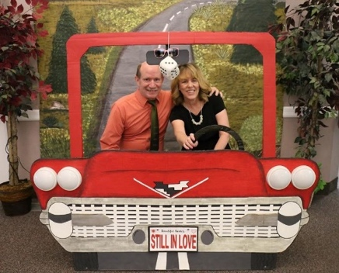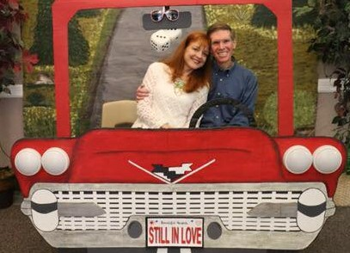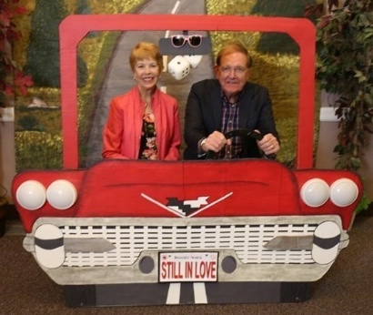
Phil and Jill Turner Roxayn and Dale Weathers Rodney and Marcia Ford


2020 Valentine’s Dance

Committee members:
8th Ward: Daniel Furner, ticket sales, Music
16th Ward: Carla and Trevor Wirth – Food, Table Décor
18th Ward: President Barry Gibbons - Music
34th Ward: Michael and Patty Hatch -Photography
54th Ward: Jimmy (MC) and Stacey Walton
Dry Creek Ward: Cameron and Jenni Halverson- Committee chairs
Heights Ward: Les Paskett – Publicity and Printing
High Council: Evan Thomas
Catering company: Home on the Range
Skylar and Kristi Goff – Set up

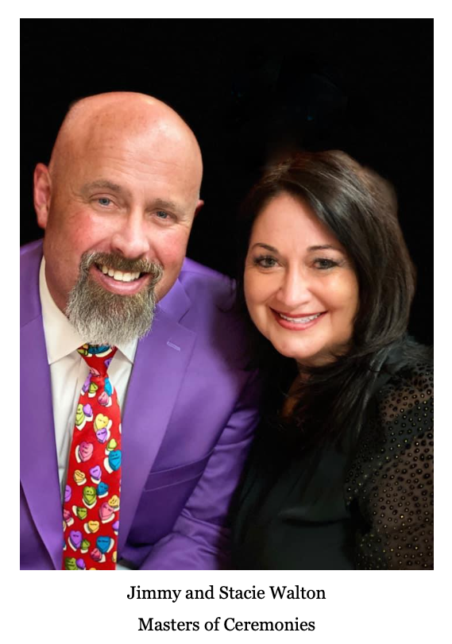

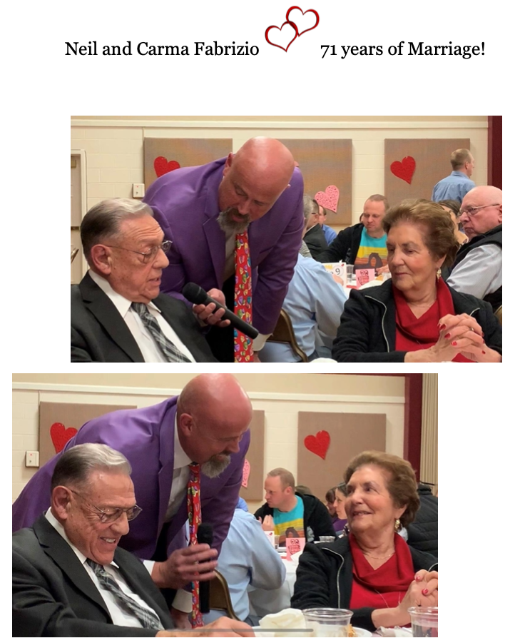

Robert and Marsha Bradbury, Dry Creek Ward

How long have you lived in the Bountiful Heights Stake: 37 years
Stake Pioneer Trek
(Robert) Marsha and I were a Ma and Pa on Trek. It was a year that was unusually hot, so we couldn’t have open fires. We couldn’t cook with briquettes or bonfire–could only cook with propane stove, the Trek experience was great, the Spirit was great, our family was the best.
Stake Girls Camp, Camp Piuta, etc
(Marsha) I had so many opportunities to attend stake girls camp, usually at Piuta; loved these opportunities. So many great activities, campfires, testimony meetings, skits, etc. I was there many times between 1996-2003.
Stake Sports (volleyball, basketball, softball)
(Robert) I played softball for the 24th ward every year until two years ago. Met some really great people.
Stake Service Projects
(Marsha) One of my favorite callings was when Robert and I were called to serve at the care center. I was able to serve both in the Relief Society and the Primary. Those members taught me so much about handling life’s difficulties with grace and humor and LOVE. They had such strong testimonies and were always so cheerful! Rob and I both grew so much during the five years we were able to serve there.
Gratitude
(Marsha) I especially loved the opportunity to serve with my husband in the special needs
Institute program which we taught on Tuesday evenings at Bountiful Junior High Seminary. We grew to love those students and felt their love for us and we still have connections with so many of them.
Faith in Jesus Christ
(Robert) Most of my callings in the ward/stake have been with the scouts. The most faith promoting experience happened at a BSA Wood Badge course. There was no specific thing that happened as far as faith promoting, but the people I worked with left me with the feeling working Scouts was what I needed to do. I knew it was what God wanted me to do. I have worked with the Scouts for 35 years. Through the years, we have snowmobiled Yellowstone, snowshoed at Grand Targee, Park City, Snowbird, Brighton, and Nordic Valley. We’ve water skied at Pine View, Willard Bay, Flaming Gorge, and Lake Powell.
We’ve shot shot guns, rifles, rapelled, rock climbed, camped all over the state. We went to the BSA Big Event for at least 30 years. Besides the Scouting events and the week night activities, I feel that Scouts and the Scout activities brought many boys in to the Church or strengthened them in the Church.
Scouting is the most spiritual thing I have done in the Church.
The other faith promoting experience would be Special Needs Institute–seeing and feeling the faith of the special needs students increased my faith; this experience was an amazing experience for me.
- Robert and Marsha Bradbury

Ralph and Brigitte Wilcox, Dry Creek Ward
We moved into the 24th Ward in April 1967, so we were here when the Bountiful Utah Heights Stake was organized in 1971. It was an extra special experience for us as our next-door neighbor, Joe Cutler, was called as the Second Counselor in the new Stake Presidency.
We have experienced many things over these 50 years that are worth mentioning. We will note here, just a few of them:
1. When the heavy east wind tore through Bountiful on Thursday, December 1, 2011, there were trees and power lines down virtually all over the city. (The power in our neighborhood was out for 3 days.) When we went to Church on December 4th, we had a very brief Sacrament Meeting. Bishop Jones announced that we were dismissed with the plea that all able-bodied people were to come with chain saws, shovels, rakes, brooms, etc. to help clean up areas in our Ward. The younger ones and the older ones were encouraged to help provide food and water for the workers. This Sabbath Day became a day of hard work and great accomplishment.
We became aware that all of the Stakes in Bountiful were involved in the clean-up project. The turnout was absolutely amazing. Members came with all kinds of equipment. Contractors came with trucks, loaders and other heavy equipment that they donated to the cause. The Bountiful Landfill soon became so crowded with rows of trucks and trailers to be unloaded that we turned to every large piece of property available and began to systematically dump the trees and debris in those areas. Many of us remember Turkey Shoot and other ballfields stacked fence to fence with debris from the cleanup effort.
I may misquote then-Mayor Joe Johnson , but I seem to remember him saying that the city-wide cleanup effort by the Church saved Bountiful City hundreds of thousands of dollars.
This operation was a very moving and memorable time for all involved. This experience has helped us with subsequent major damage from wind storms and other natural disasters.
- Some may remember that our Stake provided the space for a "Regional" Family History Center at the 34th/54th Ward Building. The Center was dedicated by President Randy Browning on April 16, 2000, and Jon Bouwhuis of the 24th Ward was called as the first Director of the Center.
- We don’t remember the year, but we sure remember the very moving experience of the 2000 Stripling Warriors marching in the Bountiful Parade. Special accolades go out to those folks who planned and carried out that project. We believe that all of the participants will remember this the rest of their lives.
- Our Stake was one of eight Stakes called to help the Baptists build their new church housein our back yard. At first, the members of the Baptist Church came eager, but ill-trained to build a church house. Dora Flack of the 24th Ward and others began to provide lunch for the workers. It became evident that the Baptists workers were struggling to make any progress. It was then that I (Ralph) was given a High Council assignment to oversee the efforts of the eight Stakes who participated in basically finishing their building. The service our stakes provided helped bring better relationships to all involved.
- We were called by President Ralph Mabey on a Church-Service Mission to the Bountiful Food Pantry on June 26, 2005. We held that assignment for 6 years and 9 months. During that time many Wards in our Stake provided people to help at the Food Pantry every week night. Through the request of President Mabey, our Stake members donated $8,000.0 for a walk-in freezer for the Food Pantry.
- Ralph and Brigitte Wilcox

Jed and Patsy Spencer, Dry Creek Ward
We have lived in the Bountiful Heights Stake for 21 years.
Stake Pioneer Trek:
We had the opportunity to participate in Pioneer Trek twice: in 2010 as a Ma and Pa and in 2018 as members of the Food Committee. Both of these Treks were held at Deseret Land &
Livestock.
Jed: We agree to take four days out of our summer to walk the dusty plains of Wyoming with no technology or contact with the outside world, just so we can feel the spirit. It turns out to be one of the best things we have ever done.
Patsy: One of the most amazing things about Trek is the incomprehensible amount of time and effort that goes into planning, organizing and executing the event. So many wonderful people are so willing to volunteer many, many hours of their time, provide resources at their own expense, and share an incredible amount of talent to make Trek a success. All these things come together to create an amazing, powerful experience for everyone involved. The spirit of Trek is unique and so special. I believe our Stake is very good at doing Pioneer Treks because the people here are so amazing.
2010 Trek - as Ma and Pa
Jed: The training and preparations were very well done and turned us into a tool for the spirit. We did the best we could as Ma and Pa and the spirit filled in where we lacked. Being a Ma and Pa on Trek is overwhelming, but the training and the effort they put into it to try to make a good experience for the kids makes a big difference. The spirit just comes in and “Wow!” It’s amazing.
Patsy: I have several specific memories of Trek that made it special for me. The preparation itself was an amazing experience. Attending the temple and fasting with the Trek Committee members just before Trek began was very special. Evan Thomas and his wife, from the 24th Ward, were acting as Ma and Pa. Evan was diagnosed with pneumonia just days before Trek was to begin. When we held our fast the Sunday before Trek, Evan was included in our prayers. I will always remember the special spirit when we gathered that night to kneel together as we concluded our fast. And our prayers were answered. Evan was able to attend and participate in Trek! The first miracle!
Meeting our kids was also memorable. The comradery and closeness developed by the families is really special. We loved our kids right off the bat. We had a young woman visiting from France in our family. All the boys were very intrigued with her. Every time we stopped for a break on the trail, our handcart was soon surrounded by young men wanting to talk to the pretty french girl.
When we were just getting started, seeing the entire company kneel in prayer as President Mabey dedicated our trek was especially poignant.
It rained and rained the first night and everyone had to sleep on the ground under tarps. One young man went sleep walking during the night and went around pulling tarps off people,
which, of course, caused some upset.
I really enjoyed watching the Stake Presidency interact with the youth. The field games were particularly fun to watch. I will never forget the look on the face of one of our kids when he found himself cornered by President Mabey and President Dibb during a tag-type game. It was hilarious. The Stake Presidency and High Councilors made up a team for the field games and they were tough for the kids to beat.
Our son Josh participated in the 2010 Trek. The experience changed his life. This is what he shared about his experience:
Trek changed my life. Before trek, I had been inactive from the church for nearly a year. I can honestly say that trek was the place where I became truly converted to the Gospel of Christ. The spirit was so strongly felt all throughout trek. The Hand of The Lord was in everything we did. The experience of being put into a family where no one really knew me was amazing. I realized that I could be whoever I wanted to be. I chose to put all my faults and fears behind me and become who I wanted to be. I then took this new person that I became and kept going with it after trek. The love I had for my trek family by the end of this adventure was so amazing. They were my brothers and sisters. Many of them I am still in good contact with and are very dear friends to me. We all grew so close together and I will always remember each one of them and how much they impacted my life. Before trek I was lost, but Christ sought me out by using his servants to bless my life and invite me to come back to Him. I gained my own testimony on trek. I know that JESUS CHRIST Lives! I know that he loves me and all of his children no matter what, and I know that He is mindful and aware of me and all his sheep. I was a lost sheep and He found me.
2018 Trek - Food Committee Members
Patsy: Serving as support for Trek is also an amazing experience. It is very different than serving as a Ma and Pa, but the spirit is just as strong and powerful. That very first day when we were meeting the other support people, I was immediately struck with how close I felt to them so quickly. It really brings people together in amazing ways. We worked hard on the committee. We worked late into the night and rose early each morning to make sure the kids were fed and ready to trek. Our committee was smaller than it should have been because some members had to cancel at the last minute. Many others were willing to step up and take up the slack. It all worked out great.
The women’s pull was a very different experience for me this time. I was asked to walk along with one of the handcarts and be there to help if needed. Since I was not having to focus on pulling the cart up the hill, I was able to observe how the experience was affecting others. I was especially touched with how the men and boys were affected. Even the support people, who did
not have families of their own struggling up the hill, were emotional and prayerful for the ladies on the pull. It was very moving to witness.
We also had our own loaves and fishes miracle. The plan was to serve pulled pork sandwiches for just one meal. But, we had so much left over, we decided to offer it again for another meal. However, we only had a limited amount of barbecue sauce to top off the sandwiches. Rather than leave the sauce on the table for the kids to serve themselves, two of the committee members stood by with a bottle of barbecue sauce each. They would squirt the sauce onto the sandwiches for the kids. We only had two bottles of sauce, but those two bottles kept providing sauce for each and every kid who wanted some. The sauce should have run out long before the line of kids ran out. It was a miracle!
Windstorm of 2011
Jed: The wind caused so much damage and there were many trees down. Everybody came out and helped clean up the yards. Literally, in two or three days we had the entire stake cleaned up. It was neat how people helped each other and cleaned up the yards - as if it were their own yard.
Patsy: The windstorm was awful, but working together side by side to clean up the mess as quickly as possible was an amazing experience. I remember attending sacrament meeting in my jeans because we knew we would be heading out to start cleaning up right after the sacrament. It was wonderful to see so many people helping one another. And the many trucks that were provided by members of the stake to transport the debris was also amazing. That was a very different Sabbath day, but a very special one. There was a sweet spirit present as we worked together to help our neighbors.
Stake Girls Camps
Patsy: I participated in two Stake Girls Camps.
2008 - Heber Valley Girls Camp
I was the ward camp director for this Girls Camp. I really enjoyed getting to know Andrea Peterson who was the Stake camp director. She did a fabulous job getting us organized and ready for camp. The facility was really nice. The cabins were great, and it was awesome having showers. I remember the girls having a lot of fun canoeing. There was also a special fireside by President Harding (and his wife, I think). I do not remember what was said, but I remember there was a very strong spirit there.
2012 - Piuta
My journal says “Piuta is beautiful, but our camp has a lot of flies!” Those flies were making us pretty miserable. Some of the leaders went into town and bought fly strips, bug candles and an electric hand-held bug zapper (which turned out to be great entertainment for everyone).
They even bought some mosquito netting.
They brought in a special ropes course and climbing wall for the girls to use. They were a hit and we even witnessed girls who usually shied away from such things find their courage and make it all the way to the top! Seeing these young women grow and stretch is a wonderful thing to
behold.
They had a special fireside featuring Jill Stevens who is a former soldier in Afghanistan and former Miss Utah. She shared wonderful, inspirational stories and many lives were touched that night, including mine.
Sons of Helaman March
Our two sons both participated in the Sons of Helaman March. They really enjoyed the experience. We still have their staffs propped in a corner at our house. What an impressive sight those 2000 young men were! We have framed posters made from photos of the march hanging in our sons’ homes and at Jed’s office. It is a great conversation starter for those who are unfamiliar with the story or the event. And, it is a good reminder that They Did Not Doubt!
Other
I have a special memory of attending a Stake Temple night a year or two after we moved into the ward (approx. 2001 or 2002). After the session, we met back in the chapel to hear a message from the Temple President. I do not remember what was said, but I remember how powerful the spirit was that night. After the President finished his remarks and sat down, no one moved or said a word. Everyone just sat there. We did not want that amazing feeling to end. It was very cool!
What We Are Most Grateful For
Jed: I am most grateful for the resources and support the ward members provided to the scouting program. We were able to do amazing things and provide many wonderful opportunities for the boys because so many were willing to share their time and resources.
Patsy: We are blessed to live among such wonderful people who are amazing examples of charity and service.
- Jed and Patsy Spencer

Burnham Family - Crystal Burnham, 16th Ward
We moved into the stake 29 yrs ago, into the 16 Ward. Dennis, Crystal, Leah, David and Anthony (Tony) Burnham. Marvin Gardner was the bishop when we moved in. We have since had the following bishops: Ralph Benson, Ron Hardy, Gary Meacham, John Alley, Justin Shaw and Jason Burningham. The one thing that needs to be said about the 16th ward is how service oriented it is. The people are very Christ like in their commitment to blessing the lives of others. We have had occasion to need that help more than once and the 16th ward has been there every time to assist us. My sister, who lives in Tennessee, has often stated that she wishes her ward were like ours. I have told her many of the things that have transpired and she is amazed. I have never lived in another ward like this one and hope to die in this ward. My husband, Dennis, passed in September 2020 and once again I have felt the blessings of this ward family. I truly believe it is a family. The Lord wants us to be more like him as we progress along life’s highway and this ward has shown their love and commitment to the Gospel of Jesus Christ.
- Crystal Burnham

Dwight Galloway Assigned to the SA Ward
This has really been an interesting year; this is part of my personal story and that of a High Councilor.
About the second week in March, I had an emergency root canal and so had to be in the dentist chair, as the dentist was wrapping up and I was able to use my mouth again. I said, in continuing our conversation about Covid and what was happening... “I am not sure if you are LDS or not, but this (meaning what was coming) will bring new meaning to the term “home centered” approach. Neither he nor his aid said anything, but I wonder if they reflect on that conversation like I do. Little did I know at that time what was coming, but for me personally it was going to be an exercise in faith....
A few days later I was cleaning off my desk and taking my computer and monitor home as I have been working from home ever since. This was between the second and third Sunday in March. I spoke in the Ward Canyon Ward on the second Sunday that month and from there did not speak again until July.
I found that sitting outside in the sun provided personal peace through these times. I was contacted by President Lake about distributing potatoes to members throughout the Stake. I contacted Bishops and received about 5 families in each ward and delivered about 30 pounds of potatoes to those families. I am so grateful for that opportunity; it gave me personal joy! Service is the real deal; it can turn a gloomy day brighter.
In November my wife and I contracted Covid through her 88-year-old mother; we all survived! I was to speak in the 18th ward but had to cancel. I was able to speak in that ward later that month. I am grateful Heavenly Father was there supporting and comforting me.
The biggest hesitation for me regarding Covid is the fear of not knowing how it is going to affect you, or the lingering conditions. I can testify of the comfort I was given. I am grateful for this calling, keeping busy through all the turmoil has certainly been a blessing.
I reflect back to that day in March when I was sitting in the dentist chair. If I could have known then what I know now, having a perfect knowledge of what was to come, I would not have felt anxiety or fear in the following months. Life would certainly have been easier and calmer.
However, I would not have had the opportunity to exercise my faith, and receive the blessings that comes through living by faith, believing in our Savior and Heavenly Father, that they are there comforting and guiding us through those times.
- Dwight Galloway
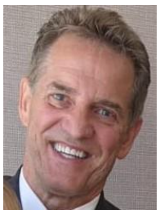

Curt Wilbur - Assigned to Bountiful 18th Ward
The year began with scheduled speaking assignments, meetings about Camp Piuta, and planning meetings for Handcart Days. My speaking assignments included the 8th Ward, the Heights Ward, the 50th Ward, and in April the South Davis Branch. However, the Branch was not functioning as the hospital was undergoing renovations and the patients had been moved to other facilities. Then, in March, the Covid-19 pandemic hit and, because I’m 72 and in the so-called “at risk” category, all my subsequent speaking assignments were canceled. My monthly speaking assignments were one of my more enjoyable assignments.
My other two major assignments were Camp Piuta in the Uinta Mountains and Handcart Days. I received an email from the Senior Missionaries assigned to Piuta that effective March 1st the Church would be handling the reservations. Then we (the 9 Stakes who are involved with Piuta) received word that all camps for 2020 would be canceled due to Covid. That removed one of my major assignments on the High Council.
In November 2019 I received the meeting schedule for Handcart Days. We typically met once a month. However, in the Spring we received word that Handcart Days 2020 was canceled, again due to the pandemic. Another significant assignment just went into limbo. I did have other significant assignments including missionary work, emergency preparedness, Melchizedek Priesthood training and advisor to the 18th ward, but due to in- person restrictions much of this work was done online. I am also the Stake Radio Response Specialist. This assignment is separate from my High Council calling.
Then in July the Stake Presidency assigned me to be the Missionary Work Leader. This was an exciting assignment. Since then, working with Carson Gautavai and Michael Gibbons (beginning in Oct.), we’ve been teaching the various Elders Quorum presidencies their responsibilities with respect to missionary work. One of the tools has been a PowerPoint presentation that teaches how to organize this work within the wards. A new tool, calendly.com, was introduced with much of the training for this done by James Stubbs of the 41st ward. This calendar tool facilitates setting appointments with the fulltime missionaries. The wards are still going through a learning curve, but progress has been made.
Service on the High Council has been one of the highlights of my Church callings. I’ve grown spiritually, made many friends across the stake, and learned a lot about Church government. My testimony is stronger and my progress towards a complete conversion is more focused. Someday I will be released and I will miss the associations; even the 6:30 am meetings!
- Curt Wilbur

Evan Thomas - Assigned to Bountiful 24th Ward
My name is Evan Thomas and I am currently on the Stake High Council of the Bountiful Utah Heights Stake. It is currently October 9, 2020 and as we look back on this very interesting year it is notable that many of our standard relationships have changed as result of the quarantine and crisis of COVID-19.
In my position I have watched as our High Council has attempted to maintain a Brotherhood inside the confines of the virtual universe. We have had many zoom meetings and done our best to try to keep in contact with people that need help, and with organizations in that need support. For the most part, I think this has been effective. I still feel the brotherhood with my quorum, I feel a strong connection to my neighbors, and I feel as if we are accomplishing a lot of good work. However, it appears to me that we do suffer when we as people do not share the same physical space as others. Our attention is not as dedicated and our perception is not as clear as when we are in the actual world with people as opposed to the virtual world.
It was my privilege to help organize and direct the last social activity done in our area before restrictions from the quarantine were enacted. We held a Valentines dance on February 14, 2020 that involved members of the Stake of all ages coming together and dancing and having dinner and a good time. This was a wonderful event and supported well by the Stake. On a personal note this particular tradition was started many decades ago and my own mother was in charge of the first Valentines dance. As the year progressed and we watched restrictions limit our get-togethers I have become increasingly concerned that events like the dance may not continue.
In March 2020 we had an earthquake that shook everybody sensitivities and made us more concerned that we might not be as prepared for things as we once were.
In September 2020 we had a large windstorm that moved through our area that was similar to the windstorm of 2011. However, it was on a much broader scale. Interestingly it was procedures and processes that we learned from the 2011 windstorm that prepared us for the 2021 storm. We learned that we could use stake centers as another area to deposit large amounts of debris from the storm and avoid huge lines at the local dump. The National Guard was then able to come in and remove this debris with greater ease. I was asked to help with the management of debris that was being deposited at the "old Stake Center".
By the time I was asked to coordinate this effort the natural volunteerism of the people in our area was already in full force. I sent out emails and organized the efforts of all the available help from the various wards. As the date approached, I was informed the day before that the National Guard had already stopped by and removed a large amount of the debris. I stopped by that afternoon and saw that there was still a significant amount of debris that needed to be removed. On the day of the coordinated effort, I arrived about an hour before start time to find that Kirby Olson from the Dry Creek ward and Mark Green were both onsite with large heavy equipment to include both a front-end loader and a large side dump semi-trailer. They were cleaning up vast amounts of the remaining debris.
In all we spent about an hour and a half onsite and the heavy equipment did most of the work. Volunteers showed up from the different wards and were able to clean up everything that remained in short order. We then turned our attention to some of the other homes in the area that had remaining debris. We split up into groups and helped to clean this up as well.
Evan

Clint Beisinger - Assigned to 34th Ward
As we move into the holiday season the quarantine continues and will limit our ability to get together for Halloween parties, Christmas parties, and probably again, our Valentine dance. My hope is that this will all resolve, that fear will subside and that we will be able to be with each other as a people again.
During the 2020 year, I have served as a High Counselor and have been assigned as the Stake Young Men’s President. I’ve loved this calling and assignment. It’s been an honor to work closely with the young men and also youth, in general. I’m strongly encouraged by the strength and valiance of the youth in this generation.
I think the highlight of 2020 for our stake youth committee was seeing them plan and put on the live nativity in December. The Stake Presidency reached out and wondered if the youth would feel good about putting this performance on. Even though they had previously scheduled a Christmas Eve morning side, the youth council decided to adjust and put this activity on. We only had 13 days from idea to performance. It was incredible to see the support from the Stake Young Women’s Presidency, Stake Relief Society Presidency and the Stake Presidency. We received really positive feedback and it was incredible to see individuals and families in the stake attend this outside performance.
There were 3 performances in one evening to help with social distancing and we believe there were close to 700 people that attended, in total. Like so many, I’ve seen the Lord’s hand in my life and been supported by him. I know the restored Church of Jesus Christ is true and it’s a privilege to serve in the Bountiful Heights Stake.
Clint

Erick Anderson - Assigned to the Bountiful 41st Ward
It has been a great blessing to be called to the Stake High Council in June of 2020. One of my main responsibilities was to be assigned to be the coordinator for the stake with Bountiful Handcart Days, but due to Covid, there was nothing to do as that event was cancelled. Hopefully next summer we can have it going again.
I have worked with Brother Carson Gautavai to train new Elder’s Quorum Presidencies in the Stake. We have been able to train a total of five of those over the past 5 months.
Those meetings were very spiritual as we felt the Lord’s hand in directing the messages and experiences we shared and I testify that the Lord knows each of these new Presidents and deeply cares about the saints under their watch.
One of the things I have appreciated the most during my short time so far in the High Council is the blessing of preparing talks to share in Sacrament Meetings. We have not met in person until recently, so it has only been a couple of talks, but I learn so much in my preparation and try to listen to the spirit to direct what personal experiences I can share and messages from Prophets that touch on the topic and build our faith.
Covid has made me understand better my dependence upon God for all things in my life. I took far too much for granted prior to Covid. Now I realize better that everything I am and am blessed with comes from God each moment, even the very air that I breathe. I have appreciated the blessing of partaking of the Sacrament each Sunday in my own home with my family, and the sweet spirit that brings to feel the Savior’s atonement in my life.

I testify that the Lord lives and loves each of us more than we can begin to comprehend. I am so grateful for the Priesthood being restored to the earth and that we have living prophets to guide and direct us today.
- Erick

Jim Bergstedt - Assigned to the 50th Ward
Reflections on 2020 - Give Me This Mountain
Never could we have predicted what 2020 would hold for our family, this nation, the entire world—and indeed, for the Church.
Adversity has an uncanny way of being a steady, yet unpredictable teacher. Arthur Golden noted that “Adversity is like a strong wind. It tears away from us all but the things that cannot be torn, so that we see ourselves as we really are.” The great Nephite prophet Jacob taught that the Spirit, another great teacher and testifier of truth, “speaketh of things as they really are, and of things as they really will be” (Jacob 4:13). So adversity, whatever the cause, is in good company.
With Joshua of old, we declare, “As yet I am strong this day, therefore give me this mountain” (Joshua 14:11-12). What did “this mountain” offer in 2020?
In early 2020, the “novel coronavirus,” otherwise known as “Covid-19,” hit the United States. The World Health Organization declared it early on to be a pandemic. Once the virus began spreading in factors of ten every ten days, drastic measures were implemented beginning in early March, including: ending all major sporting events, all concerts, plays and other local entertainment; soft school closures; modified hours at grocery stores, with limits placed on certain items; dining areas of restaurants closed, with only drive-through or take-out options available; full-time, home-centered church for the foreseeable future (and cancellation of all church meetings and activities, concerts, etc., with significant modifications to General Conference); missionaries serving in foreign lands being called home; and entire cities placed on lock down.
On March 18th, a 5.7 magnitude earthquake, with an epicenter in Magna, rattled the Wasatch Front. And the end of summer produced the largest windstorm in nine years in Davis County, causing significant damage to homes, businesses, trees, and more. Unemployment reached numbers we haven’t seen in decades. Racial and political tensions rose to new levels across the country, spurring violent protests and demonstrations—even in downtown Salt Lake City.
We know from modern-day revelation that the Lord calls upon us in various ways, by the ministering of angels, and by mine own voice, and by the voice of thunderings, and by the voice of lightnings, and by the voice of tempests, and by the voice of earthquakes, and great hailstorms, and by the voice of famines and pestilences of every kind, and by the great sound of a trump, and by the voice of judgment, and by the voice of mercy all the day long, and by the voice of glory and honor and the riches of eternal life,
(D&C 43:25).
Lessons from the Lord Himself, from the Spirit, and from adversity in 2020 really have taught us about “things as they really are.” They’ve molded and shaped and refined us in ways we couldn’t have otherwise been molded and shaped and refined. But have we sufficiently learned how to become clay in the hands of the Potter? Have we looked past the adversity, the trials and tribulations, to see things as they really are and discover the positive takeaways—even the tailor-made blessings—from our challenges and setbacks and inconveniences?

Finding the Silver Linings
“We have no right to ask when sorrow comes, ‘Why did this happen to me?’ unless we ask the same question for every moment of happiness that comes our way” (Anonymous). And, as Elder Holland reminded us, “even in the golden age of civilization, someone undoubtedly grumbled that everything looked too yellow.”
The Lord is indeed mindful of us. We can “hear Him” and recognize His hand in our lives by being content with what is allotted unto us and showing gratitude for our blessings in the midst of our afflictions. He sustains us in our efforts to do so, and we will come to appreciate the blessings and tutoring that come to us in our trials—even silver linings with divine underpinnings.
What silver linings did we recognize in 2020, particularly in the context of Church participation and service?
- The pandemic and earthquake highlighted he need for increased food production at the Deseret Mill and Pasta Plant in Kaysville (among others), where our stake provides between 50-100 volunteers every other month. I was assigned with others in our ward to serve at the Mill the afternoon the earthquake hit—and a 4.6 magnitude aftershock in fact occurred during our shift, but thankfully we didn’t feel it! I have oversight of the Mill assignments for the Bountiful Utah Heights Stake, and have been grateful for the willingness of stake members to step up and serve in greater numbers this year.
- As a member of the Davis County Communication Council—which helps facilitate ecumenical/interfaith service opportunities in our area—I was impressed by the level of awareness of the needs around us, and the willingness of Stake members to step up and give more of their time, talents, and resources to lighten others’ loads.
- In particular, the September windstorm required herculean efforts to remove fallen trees and other debris throughout our neighborhoods and community—and a county-wide effort to preserve the logs for Native American tribes in southern Utah and Northern Arizona culminated in more than 80 semi-truck loads of firewood for these good people. Donations at the Bountiful Food Pantry have also increased the past several months, and Stake members organized projects within their wards to contribute to this worthy cause.
- The inability to worship together in congregations on a weekly basis and gather for other church activities helped us appreciate more fully the freedoms to assemble, worship, and share our convictions openly and freely, without repercussion.
- Moreover, the miracles of technology have enabled us still to participate in meaningful ways in general conference, in Ward and Stake Council meetings, high council meetings, and in our ministering efforts.
- Rather than view stay-at-home orders, social distancing, and unemployment as a burden, we came to appreciate extra pockets of time we had to spend with immediate family, for personal study and reflection, and for eliminating much of the unnecessary distractions and noise in our lives. We truly became more appreciative of the remarkable gift of time, but also gained a renewed appreciation for family and friends we were unable to spend as much time with on a regular basis.

Great Blessings of the Lord Upon Us...in the Wilderness
In reading 1 Nephi 17 before Covid-19 captured headlines and changed many aspects of our lives for a season, something stood out to us in verse 21 that we hadn’t noticed before. Laman and Lemuel are murmuring (again)—this time about wandering in the wilderness and in reference to Nephi’s plans to build a ship. “Behold, these many years we have suffered in the wilderness, which time we might have enjoyed our possessions and the land of our inheritance; yea, and we might have been happy.”
We have come to hear Him more plainly and recognize His hand in our lives by striving to be more “content with what is allotted unto” us (Alma 29:3) and learning to look for the positive even in the midst of adversity and affliction. In the process, we have come to learn the importance of showing gratitude in and for the challenges that shape and refine us - realizing that it is in our extremities that we become acquainted with and hear Him.
Contrast their response to their sufferings to Nephi’s in the first part of that chapter. Although he recognizes that they “did travel and wade through much affliction in the wilderness” and that they “live[d] on raw meat,” he recognizes that “so great were blessings of the Lord upon us” and that the Lord “did provide means for us while we did sojourn in the wilderness” (vv. 2-3). Nephi would likely have agreed with the Buddhist proverb, “Enough is a feast.” He also knew and recognized that “no one escapes the wilderness on the way to the promised land” (Annie Dillard).
Nephi—like Alma—is one of the great examples in the Book of Mormon of learning “to be content with the things which the Lord hath allotted unto [them]” (Alma 29:3)—of truly finding joy in what can otherwise be a treacherous and unpleasant journey. How many life-changing lessons are we missing out on because we are focused on all that can’t do as result of the pandemic and other challenges in our lives—instead of the unique gifts and opportunities He bestows upon us, even in our trials?
Amulek encourages us to “live in thanksgiving daily, for the many mercies and blessings In speaking to the world in a special broadcast in November, President Nelson extended a similar invitation—even a “prescription”—in the form of the healing power of gratitude. “Over my nine and a half decades of life,” he said, “I have concluded that counting our blessings is far better than recounting our problems. No matter our situation, showing gratitude for our privileges is a fast-acting and long-lasting spiritual prescription. Does gratitude spare us from sorrow, sadness, grief and pain? No, but it does soothe our feelings. It provides us with a greater perspective on the very purpose and joy of life.”
- Jim Bergstedt

Jonathan Rupp - Assigned to Dry Creek Ward
Like everything else, my time on the High Council in 2020 was completely dominated by COVID-19. Beginning in late March church meetings were cancelled almost entirely. TheStake Self Reliance Committee met to assess the temporal needs of the stake members. Although a few families in the Stake were affected greatly, compared to the financial concerns facing so many, the members of the Stake fared relatively well, with few families losing their income. Most Stake members were able to work remotely. Wards worked to ensure that essentials were provided for those significantly impacted. Not long into the pandemic another round of the Self Reliance Initiative meetings was scheduled. This round was held virtually as in-person meetings were discouraged. Over seventy people in the Stake signed-up. These courses provided not only financial direction, but also an opportunity to socialize for many of our single members, who often felt isolated. Although COVID-19 caused sickness, worry, and anxiety, the Stake continued to move the work of the Lord forward, albeit in some non-traditional ways.
- Jonathan Rupp

Roy Woodbury - Assigned to the 54th Ward
2020 has been a most unusual year, it has been filled with many tender mercies seeing the Lord’s hand at work in moving the gospel forward. Through my experiences of this year my testimony has grown. After the lockdown occurred due to the Covid-19 Pandemic it was a blessing to see how many technology efforts that had been planned and were underway prior to the pandemic were able to leveraged to bless the lives of members in our Stake and around the world to bring meetings into their homes.
When the pandemic announcement about lockdowns was announced and we were given dispensation to administer the sacrament in our homes I remember feeling the sweet blessing of being able to still renew our covenants and partake of the sacrament with my wife. Those were sacred memorable experiences. As restrictions began to lift it was a blessing to assist with the efforts to stream sacrament meetings and Sunday school, Priesthood and Relief Society meetings. It also made you appreciate the socialization of friends, neighbors and Ward members, and look forward to the time when things can get back to normal and we can all meet in person again. It was a challenge seeing the temples close and then open with limits to only perform live ordinances. Our daughter’s sealing had to be postponed and they were married on a beach in Hawaii (where they are living) by their local bishop. My mom also passed away in July and due to restrictions in place the services had be very restricted. Through all of this I could still see the Lords hand in moving His work forward. I have a testimony that he lives and directs the earthly affairs of the church through a prophet Russell M Nelson and his apostles. The past two general conferences were held virtually and were spirit filled meetings with vital instruction for our days and time. I also have a testimony of President Lake, the Stake Presidency and our other local church leaders and know these men and women have been called of God. It was also a blessing to serve as the Stake Employment Specialist during this time of need.
Our Stake was blessed to not be to hard hit by unemployment, however for those effected I appreciated when I would receive a prompting to reach out or contact someone on a jobseeker’s behalf, to listen, support and provide encouragement. It was also a blessing to see people coming forward with job leads or reaching out when a need was identified and offering networking assistance. All of these experiences blessed my life in ways I was not expecting in 2020.
- Roy Woodbury

Carson Gautavai - Assigned to Heights Ward
Missionary work, Elders Quorum Presidency Training, Blood drive
My faith and testimony in the Savior have deepened in the last 6 months as I have been able to apply His atonement and witness His hand in my life and the lives of loved ones; as well as our brothers and sisters, and friends and neighbors in the Heights stake. My life and faith are full not despite the challenges of the past 6-12 months but because of them. I am grateful for the opportunity I have to lift where I stand to build the Kingdom here in the Heights stake as a member of the Stake high council. Working with the full-time missionaries assigned to our stake has been an amazing experience participating in the work of Salvation and Exaltation in different yet truly meaningful ways. The work of the gathering continues moving forward. The challenges with the Pandemic have provided our members with opportunities to host the full-time missionaries and be taught by the spirit in brief 15-minute virtual meetings. With technology sharing personal stories and testimonies with our friends and neighbors has never been easier. I have been warmed by the response of the members of the stake and community in a strong show of support and volunteerism with the neighborhood wind storm cleanup and assistance in the last six months.
Many acts of kindness and faith were demonstrated as friends and neighbors of all faiths worked together to help those in need. I also witnessed this love for neighbors and our fellowmen/women with the annual Stake blood drives. The Heights stake hosted 2 annual blood drives in 2020, one mid-year (June) for ARUP and a second end-of-year (December) for the American Red Cross. Despite the concerns with COVID19 and the Pandemic members of the Heights stake, friends and neighbors rallied to support this community need and service. Blood donations nationwide were in critical short supply. The Heights stake donated in 2020 the following:
American Red Cross:
2020:*56
2019. 43
ARUP:
2020 19
2019: 19
Both totals show a great commitment to follow the first two great commandments to love God and to love our fellowmen (Matthew 22:37–40). The 2020 totals are a great response to a community call. Even in the case of ARUP the timing of its blood drive (June) shows that even with a more restrictive and uncertain social-health setting the Height stake members matched the 2019 non-Pandemic total. In the case of the American Red Cross, its event just ahead of the announcement of an approved vaccine and yet the donations exceeded the previous 2019 non-Pandemic donations. *The 56 units is second only to an all-time high in 2017.
This is His work and His kingdom here on earth. We are lead by a living prophet, President Russell M. Nelson. Jesus Christ is the head of this, His Church. This I so testify in Jesus Christ, Amen.
- Carson Gautavai

Scott Kimber - Assigned to Ward Canyon Ward
During 2020, I was blessed to have been given assignments within that Bountiful, Utah Heights Stake, as follows:
• Advisor - Ward Canyon Ward
• Stake Sunday School President
• Food Pantry and Community Outreach
• Audit Committee
• Activities – Cultural
• AP Leadership Training
• Missionary Work - Ward Canyon Ward
Beginning in March 2020, our world suddenly changed with the world-wide COVID19 Pandemic. Our old ways of doing things were no longer available to us. We adopted a new normal. The most significant change involved the guidelines for social distancing, we meant that we were unable to meet in person to work with leaders and members.
Bountiful Food Pantry. Under normal circumstances, the Food Pantry has an annual food drive, where thousands of pounds of food is collected for the local food pantry, but with the Pandemic, the food drive in March 2020 was cancelled. This had a significant impact on the Food Pantry’s collections. In addition, because of the Pandemic I was unable to meet in person with the Food Pantry leaders, which further limited my ability to assist them. During the Christmas season of 2020, the Bountiful Community Food Pantry prepared a flyer requesting that people in the community provide Christmas Breakfast. The email from the Food Pantry was distributed to members of the Stake.
Audit Committee. As High Councilor, I assign each of the wards to one of our six Stake auditors. After the assignments were made and the July 2020 audits were underway, one of our auditors was exposed to COVID and was unable to complete his two assigned audits. Without missing a beat, one of the other auditors volunteered to take his assignments, and the audits were completed on time. In the past, the all of audit procedures were conducted in person. But, thanks to the inspiration of Church Leaders much of the data is now accessible electronically, so the time spent with the Bishops and Financial Clerks is lessened. For those that were particularly sensitive to the social distancing restrictions, the audits could be performed through telephone or Zoom. This is a testimony to me that the Lord knows us and that he will provide a way for his work to go forth.
Stake Sunday School President. In March or April 2020, all in-person Sunday School classes stopped, and Zoom conferences were commenced. Our ward Sunday School presidencies have done an outstanding job of making sure that the Sunday School classes are being held. I am thankful for all those leaders and teachers that have excelled in their callings during the difficult Pandemic. I know God loves us and is aware of our needs.
- ScottKimber

Steven Moffit - Assigned to Bountiful 16th Ward
My responsibilities included missionary preparation and special needs mutual representation. The special needs mutual was postponed indefinitely during the Pandemic. Those serving in that group worked to stay connected with the youth through technology and the weekly meetings are yet to resume. Missionary preparation was postponed for a short time and resumed with the Dibbs using technology through the fall. Virtual meetings were very successful and with the return of missionaries while being furloughed is a unique experience for many youth.
- Steven Moffit

Heights Stake Auxiliaries Stake Primary President - Rochelle Gautavai
Ward Conferences were held Jan. 12th – March 8th until they were shut down due to COVID. The Stake Primary Presidency introduced the new theme for the year- The Book of Mormon. Each member of the presidency reviewed some part of the history or story of the Book of Mormon including where the gold plates came from and how Joseph Smith found and translated the plates; the prophets who wrote on the plates including Nephi; and how the Book of Mormon can be used to do missionary work. Songs were sung with each presentation. Due to COVID restrictions, Heights Ward and South Davis Branch did not have ward conference.
The stake baptism schedule was rearranged so that instead of holding individual baptisms each hour, each ward was given an hour on the Stake baptism day and all candidates from that ward were baptized one at a time during that hour. The baptism letter that was sent to parents was changed to give increased information to parents and to stress the spiritual nature of the baptism. A new baptismal instruction packet was created and sent to all Primary presidencies so that baptisms would run more smoothly. In addition, primary presidents were encouraged to have more responsibility for ward baptisms and to coordinate with the Stake Primary Presidency member (Heidi Allsop) regarding baptisms.
COVID drastically changed the format of baptisms when it hit in March. Baptisms were changed to be under the direction of the bishop and coordinating with the Ward Primary Presidency. Stake baptisms were stopped, and baptism dates and times were up to the family and ward. The first restrictions only allowed the baptismal candidate, priesthood holder and witnesses in the font room. No program was allowed. Family and friends could watch remotely. When restrictions were relaxed, up to 20 people could attend the baptism, but the program was still limited to the baptism. Feedback from family showed that there was an increased focus on the covenants made at baptism and less on the program. Families reported an increased spiritual focus and feeling in this new format.
Church was shut down for several months and all Primary functions became home focused with primary presidency support. For support, some primary teachers sent letters, some wards had virtual activities, other primaries struggled to know what to do. Activity days was stopped for a while, and then some wards started up occasional activities. When church attendance was again allowed, primary was not held either in person or virtually. Traditional Primary Programs were not held this year. Individual ward primary presidencies could create their own primary program format or not hold one at all.
Primary training was held Nov. 5th via Zoom (virtual meeting format). The theme was 2nd Nephi 25:26. Short talks were given by the Presidency members with the focus being that the primary presidencies should focus on receiving revelation for their ward primary on how to adapt to the new church format and restrictions caused by the pandemic.
Concluding remarks by Pres. Anderson reflected our year perfectly when he said, “We may not know (what to do), but our Heavenly Father does know”. This year has shown us the power of prayer, faith and revelation; that even during trying times where there is no longer any form of what was “normal”, we can still meet the needs of our primary children by looking to our Savior, Jesus Christ and moving forward with faith.
Rochelle Gautavai Primary President, Heidi Allsop 1st Counselor, Amy Bain 2nd Counselor, Camille Giebel Secretary, Shannon Moffit Music Specialist
- Submitted by Camille Giebel

Stake Young Women’s 2020
We started the year off with a Stake Wide Activity for the 11–13-year-old young women. They all came to the Stake Center where we did some activities to get to know each other better and then had a fireside presentation from Sister Lucy Gibbons. It was a great night. At the end of January, we had a fireside for youth and their parents that was combined with 3 other stakes at the Regional Center. We are addressed by Collin Kartchner and he talked about the dangers of smart phones and living in the digital age. We started our Stake Young Women basketball league but did not get to finish because of the COVID pandemic. Right after the pandemic started, everyone hunkered down, and all activities stopped. The Ward Young Women leaders were fabulous at finding creative ways to still meet using Zoom, or individual ways to share participate and then share as a group through zoom. Our leaders continued to contact the young women through messages, notes or phone calls. They would also find ways to meet under the social distancing guidelines and help keep the unity of their young women classes strong. I was very impressed with the new ways they found to support their young women.
Another positive thing that came out of the pandemic was that we had a fresh perspective on how to organize the Stake Youth Council. Instead of following the patterns of the past, we were able to let the Youth Council lead and come up with new ways to help the youth in our stake. One activity we had in November was a Stake Wide Kahoot activity. Each ward was given treat bags for each of the youth and then they participated in an on-line trivia activity with gospel related trivia and regular trivia that the youth council created. Another great event was a live nativity in December. The youth all took part being shepherds, wise men, angels, as well as Mary and Joseph. We used the script and music that was passed out to each household in the stake and turned it into a live production. The Nativity was staged at the 16th/18th/24th/Dry Creek building outside on the West lawn. We had 3 different sessions so that we could invite the whole stake and still be socially distanced. It is estimated that 600-650 people came to the Live Nativity.
The pandemic certainly stopped some regularly planned activities like girl’s camp, but with some persistence and creativity a lot of great opportunities and activities were also created.
– Andrea Davis

Stake Relief Society - Monday, Apr 13, 2020 Service Opportunity
Hello Wonderful Stake Sisters,
I received a text requesting help from the Davis County Emergency Preparedness Council. They are in desperate need to help city employees. They specifically need face masks for those who work with the public all the time. They are kindly asking if we could rally and help make masks. This request for masks covers all of Davis county cities employees. This need is great! They have asked for 1000 total but our stake is being asked for 90 masks at this time. I have attached a few mask patterns for you to choose from. The CDC one is the easiest to make. One of the patterns includes instructions for a pocket for a filter. You can choose what kind of mask you want to make. Don't sweat over which mask is best. Just make the one you think you would like to make and produce quickly. We cannot make masks that will 100% protect people from getting the virus. But we can provide masks to help protect us as best we can. As soon as you have masks made you can call or text me and I will get them picked up and delivered. My phone # is: Tammy Matheson 801.512.1764 (I will coordinate all pick up efforts)
I have also had a call from two assisted living centers to see if we could sew some masks for their caregivers and fragile patrons that live there. combined their request is a total of 200 masks we have been asked to help with. If you can sew and have fabric that would be great! I have attached patterns and links to some patterns that seem to be user friendly and comply with the CDC requirements. You can use your own pattern if you would like. They just need masks soon as well.
I recognize these are big requests but they are also BIG needs for our community. This can be a great opportunity for us to serve.
Many of you may have fabric but cannot sew. If you want to donate any I will pick it up and give to others that can sew but have no fabric. I will field any questions you may have and will be happy to help you in any way. You can text or call me and time!!!
I hope that we as a stake can rally our resources and fill this great need. Our beloved prophet has said that when we are serving others it is one of the best ways to #hear him. We join our daily prayers with yours for the world and for our Stakes safety, protection and unity.
If you do not sew and would like to help in other ways and have ideas you are welcome to call me. Many hands make light work!
"Do and Hope" with Love and Many Thanks,
- Bountiful Heights Stake Relief Society Presidency

Face Mask Pattern
Tammy Matheson 16th Ward
Teresa Williams 54th Ward,
Nora Cook 24th Ward,
Tanya Whitney 50th Ward
Pattern A -https://www.unitypoint.org/filesimages/COVID-19/UnityPointHealth- OlsonMask-Instructions.pdf
Pattern B - CDC pattern
Pattern C- https://sewitonline.com pattern 2. below
CDC: Sewn Cloth Face Covering Materials
• Two 10”x 6” rectangles of cotton fabric
• Two 6” pieces of elastic (or rubber bands, string, cloth strips, or hair ties)
• Needle and thread (or bobby pin)
• Scissors
• Sewing machine
Tutorial
1. Cut out two 10-by-6-inch rectangles of cotton fabric. Use tightly woven cotton, such as quilting fabric or cotton sheets. T-shirt fabric will work in a pinch. Stack the two rectangles; you will sew the mask as if it was a single piece of fabric.
2. Fold over the long sides 1⁄4 inch and hem. Then fold the double layer of fabric over 1⁄2 inch along the short sides and stitch down.
3. Run a 6-inch length of 1/8-inch wide elastic through the wider hem on each side of the mask. These will be the ear loops. Use a large needle or a bobby pin to thread it through. Tie the ends tight. Don’t have elastic? Use hair ties or elastic head bands. If you only have string, you can make the ties longer and tie the mask behind your head.
4. Gently pull on the elastic so that the knots are tucked inside the hem. Gather the sides of the mask on the elastic and adjust so the mask fits your face. Then securely stitch the elastic in place to keep it from slipping.

Facemask Memorandum - April 15, 2020
Selected Area Seventies in the Utah Area Utah Area Presidency
Subject: Need for Volunteers to Sew Clinical Face Masks
With the current worldwide challenges associated with COVID-19, we wish to express our appreciation and gratitude for the outpouring of love and service by so many throughout the Utah Area.
The First Presidency issued a statement on April 14, 2020 regarding the significant efforts of the Church worldwide to address needs related to the pandemic. The First Presidency specifically mentioned that in Utah the Relief Society is leading our participation in a partnership between Latter-day Saint Charities, Intermountain Healthcare, and University of Utah Health to sew 5 million clinical face masks to be donated to health-care workers.
To accomplish the production of 5 million face masks, 10,000 volunteers will be needed each week for the next five weeks. Each participant will be asked to sew, in their homes, 100 pre-cut face masks. Face mask kits will be available for pick-up and drop-off at designated times at select Deseret Industries locations along the Wasatch Front. More information on this project and the required link for participants to sign up can be found at https://projectprotect.health/
We ask you to share this memorandum with stake presidents in your coordinating councils immediately. They should distribute it to stake Relief Society presidents and invite them to encourage Relief Society sisters, families, and friends who have sewing machines and are able to sew to participate.
We are grateful for the devoted service of all who will participate in this important effort.

Facemask Thank Letter April 18, 2020
Dear Wonderful Relief Society Sisters,
Thank you so much for heeding the emergency call to make face masks. You came to the rescue and combined there were 418 masks made from our stake!!! We met our quota from Davis county and the assisted living centers.
Thank you very much!!! There were 13 stakes that were asked to provide masks from the county. Together we made 1,800 masks which far exceeded the request of 1300!!! These
masks have been distributed to Sheriff’s offices, Bountiful PD, Animal Control, Fire Departments, and other first responders. Thank you so much! I love this stake!!!
Some of you have asked if more masks are needed. You have such generous hearts. It is amazing!!!! At this time the county is not asking for any more. They "encourage each of you to make sure you, your family and neighbors have at least one mask per person." We echo that suggestion, so keep on sewing as you are able. Now there is another call. The Relief Society of the Church of Jesus Christ of Latter- Day Saints had been asked to lead a charge. I am sure you have heard the call to help make 5 million masks, in 5 weeks.
Attached is the memo that went out. If you can and have the time please consider participating. This seems like a once in a life time opportunity to help teach our children how to "give of your time and your talents" to bless the lives of others.
Here are some things we know about this request called: ”Project Protect":
We are not being asked as a stake to produce a certain number of masks. We are being asked to participate as individuals and families as we are able.”
It will not cost you money to buy the kits. You do need to sign up on the website to participate. The website is overwhelmed and it is hard to get in to sign up. Be patient. This will be going on for 5 weeks. It will get easier to log in and sign up. Once signed up you will pick a convenient location to pick up the kits and then drop off the completed masks. You have one week to make all masks in your kit.
Now if you decide to participate but have issues getting to your appointment to pick up your kit or drop it off. Please let the Stake Relief Society Presidency know. We will do our best to help you. We would like to be the point men for this. This will allow your ward Relief Society President attend to her ward's needs.
Thank you for your generosity and love you have shown! Keep up the great work! it is worth the effort. Hang in there and know we are praying for blessings of love, unity, protection, faith and strength as we all work together in this new kind of season we are walking through together. Thank you again.

Stake Young Men’s 2020
During the 2020 year, I have served as a High Counselor and have been assigned as the Stake Young Men’s President. I’ve loved this calling and assignment. It’s been an honor to work closely with the young men and also youth, in general. I’m strongly encouraged by the strength and valiance of the youth in this generation. I think the highlight of 2020 for our stake youth committee was seeing them plan and put on the live nativity in December. The Stake Presidency reached out and wondered if the youth would feel good about putting this performance on. Even though they had previously scheduled a Christmas Eve morningside, the youth council decided to adjust and put this activity on. We only had 13 days from idea to performance. It was incredible to see the support from the Stake Young Women’s Presidency, Stake Relief Society Presidency and the Stake
Presidency. We received really positive feedback and it was incredible to see individuals and families in the stake attend this outside performance. There were 3 performances in one evening to help with social distancing and we believe there were close to 700 people that attended, in total. Like so many, I’ve seen the Lord’s hand in my life and been supported by him. I know the restored Church of Jesus Christ is true and it’s a privilege to serve in the Bountiful Heights Stake.
- Clint Biesinger

Stake Sunday School 2020
In March or April 2020, all in-person Sunday School classes stopped, and Zoom conferences were commenced. Our ward Sunday School presidencies have done an outstanding job of making sure that the Sunday School classes are being held. I am thankful for all those leaders and teachers that have excelled in their callings during the difficult Pandemic. I know God loves us and is aware of our needs.
– Scott Kimber

Bountiful Heights Family History Center 2020
The Church and Bountiful City approved the plans and location for constructing the much needed, new Family History center on the corner of Main street and Pages Lane in Centerville, Utah. The first quarter we had full operations with 35 consultants staffing the current location at 1250 East 500 North and the Annex when needed. The stake provided funds to acquire equipment to preserve documentation of pictures, slides, VHS family movies and audio tapes.
March 9 2020 The FHC director met with President Gibbons who received instructions that the Annex was to be removed out of the home to a new location. He also notified us that the Church cancelled plans for the new FHC facility in Centerville. We had eight current reservations from Bishops for youth groups and two Relief Society groups to meet at the Annex to accommodate their large groups. There is only space for thirteen computers at the Bountiful Heights Family History Center and more than adequate space for the 25 computers at the Annex. He said we should look for another location to move the 25 computers but continue to use the Annex until reasonable solution could be found.
March 10, 2020-discovered that the JOANN Fabric building could possibly be modified to fill a temporary solution.
March 11, 2020-we heard that virus of Covid-19 could possibly be spread through public facilities. The Bishop scheduled for that night was called, who called his Stake President, who suggested there was wisdom that they should reschedule for another time.
March 12, 2020-The Family History Center and Annex were closed down. All reservation groups and consultants were notified that we would be closed until further notice.
The Family Search Department notified us to keep computers on at the Family History Center at least turn them on every 2 weeks for updates.
We did open the Family History Center for only two family members at a time who did not need consultant assistance, but they must comply with all CDC regulations and not permit any others access while they were there. We supplied an automatic hand sanitizer, and we would sanitize the area after they left.
We continued to receive calls during the year inquiring if we were opened yet.
Contact with consultants indicate they are eager and ready to go back when permitted.
-Leon Davies

Bountiful Utah Heights Stake Additional Histories

40th Year Anniversary May 2011*

Set in the beautiful hills of the Bountiful bench, the Bountiful Utah Heights Stake of Zion commemorates 40 years of unity, dedication, and consecration by its members.
On May 16, 1971, the Stake was organized under the direction of Elder Mark E. Petersen of the Quorum of the Twelve Apostles and given the name, Bountiful Utah Heights Stake. Jesse E. Godfrey was called as the first Stake President, with the gifted assistance of Grant P. Petersen as 1s^{t} Counselor and Joseph F. Cutler as 2n^{d} Counselor. Just recently, President Petersen passed away and President Cutler now serves as the Stake Patriarch. Noted also is President Bruce Smart, Stake Patriarch, who is now on inactive status as a patriarch.
Following their foundational example, other Stake Presidents and Counselors have humbly accepted the mantle of leadership. From first to last, each of these men responded to the Lord’s call with inspiration, devotion and compassion. High Counselors, speaking in ward Sacrament Meetings, often conveyed the great love and genuine concern of the Stake Presidency for all members and neighbors residing within Stake boundaries, The guiding influence of these Presidencies fostered faith and charity among the Saints in uncounted ways: lives were richly blessed, temporal needs were tirelessly met, spiritual growth was enhanced and the hearts of many in our community were touched by the gracious actions of members within the Stake and leaders at all levels,
President Godfrey recalls his time serving as Stake Clerk in the Bountiful Stake, which had twelve active wards. Ministering to such a large group became cumbersome and difficult, so in 1971, the Stake Presidency wrote to the First Presidency suggesting that they consider dividing the Stake. Elder Mark E. Petersen and Elder Harold Wright, the Regional Representative, let it be known that they would be dividing the Stake at May Conference. With that news, the Stake Presidency and Stake Clerk commenced the necessary groundwork to divide the area by geography, age and other criteria. President Godfrey hoped there would be a job for him in the new Stake, never expecting a call to be the Stake President. At that call and with only short notice, his prayerful meditation resulted in Brother Petersen, the Bountiful City Manager, and Brother Cutler, an insurance executive, being called as his counselors, the three of them to nurture the five wards of the new Stake.
At its inception, the Bountiful Utah Heights Stake served approximately 1,160 members, including almost 600 Melchizedek priesthood holders, about 560 Temple recommend holders and 34 full-time missionaries, a number that quickly grew to 65. The average attendance at all meetings was approximately 55 %.
The years between May of 1971 and September of 1980, were years of great changes within the Church, not of doctrine, of course, but advances to make ministering to the Saints more effective. Among the changes was implementation of the Correlation Program. which had been in the planning stages for nearly 20 years. Previously, every division within the auxiliaries and every program (such as MIA Maids, Beehives, Relief Society, genealogy, etc.) managed their own curricula and procedures, even to the extent of having separate checking accounts for each. With application of the Correlation Program, financial reform reduced checking accounts to one per Stake and one per Ward and, most importantly, all programs were consolidated under the leadership of the priesthood. The three-hour block plan was instigated for Sunday meetings. Of global interest was the revelation received by President Kimball on extending the priesthood to every worthy male member.
During that time, the ten Stake Presidents in the Bountiful area met once a month to correlate activities. At one of those meetings in 1977, it was suggested that Bountiful ought to have a temple. President F. Burton Howard wrote a letter requesting a temple to the First Presidency and all ten Stake Presidents signed it. At a subsequent meeting of the Stake Presidents, the First Presidency’s reply was in hand; it read in its entirety: "Noted with interest." The decision to build a Temple was made some years later when the Prophet himself, then President Ezra Taft Benson, visited the apricot orchard where the Temple now rests, and envisioned the Bountiful Temple.
One of President Godfrey’s actions was to purchase for the Stake a plot of ground up the hill in a largely undeveloped area. This would play a central role in the Stake in coming years.
From September 7, 1980 until September of 1988, Roden G. Shumway served as Stake President, with Mark E. Eubank as 1St Counselor and G. Brian Bone as 2nd Counselor. President Shumway passed away many years ago and President Eubank is currently serving a mission in Hawaii. President Shumway was known for his honest, genuine love for the people. President Mark Eubank recalls visiting hospitals with the President many times, listening as he gave healing blessings to those in need. When instructed by the Spirit, he also released the sick from this mortal life and within days, each so blessed departed for the Spirit World.
It was during this time that building above Davis Boulevard and through the foothills began to accelerate. Where there had been apricot orchards, homes sprouted; where fields had remained bare, land was put to use; and where neighborhoods had been isolated, streets were built and families filled the houses. This growth necessitated moving the 33rd Ward to the Bountiful Central Stake, realigning ward boundaries and creating new wards. President Shumway was particularly concerned about the impact these developments would have on the people. He spent countless hours, making sure that everyone felt comfortable with the needed changes.
President Shumway was also noted for his mastery of time usage. He felt that a good meeting was a short meeting. President Eubank recalls numerous high-powered meetings, in which decisions were made and important information shared, but that lasted just 60-minutes. To do this, the President always had a purpose and agenda, and he executed it flawlessly.
This May marks 28 years since the terrible floods of 1983 came roaring down the creeks of Bountiful, cutting across 13th East and Davis Boulevard, slicing the Stake in half. Those who lived through that time remember the inspired preparations that President Shumway had in place. As this was before widespread cell phone usage, radio networks were established to provide emergency communication. When the emergency came, the wards were quickly mobilized and the priesthood was ready to provide relief. Things worked amazingly well; those with needs were cared for until everyone within the Stake boundaries was safe and sound, and returned to their homes.
During the 1980s, 8 % of the individuals living in the Stake were not members of the Church. President Shumway always emphasized missionary work, at home and afar. He encouraged the youth to plan for missions and adult couples to serve. Though numbers naturally fluctuated, 1980 saw 72 missionaries serving and seven more with calls in process. Additionally, new facilities were constructed, notably the 54th Ward building, and plans were under consideration for a larger stake center in the future.
Between September of 1988 and February of 1996, Joe L. Johnson fulfilled the calling as Stake President, with Richard Newton as 1’ Counselor and Leslie F. Paskett as 2n^{d} Counselor. When President Newton was called on a mission, President Paskett served as 1st Counselor and C. Richard Chidester was called as 2nd Counselor. Following his service in the Stake, President Johnson was also called as a Mission President in Ohio.
President Johnson recalls the great contribution made by his counselors, both when he served as a Bishop and as Stake President. In particular, an emphasis on missionary work led him to a vision of what a Stake of Zion could be and the recognition that the great growth of the Stake and of the Church takes place because of our missionaries, including the creation of stakes, wards, branches and the building of new temples. In 1996 alone, 116 wonderful full-time missionaries served with the support of their faithful families.
The growth of the Stake continued until there was not room sufficient to house the High Priests Quorum. President Johnson went to the Church with the suggestion to build a cultural center on the baseball diamond west of the Stake Center. Unknown to President Johnson, the land purchased by President Godfrey was available; therefore the Church authorized building of a new Stake Center on this property. This elegant building now sits where little development had then taken place, but where the servants of the Lord could foresee future growth.
Additionally, the South Davis Community Hospital Branch was created, with Leon Davies serving as Branch President. Established to provide tender and caring help to those residing at the hospital, the Branch was, and continues to be, staffed through callings extended to members of the Stake. As many have testified, serving in the Branch is full of unanticipated blessings as sweet associations between members and patients are formed.
From February of 1996 to February of 2005, Randall M. Browning served as Stake President with President Chidester, as 1st Counselor and Darwin F. Peterson as 2nd Counselor. Subsequently, President Chidester was called to be a Mission President in the Czech Republic and Slovakia. President Peterson was then called to serve as 1s^{t} Counselor and John L. Robison as 2nd Counselor. Additionally, President Peterson was later called to serve as Mission President in Argentina and will be returning from that service in June.
During these years, the Millstream Ward was created as part of the Bountiful Heights Stake, providing a ward setting for single members in the area and Bishoprics were called from among Stake members. So successful was this concept that on May 1, 2011, the ward became part of the newly-organized Bountiful Utah YSA Stake.
President Browning recalls counsel he received from two differing sources prior to speaking at a
Stake Conference at the Regional Center. Seated on the stand next to the President, Elder Marlin K. Jensen, the visiting General Authority, leaned over and said, "Just tell them how much you love them." This confirmed counsel that President Browning had received earlier. as he had entered the building. His eyes happened to rest on the painting, "Christ and the Rich Young Ruler". and the voice of the Lord came into his heart, "Tell them how much I love each one of them." With that sure witness, President Browning often bore testimony to the Stake of Heavenly Father’s love and care for each member.
July of 2002, saw the organization of a rewarding Stake Pioneer Trek, with Pepper Murray as trail boss. In response to scorching heat that had affected other groups, the trek leadership gathered to fast and pray. Giving voice to the prayer, President Browning received the strong impression not to pray for the elements to be tempered, but for all to have the strength to withstand whatever weather occurred. With wisdom and judgment they set out; the trek was successful and inspirational, with no one harmed.
Continuing the pattern of growth, total membership in the Stake reached 3,585 by the end of 2001, with an average of 70 % attendance at Sacrament Meeting. 76 % of endowed adults held temple recommends, while Melchizedek priesthood holders averaged 78 % attendance at priesthood meetings and sisters were at 72 % Relief Society attendance. In like fashion, member families totaled 1,407, with a 77 % home teaching average and an 83 % visiting teaching average. The youth had even more impressive numbers: 88 % of young men attended priesthood meeting and 90 % of young women attended Sunday Young Women’s meetings. Rounding out the figures, of 438 Primary-age children, 93 % attended Primary, a tribute to the strength of families throughout the Stake.
President Browning bears testimony of the hand of the Lord working in the Stake in both large and small, simple ways. Among them: the Aaronic priesthood blessing and passing the Sacrament in a reverent and dignified manner; individuals serving as care-givers at the South
Davis Branch, caring for those who could not care for themselves; Primary organizations, Young Women and Relief Society sisters working in the divinely inspired programs of the Church to bless the lives of Heavenly Father’s children day in and day out. Through these small and simple things is borne witness of the majesty of the great Redeemer, whose Church this is. Following President Browning’s service as Stake President, he served as Mission President in Georgia.
In February of 2005, callings were extended to Ralph R. Mabey to serve as Stake President, to
John L. Robison to serve as 1 ^{g} Counselor and to Bruce L. Dibb to serve as 2n^{d} Counselor. In consequence of President Robison’s call as Mission President in the Lubbock, Texas Mission, President Dibb replaced him as 1s^{t} Counselor and John R. Harding was called as 2"^{d} Counselor, completing the current Stake Presidency. President Robison will conclude his mission service this month.
During the last five years, Stake membership has remained fairly level, around 3500 individuals and just under 1400 families. Sacrament Meeting attendance has risen again from 65 % to 69 %. Demographically, the Stake Membership is aging somewhat, but many young families are now gathering to the Stake. An impressive statistic is the increase in current temple recommend holders from 79 % to 83 % of endowed adults. Both youth and children’s numbers remain high and stable, while the number of converts is rising, along with 107 individuals who achieved significant spiritual milestones during 2010. As President Mabey and the scriptures attest, the Bountiful Utah Heights Stake is a gathering place of Zion. "The mission of each of us as disciples of the Lord," President Mabey repeatedly emphasizes, "is to minister to the spiritual and temporal needs of God’s children, one at a time."
-Prepared by Jan Walker, Stake Historian

The Vineyard Neighborhood: A Brief History By Ralph Mabey
Pettingill Mountain rises above Bountiful Boulevard between the Bountiful Temple and 400 North; it is flanked on the North by Big Mountain and on the South by Sessions Mountain.
Our neighborhood lies at the foot of Pettingill. Our neighborhood is bordered on the East by the Bonneville Lake Terrace (now Bountiful Boulevard) and on the West by Tolman Road (now 1300 East). It reaches on the North nearly to Stone Creek (at 400 North) as it flows out of Ward Canyon and on the South nearly to Barton Creek (at the Bountiful Temple) as it flows out of Holbrook Canyon and through Meetinghouse Hollow.
The farmers of the Fremont culture found our area hospitable many centuries ago. In the 19th Century it was shared by Ute, Shoshone, Goshute, “Eutaw” and Cumumba peoples, largely hunters and gatherers.
By 1846, California bound emigrants traveling south through our land watched the summer sunset turn the Great Salt Lake into “a sheet of fire, varying in tint from crimson to a pale scarlet” and one noted that the land “extends from the mountains down to the lake in a splendid inclined plane broken only by the fresh water running down from ever-flowing springs above. The soil is rich, deep black sand and composition doubtless capable of producing good crops. The clear, sky-blue surface of the lake, the warm sunny air, the nearby mountains, with the beautiful country at their foot...made on my spirits an extraordinarily charming impression. The whole day long I felt like singing and whistling.”
On September 27, 1848, Perrigrine Sessions, a 34-year-old farmer from Maine and a convert to the Church of Jesus Christ of Latter-day Saints, was authorized by the Salt Lake high council to winter cattle in our area. He set up camp on Barton Creek at about 251 North 200 West--and Sessions Settlement was born.
By 1851 Sessions Settlement reported 444 settlers in 84 houses. The settlement, also known as Stoker and North Mill Canyon Ward, took the name Bountiful on February 27,1855. By that date the city had been platted and a wall to surround the city (400 East/ 400 North/ 200 West/ 500 South) was under construction. Far above in our neighborhood, the community grazed cattle.
In 1854 Judson Tolman returned to Bountiful to gain respite from the Indian troubles in Toole and thereafter began to lay claim to our neighborhood together with the Eggetts, Cooks, Barlows, Burninghams, Mosses, Stringhams, Bowens, Strands and others.
Judson Tolman and his father-in-law Joseph Holbrook, who lent his name to Holbrook Canyon (just south of the Bountiful Temple), built a sawmill in the canyon and provided lumber for the construction of the Bountiful Tabernacle. Dedicated in 1862, the Tabernacle is the oldest LDS church in continuous use as such in the world.
The second oldest church building in Bountiful is the Rock School House/Bliss Hall built in 1872 at 170 West 400 South where the Congregational Church provided free schooling for the city’s children.
Judson and his 28 children, by three plural wives, spread out along Tolman Road (1300 East).
Judson’s son Jaren, born in 1853, built his first home on the east bench in 1890 at 180 North 1300 East: This home still stands. Originally it was a two-storey brick home. At times it served as a schoolhouse with Jaren as the teacher. Nearby was a fresh spring or flowing well.
Jaren farmed our neighborhood, raising hay (probably without irrigation) on the north 18 acres of the 40 acre plot on which now stands the Bountiful Temple. John Barlow and his descendants owned and farmed the balance of this plot. Its last agricultural use was as an apricot orchard--planted high on the bench so that the early-blossoming fruit would not be threatened by the cold air that settled in the lowlands.
Jaren also worked in the summer at the sawmill in Ward Canyon (so named because the LDS ward supervised its use) which is at the top of 400 North. In the winter, as Stone Creek flowed out of Ward Canyon just below 1300 East at about 300 North (where a ballpark at “Rocket Park” now stands), Jaren diverted water to make a pond a foot or so deep. After the pond was frozen solid, Jaren plowed furrows in the ice and cut out blocks which were stored under sawdust from the sawmill until the summer. Often three crops of ice were harvested and sometimes the ice served the needs of the community until late July.
Like his father, Jaren had three plural wives, and 24 children. Ephraim, born in 1882, lived in our neighborhood until his death in 1957. His home, which still stands at 50 South 1300 East, was built in part from bricks from one of his father’s earlier homes on the same site (his father had four homes). The home is remarkable for the outer wainscot of cobblestones taken from the bed of Stone Creek and still visible from the street.

The fertility of Bountiful’s soil became well known. On July 24, 1888, the Millennial Star called it the best in the entire territory. But in our neighborhood the soil varied: In some areas (Viewcrest Circle) it was largely sand; streambed pebbles rose every year to the surface of some plots to the farmer’s consternation; a light and fertile loam blessed much of the land.
The Tolmans, and just below them the Briggs, raised row crops on fertile soil and sold those crops on the streets of Salt Lake City and after 1875 at the Farmer’s Market there. Watermelons thrived on the hillside. Winter wheat was raised where water was unavailable.
In Holbrook Canyon and on the north slope of Sessions Mountain (just south of the Bountiful Temple), the Stringhams and Burninghams raised raspberries, currants, strawberries, blackberries, gooseberries, alfalfa and beans. Heber Irvin Burningham’s 640 acres on Sessions Mountain produced berries which ripened two or three weeks later than those in the valley and won premium prices at market. His section was later sold to Brown Floral which planted, but never harvested, Christmas trees--still there to be enjoyed by the hiker. (The land is now the city’s.)
Robert William Moss, whose home still stands at 805 East 500 South and for whom Moss Hill is named, owned land half way up Pettingill Mountain and ran a large cattle herd.
Ephraim Tolman’s 80 acre farm was divided into 10 Acre parcels, apparently for his 8 children. Einar Harold Strand and his wife Grace bought 10 acres. His son Randall Strand still lives there and his daughter Dixie Heiner lives nearby. The Utah State Agricultural College is said also to have farmed some of this fertile land.
Above, in the vicinity of the Bonneville Lake Terrace, water was brought by two canals from Barton Creek out of Holbrook canyon north into our neighborhood. The water nourished the high crops and recharged the aquifer and thus the artesian wells in lower Bountiful.
In the early 1920's, Salvatore (Sam) Granato, who had earlier immigrated from southern Italy, purchased 140 acres in the high reaches of our neighborhood and also leased (possibly from Deseret Land and Livestock) 1000-2000 acres on Big Mountain (which rises high above the “B” which is now to be seen on the “Hogback” above Skyline Drive).
For their family of 13 children, the Granatos built a house and dug a well in the vicinity of the junction of Granada and Vineyard (or possibly higher up Vineyard; an old lilac bush bloomed for many years at about 1600 east). The Granatos planted an extensive vineyard north and probably east of their house in the vicinity of Moss Hill Drive. From the grapes, the Granatos made wine, not for sale but for personal use: Sam followed his Italian traditions and drank only wine.
Perhaps it may be said that the Granatos lent us both of our names: Granada Hills and Vineyard.
At the top of Vineyard, just above Bountiful Boulevard, a spring emits from the hollow. The Granatos tunneled out this spring, probably in order to encourage its reliability. They built a concrete reservoir nearby which was buried several years ago.
Below the Granatos, on 1300 East, the Tolmans and Seiferts lived to the south of Center Street, the Hansens and Bowens to the north, with the Briggs just below.
The Granatos were goatherds, tending 900 goats, milking each morning, selling the kids in the spring, wintering the herd in Stockton, Utah. From the goat’s milk, they made and sold their own cottage cheese and hard Parmesan or Romano cheese. The resulting skim milk they fed to their hogs.
The goats grazed on Big Mountain and were corralled east of the Granato’s house. In order to reach their grazing grounds, the goats followed a path along what is now Bountiful Boulevard north across Stone Creek in Ward Canyon. They had their own bridge across the stream.
During this time Bountiful City obtained some of its drinking water from Stone Creek. The city’s and the goat’s needs were incompatible. In the 1930's, after a decade of litigation battles which the Granatos won, Bountiful won the war by purchasing the grazing grounds on the mountain. The Granatos then moved their herd south to the vicinity of Mill Creek below Mueller Park and finally to Draper.
Above the Granato’s homestead was an isinglass (mica) mine whose entrance was on Pettingill on the north side of Holbrook canyon (above the Bountiful Temple) and whose tunneling has been said to traverse north under Pettingill into an underground lake and all the way to Ward Canyon (above 400 North). Others mined our neighborhood and its mountains without success. Henry Stahle owned east of 1300 East and attempted some mining. Bucklin also mined in the area of Big Mountain. The Tuttle mine may still be seen far up Ward Canyon on the Tuttle Loop.
For many years the Tuttles also lent their name to 400 North.
From the departure of the Granatos in the mid to late 1930's until the last quarter of the 20th Century, our neighborhood appears to have been farmed by the Tolmans, Strands, Hansens, Seiferts, Bowens, Barlows, Burnighams, Knightons, Stringhams, Eggets, Cooks, Spiesses and others--with some of its upper reaches largely neglected.
A vineyard at 33 South Moss Hill Drive endured many years.
These landowners battled the floods of the 1930's and welcomed President Roosevelt’s CCC camps to the neighborhood, in the vicinity of Oak Hills School’s playing field, and also near Hannah Holbrook School. From these camps the CCC “boys” hiked into the mountains to reclaim the watershed by raking wild wheat into the soil and by digging protective terraces--although the primary terracing was done above Farmington and Centerville.
Houses and families supplanted barns and crops beginning in 1974 when Eubanks purchased property at 1375 East and about Center Street. The Harwards, Cutlers, Lewises, Stewarts, Ridges, Weeks, Nielsens and others soon followed as Doxey Layton (purchasing from Bill Spiess) and the Strands (on the south side of Vineyard up to about 1375 East) developed their property.
The historic pioneer road which struggled from the town up about 200 North to the mountain was largely abandoned. The road had first been known as “Rocky Road,” then later was called along some stretches “Turkey Shoot Road” for the Lion’s Club Thanksgiving Turkey Shoot held at the firing range on the site of Rocket Park (which itself is sometimes called Turkey Shoot Park and is scheduled soon for a another name change).
Soon the neighborhood’s primary crop was children. The local deer herd, which had long since replaced the goats, saw its winter range change from balsam root to rosebushes--and prospered all the more. The golden eagles moved higher; the meadowlarks succumbed to imported felines and racoons; blue jays largely but not entirely supplanted magpies. Starlings, sparrows, robins and chickadees moved next door and boldly serenaded their new neighbors.
Thanks to Weber water, the land became green enough to turn a 19th Century farmer green with envy.
The neighborhood now knitted families of many backgrounds and interests together. Like the immigrant of 1846, they enjoyed the nearby mountains and marveled at the fiery sunsets.
May they also feel like singing and whistling the whole day long.

Ralph R. Mabey
_________________________________________

The following sources were consulted for this brief history. No original sources, deeds or the like were researched, except for personal interviews. The material gained from many of those interviews was based on recollections from the distant past or on oral history. Much remains to be done. In the meantime, the reliability of this brief history cannot be warranted. It is simply my modest and approximate effort to put a few things down which have been unsystematically said about our neighborhood. Please feel free--and duty bound--to correct me.

Leonard, Glen M., A History of Davis County, Utah Centennial County History Series (1999)
Foy, Leslie T., The City Bountiful, Horizon Publishers (1975)
Daughters of the Utah Pioneers South Davis County Company, East of Antelope Island, Publishers Press (3d ed. 1969)
Tolman, Thomas B., The Life & Times of Ephraim & Phebe Hogan Tolman, Privately published (1999)
Bountiful Area Centennial Committee, Dwellings: A Guide to Early Bountiful Homes Built Before 1900, Bountiful City (1993)
Barlow, John Paul, Bountiful Utah Temple Site History, Privately published (1995)
Foy, Florence Tuttle, Mountain Streams in the Bountiful Area (a map), Privately reproduced (date unknown)
Tolman, Jaren Thomas, Historical Tour of the Bountiful Area, Privately published Eagle Scout Project (1992)
Interviews with Thoral Tuttle, Haven Burningham, Joe Granato, Thomas B. Tolman, Dixie Strand Heiner, Mark and Jean Eubank.
Personal recollections.

